Science Student’s Association Meeting Attendance
September Monday 14th, 2020

Position | Name | Present

President | Eric Vasas | Yes
Vice President | Jaime McNicholl | Yes
Chairperson | Anika Khan | Yes
Secretary | Jasmine Tingey | Yes
Senator | Dustin Erickson | Yes
Senator | Emily Kalo | Yes
Senator | Serena Philips | Yes
UMSU Representative | Bryan Kwak | No (excused)
UMSU Representative | Chloe McElheron | Yes
UMSU Representative | Katelyn Casalla | Yes
UMSU Representative | Riley Shannon | Yes
Accessibility Representative | Tristan Rohatynsky | Yes
Indigenous Students’ Representative | Zoe Quill | Yes
International Students’ Representative | N/A
LGBTTQ* Representative | N/A
Women’s Representative | Kyra Cebula | Yes

Treasurer | Justin Cruz | No
Director of Academics | Tooba Razi | Yes
Director of Communications | Zachary Hiebert | Yes
Director of Special Events | Rashawna Blair | Yes
Director of Student Services | Natalie Ngu | Yes
Executive Assistant | Stuti Gupta | Yes
Academic Programmer | Ethan Lin | Yes
Academic Programmer | Fares Hossain | Yes
Communications programmer | Sem Perez | Yes
Lounge Programmer | Aishat Bello | Yes
Special Events Programmer | Andrea Warzel | Yes
Special Events Programmer | Demi Andromidas | Yes
Special Events Programmer | Sion Yi | Yes
Special Events Programmer | Tiffany Tantakoun | Yes
Student Services Programmer | Dana Segal | Yes
Student Services Programmer | Kanso Alaka | Yes
Student Services Programmer | Selina Audino | Yes

Science Student’s Association Meeting Minutes
September Monday 14th, 2020
Called to Order: 6:36 PM
- Acknowledgement to use of Treaty Land
Zoe Quill acknowledges that we are meeting on treaty land.

- Approval of Agenda
Eric Vasas moves to amend the agenda to move the exec report first and motion to after that in the president and vice president report that Bryan Kwak, Riley Shannon and Stuti Gupta are excused from meetings on Mondays because of class, Jaime seconds; Motion passed.
Emily Kalo motions to approve the amended agenda, Jaime McNicholl seconds; Motion passed.

- Approval of Minutes
Eric Vasas motions to approve the previous meeting minutes from the meeting held on August 31st, 2020, Emily Kalo seconds; Motion passed.

- Council Reports
- President & (Vice) President
Eric Vasas and Jaime McNicholl Reports:
- Motion to excuse Riley Shannon and Bryan Kwak and Stuti Gupta from future meetings due to a class conflict
  - Motion Passed
- Senate
Serena Phillips reports:
- Due to COVID-19 students are not required to provide a medical note when missing an exam, quiz, etc. due to illness. They simply have to contact their professor or academic adviser by email within 48 hours.
  - For final exams you need to get into contact with an academic adviser because professors don’t deal with the final exams
- College of Nursing, & Pharmacy are changing their N95 mask fitting requirement from Mandatory to an as need basis due to N95 shortages because of COVID-19
  - Motion Passed
- Eric asked “when it means academic advisor is it anyone in your faculty?” – serena said yes

- UMSU
Chloe McElheron reports:
- Presentations: UCRU
  - Federal advocacy for large student unions
  - Exclusive to U15 Universities
  - Schools must serve more than 25000 students
  - Currently represents more than +250000 students across Canada
  - 9 member schools – small number, larger say, a lot of opportunity for leadership
  - Easy in, easy out
  - 9 schools – all across Canada
  - Values
    - Aspirational
    - Evidence-based
    - Collaborative
    - Focused
    - Non-partisan
    - Equitable
  - How they do advocacy?
    - Lobby weeks
    - Nationwide campaigns
    - In-person meetings with politicians
    - Research briefs
    - Relationships with staffers
    - Letters to ministries
  - Motion 0489 – UCRU – PASSED
- Issue of membership with CFS brought up
  - Due to current view on membership with CFS and the easy in, easy out aspect of UCRU there was no harm in voting on the motion today – it is mainly a formality
- Reports of Executive President
  - If your council has not scheduled with Justice for Women – DO IT NOW – will not get funding
- Board of Trustees
  - Meeting on October 7, 2020 to request additional funding for the Hardship Fund
  - Influx of applications presumably due to COVID-19
  - Office Reopening Strategy – have reopend the service center – looking into mandatory covid -19 tests – not attainable – but looking for a way to get easy access to testing for COVID-19
    - Put together a COVID-19 relief team
      - Working together with international students for student ids, visas – up to the professors to establish the proper tools needed for the students in their classes who are studying in different time zone (but not mandatory)
      - Holding a mental health awareness month instead of week – due to COVID-19
Keep receipts for UPASS – to get reimbursed

- Communications
- Nothing to Report

- Councillor Reports
- Special Events
Rashawna, Demi, Tiffany, Andrea and Sion report:
- Item 1: Motion for reimbursement in amount of $280 for gift card prizes used in Kahoot
- I motion to approve $280 for gift cards for Kahoot winners and faculty members
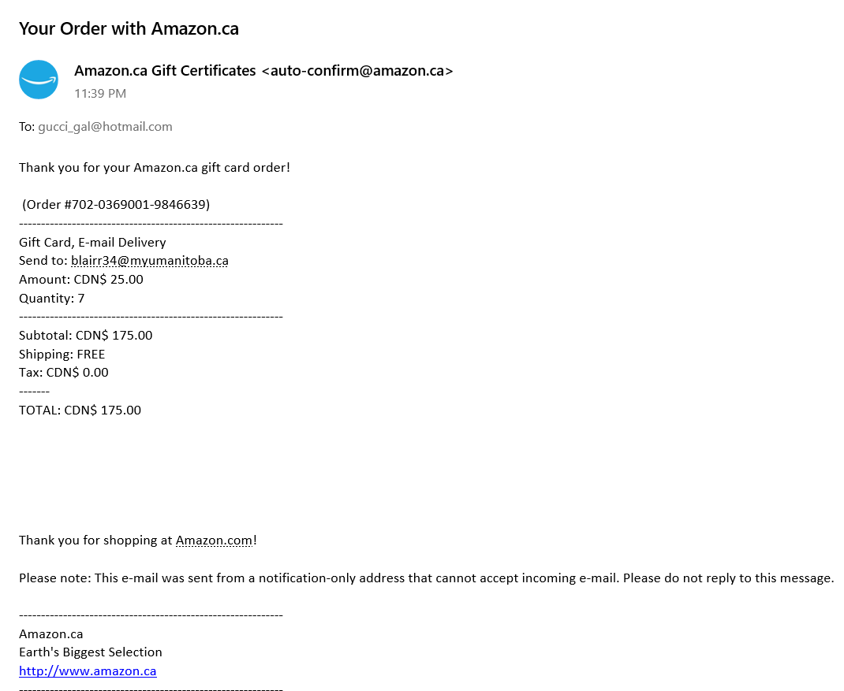
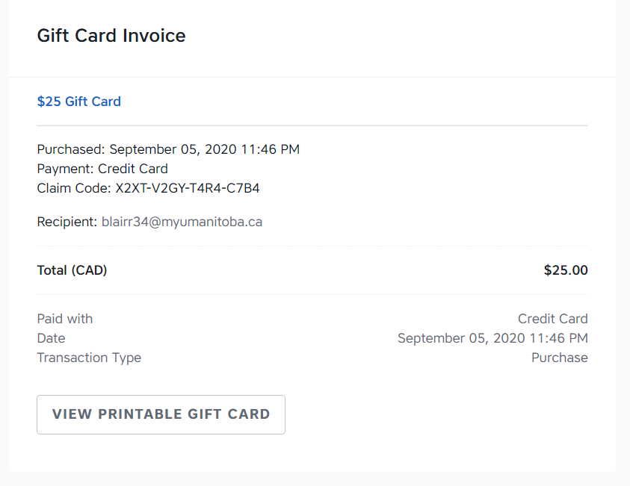
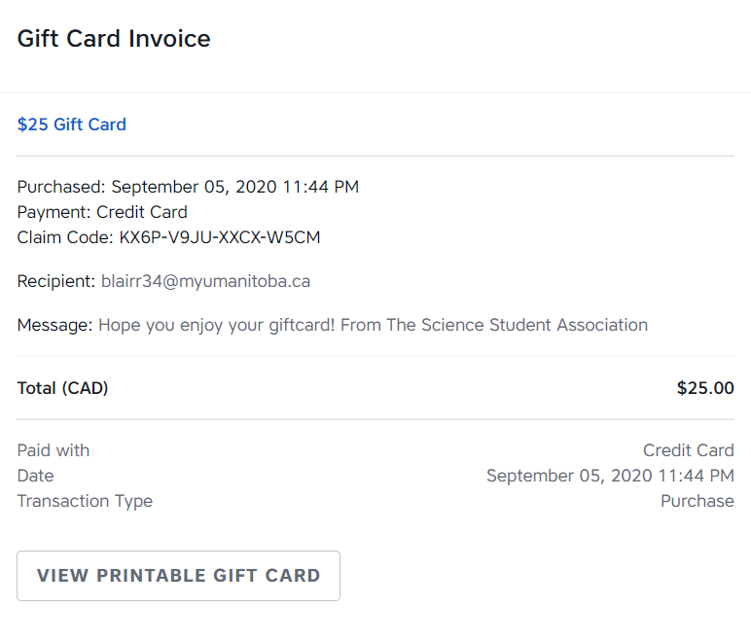
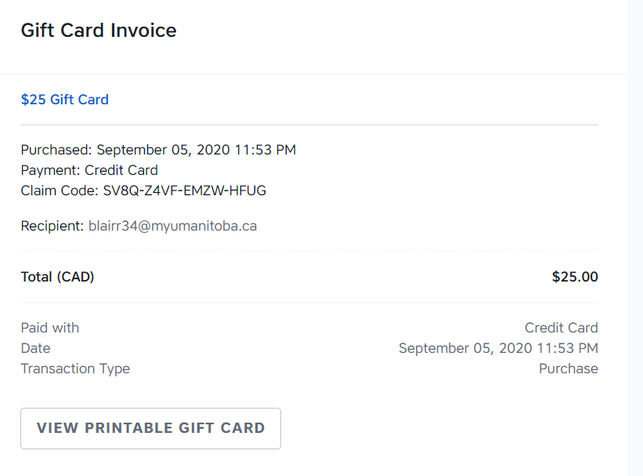
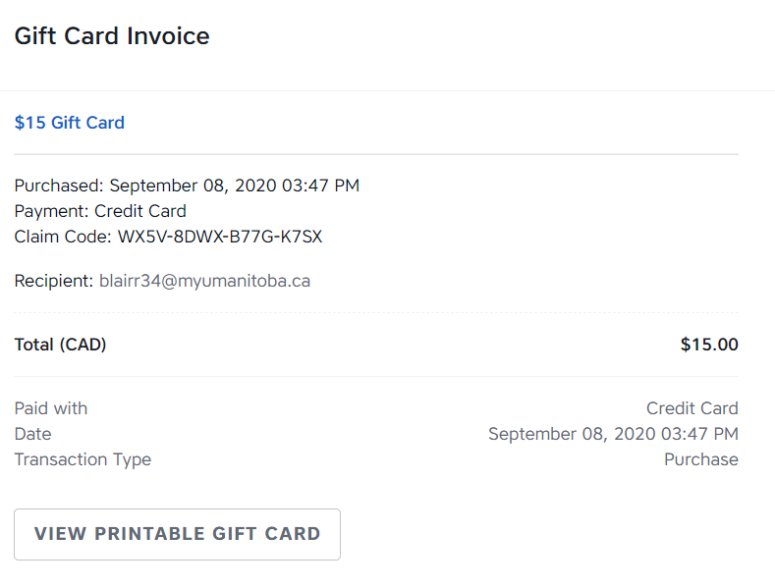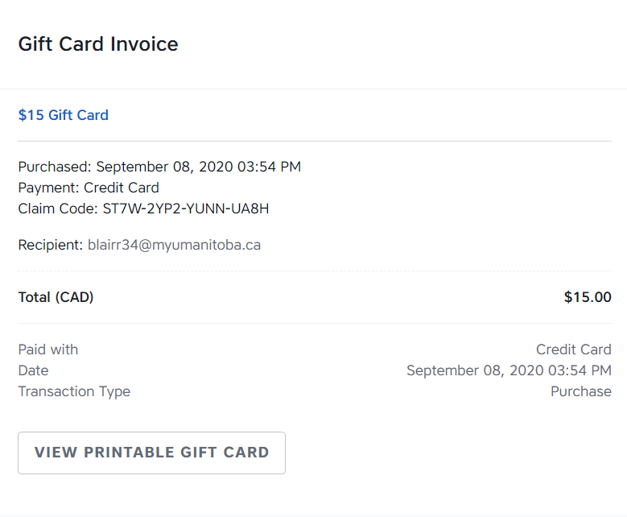

- Academics
- Nothing to Report
- Lounge Programming
- Nothing to report
- Accessibility
- Nothing to report
- LGBTTQ*
- Nothing to report

- Women’s
Kyra Cebula Reports:
- Update on offer for possible collaboration with ASBC
  - Have been informed that the project has now turned from a COVID-19 Relief hamper to “Remote-Learning packages”
    - Said to be given out to students around the first week of December (in time for the Holidays)
  - There are two possible options for how SSA could be involved in the project
    - To be a sponsor (contribute to one specific item to the packages)
- important thing to note – that the packages would ONLY be going to the Faculty of Arts Students
    - To collaborate and extend the eligibility of the hampers to both Arts and Science students
- For this option to happen, SSA would need to match ASBC’s budget for $6K for contributions to also cater for Science Students
  - Kyra would like to discus this with council and hear everyone’s thoughts on this project to determine if this is something SSA would like to be a part of or not
    - Katelyn said that the remote learning sounds like technology stuff – doesn’t think we should join since we are also doing something similar to our own students – or could do a holiday hamper in December – but it won’t come out of Kyra’s budget
    - Emily offered to send over past contacts from last year
    - Eric says he doesn’t see the need for the $6K for the remote looking package
    - Jaime says if its for all students and isn’t specific towards Kyra’s role then their council should get in contact with Jaime and Eric if it’s their whole council doing the project – and if it is towards all students, it doesn’t make sense for it to come out of the Womens rep budget
  - Will organize a meeting with Eric, Jaime, Kyra and the Arts women rep (Victoria)
If you have any questions, feel free to message Kyra
- Indigenous
- Nothing to report
- International
- Nothing to report

- Student Services
Natalie Ngu Reports:
- Locker clean out on September 8th
  - Email was sent out late so not many people could make it
- New locker clean-out date to be decided
  - Once all responses are in on September 15th a date or range of dates will be decided
    - Ask Krystyna if we can have multiple days open for students to come in to clean out their lockers
    - We’ll ask for Sept 21st-25th to be open for students to come in
- Students services will clean out lockers in reading week (tentative)
  - Find out when the Faculty is open to getting trolleys to carry stuff – call and ask to see if you can rent trolleys
  - Get access to the SSA offices – Eric can drop off a key
- Once a date is finalized Natalie asked that councilors post it to their stories to promote them
- Treasurer
- Nothing to Report

- Committee Reports
- Executive
- The Executive Committee motions to move into closed session.
- By-Laws
- Nothing to report

- Other Business
- Important Dates/Notes
- Dustin asked Zack to put up new agenda with black out for the redemption codes from previously uploaded agenda
- Zack put up a poll for hoodies, will send out a forum for the hoodie orders and everyone will pay their own hoodies and then everyone will get reimbursed later
- Emily brought up doing headshots – doodle poll for the individual headshots by then end of October
- Emily also brought up by-elections
- Eric asked Anika to run the by-elections – Anika said yes

- Dismissal
Emily Kalo motions for dismissal at 7:44 PM, Katelyn Casalla seconds; Motion passed.
Motions
September Monday 14th, 2020

Motion Regarding: Gift Card Prizes | Category: Reimbursement
Motion: To be reimbursed in the amount $280 for gift card prizes used in Kahoot games.
Status: Motion Passed

Moved By: Rashawna Blair
Seconded By: Eric Vasas

Motion Regarding: Closed Session | Category: SSA Meetings
Motion: The Executive committee motions to move into closed session
Status: Motion Passed

Moved By: Eric Vasas
Seconded By: Jaime McNicholl

Motion Regarding: SSA Meeting attendance | Category: SSA Meetings
Motion: To excuse Riley Shannon and Bryan Kwak and Stuti Gupta from future meetings due to a class conflicts for fall semester
Status: Motion Passed

Moved By: Eric Vasas
Seconded By: Jaime McNicholl

Motion Regarding: Closed session | Category: SSA Meetings
Motion: To move out of closed session
Status: Motion Passed

Moved By: Eric Vasas
Seconded By: Emily Kalo

