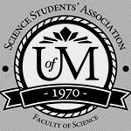
Science Student’s Association Meeting Attendance
March 10, 2021

Position | Name | Present

President | Eric Vasas
Vice President | Jaime McNicholl
Chairperson | Anika Khan
Secretary | Jasmine Tingey
Senator | Dustin Erickson
Senator | Emily Kalo
Senator | Serena Philips
UMSU Representative | Bryan Kwak
UMSU Representative | Chloe McElheron
UMSU Representative | Katelyn Casalla
UMSU Representative | Riley Shannon
Accessibility Representative | Tristan Rohatynsky
Indigenous Students’ Representative | Zoe Quill
International Students’ Representative | Juanita Garcia
LGBTTQ* Representative | N/A
Women’s Representative | Kyra Cebula

Treasurer | Justin Cruz
Director of Academics | Tooba Razi
Director of Communications | Zachary Hiebert
Director of Special Events | Rashawna Blair
Director of Student Services | Natalie Ngu
Executive Assistant | Stuti Gupta
Academic Programmer | Ethan Lin
Academic Programmer | Fares Hossain
Communications programmer | Sem Perez
Lounge Programmer | Aishat Bello
Special Events Programmer | Andrea Warzel
Special Events Programmer | Demi Andromidas
Special Events Programmer | Sion Yi
Special Events Programmer | Tiffany Tantakoun
Student Services Programmer | Dana Segal
Student Services Programmer | Kanso Alaka
Student Services Programmer | Selina Audino

Science Student’s Association Meeting Minutes
March 10th, 2021
Called to Order: 0:00 PM
- Acknowledgement to use of Treaty Land
Zoe Quill acknowledges that we are meeting on treaty land.

- Approval of Agenda
motions to approve the amended agenda, : Motion passed.

- Approval of Minutes
motions to approve the previous meeting minutes from the meeting held on February 24th,2021. seconds; Motion passed.

- Council Reports
- President & (Vice) President
- Nothing to report
- Senate
The SCA (committee on awards) approved some new scholarships the main one that pertains to Indigenous science students is the Delaney Graduate Scholarship for Indigenous students. The conditions and requirements are
  - Dr. Kiki Delaney and Mr. Ian Delaney established an endowment fund at the University of Manitoba with
a gift of $500,000 in 2020. The purpose of the fund is to provide scholarships to Canadian Indigenous graduate students enrolled full-time in a Master’s or Doctoral program at the University of Manitoba. Awards will be offered to meritorious graduate students who demonstrate significant research or scholarly ability or potential. Each year, beginning in 2021-2022, the available annual income from the fund will be used to offer one or more scholarships to graduate students who:

(1) have self-declared as First Nations, Métis, or Inuit people from Canada;
(2) are enrolled full-time in the Faculty of Graduate Studies within the first two years of any Master’s program or the first four years of any Doctoral program;
(3) have achieved a minimum grade point average of 3.0 based on the last 60 credit hours (or equivalent) of study; and
(4) have, in the opinion of the selection committee, demonstrated excellent research or scholarly ability or potential.

Applicants will be required to submit to the Faculty of Graduate Studies: (a) a current curriculum vitae, (b) a letter of reference from their graduate advisor or proposed graduate advisor, and (c) one other academic letter of reference.

The Faculty of Graduate Studies will set the competition deadline each year. The award is not automatically renewable, but previous recipients may reapply.

The selection committee will have the discretion to determine the number and value of awards offered in each year based on the available funds, as outlined in the criteria above. The selection committee will be named by the Vice-Provost (Graduate Education) and Dean of the Faculty of Graduate Studies (or designate) and will include the Vice-President (Indigenous) (or designate).

This agreement may be amended by the mutual consent of the donor (or designate) and the University of Manitoba. All such amendments shall be in writing. In the absence of the donor (or designate), and providing all reasonable efforts have been made to consult, the Board of Governors of the University of Manitoba has the right to modify the terms of this award if, because of changed conditions, it becomes necessary to do so. Such modification shall conform as closely as possible to the expressed intention of the donor in establishing the award.
  - Motion
Passed
- A couple in Memoriam tributes to professors who passed away were read
- The Equity, Diversity and Inclusion taskforce the president commissioned presented their final report. The main findings and recommendations are
  - The main findings are that for U of M to advance EDI we need to strengthen the leadership and planning, increase diversity and equity, and build an inclusive community.
    - Greater diversity among university leaders was identified as a necessary goal as was greater knowledge, commitment, and accountability of current leaders to ensure that EDI is a priority
    - Noticed that the focus on EDI initiatives has been among students and faculty and it has way less attention among staff
    - Noticed there was an overall lack of a common EDI strategy and someone to lead this strategy
    - Concern and complaints that the human resources and the office of human rights and conflict management works on behalf of the university and not victims. There's also a lack of access to these offices making it hard to report incidents
    - Administrators aren't held accountable for how they respond to complaints of discrimination or harassment. Problems are being swept under the rug and not being resolved
    - Scheduling of classes creates barriers for certain groups of students (for ex very limited online and evening classes on a regular basis)
    - Application forms are too binary and alienating to the 2SLGBTQ+ community
    - Lack of social support for certain groups of students like parents and low-income
    - There is inadequate funding for staff positions that provide support to students from marginalized groups
    - Not clear on EDI training and where to get it
    - Marginalized staff felt like they weren't treated equitably and given the same opportunities
    - Lack of women, people who identify as disabled, and 2SLGBTQ+ in faculties
  - The main recommendations to strengthen EDI in the university are
      - Create an administrative structure for advancing EDI that includes a senior EDI to oversee EDI across the institution as well as a network of leaders working at the unit level to engage the entire UM community in working towards change.
      - Ensure that advancing EDI is a key element of the University’s strategic plan, is integrated into academic and administrative/support units’ plans, and supported by the policies and guidelines governing the University.
      - Develop plans, processes, and supports for evaluating and reporting progress on EDI goals to ensure accountability and to inform future action.
      - Develop unit-level plans for increasing the diversity of students, staff, and faculty that include initiatives that address equity.
      - Ensure central planning and support for increasing accessibility at UM.
      - Develop and implement a plan for increasing awareness and support for EDI among all UM community members
      - Encourage, support, and monitor the integration of EDI within academic programs and enhance the knowledge and skills of academic staff to address EDI in their teaching and research.
      - Develop and implement a plan for promoting a greater sense of inclusion and safety at UM that involves both university-wide and unit-specific activities that encourage engagement and participation of all students, staff, and faculty; that foster greater understanding, acceptance, and mutual respect among community members; and that celebrate diversity.
- The SCUR (committee on university research) put forth a proposal to establish a professorship in Lab-on-Chip technology in the faculty of science department of physics and astronomy
    - The purpose of the Professorship is to allow for the development of “an
internationally competitive research program in innovative lab-on-chip
technologies at the University of Manitoba”, enable interdisciplinary training
opportunities, and facilitate academic-industrial collaborations.
  - The Chair will be funded through a philanthropic gift from BWL Investments for a
period of five years with a contribution of $250,000 ($50,000 per year).
  - Motion
Passed
- The operating budget for next year has a 1.75% cut which is larger than usual but they also increased funding for maintenance of old buildings
  - Managed to shield academic departments from the 1.75% cut but also depends on enrollments in the next year.
- There will be a 3.75% increase in tuition fees for essentially all u of m programs (lowest tuitions compared to other universities in Canada)
- UMSU
Bryan Kwak Reports:
Feburary 25th, 2021
UMSU Board of Directors Meeting Report
- Presentation of CASA/UCRU comparison & Recommendation by the VPA:

-The VPA suggests UMSU join CASA effective fall 2021 and provided a supporting presentation. The presentation report will be out for viewing in the next meeting’s agenda.
- New Updates:

Campus advocacy
- Flex parking proposal: Since the UMSU team promised to advocate for completely personalized flex parking, Kristin brought it up to Laurie Schnarr, Vice Provost (students), and she suggested to submit a proposal to senior admin. The university wanted some evidence that this is the service the students want/need. UMSU is not working on preparing a proposal for the university for the submission by the end of this term for the implementation in fall 2021 hopefully.
Provincial advocacy
- MAPSS is preparing its first campaign, which is planned to run a 3 week campaign, from March 8th to March 26th – calling students to mobilize on a different advocacy ask each week (cuts to operating grants/tuition hikes, lack of international student healthcare, and bill 33)
- It will be launched on MAPSS social media , as well as UMSU, UMGSA, RRCSA social media platform.

- Continuing updates:
Budget submission
- Since the last report, the UMSU completed their budget submission to the University Budget Advisory committee. – details of the submission is available in the last UMSU report.
UMSU legal services
- The survey results showed that 80% of the students think it is very important for students to have easy access to legal advice and services to protect their rights. UMSU will present the board with a motion in the coming weeks, seeking to begin the process of running a referendum on this issue.

- Communications
- Nothing to Report

- Councillor Reports
- Special Events
- Academics
- Lounge Programming
- Nothing to report
- Accessibility
- LGBTTQ*
- Nothing to report
- Women’s
Kyra Cebula Reports:
- Collaboration with SSA Indigenous Representative Zoe Quill
  - Zoe and I continue to team up in an effort to create a sense of community as well as promote wellbeing for all students within the Faculty of Science.
  - We are hosting sharing circles.
    - Our second sharing circle was on February 26th at 6:30pm CST over Zoom.
      - A done previously, Zoe and I do a great deal of preparation for this event. We have several meetings to discuss and a lot of effort was put into respecting the traditional protocol of the sharing circle.
        - We created an updated slideshow to educate our participants on the tradition of sharing circles.
          - In our slide show we touch on why it is important to us that SSA hosts these sharing circles, background information on what a sharing circle is, as well as the traditional rules of a sharing circle.
          - We also continue to create discussion topics that are relevant to students to help guide the conversation.
            - Students were given the opportunity to voice what topics they would like to discuss during the sharing circle when they RSVP’d to the event, and those suggestions will always be incorporated into the event.
        - Promotion took place over social media such as on Instagram and Facebook.
          - Both Zoe and I created a new poster, RSVP Form, and Feedback form.
        - Resources and supports were also provided during the event if any participants needed and chose to access them.
      - After last meeting where Zoe and I brought up our concerns about the lack of Indigenous involvement and support, our council had proven to put forth their best effort to learn more about the tradition of sharing circles and Zoe and I are very pleased with the immense support from our fellow SSA councilors in regard to our effort of build up the Indigenous community within the Faculty of Science
        - I can confidently say SSA as a whole is strongly committed to supporting the Indigenous community and Zoe and I’s effort to bridge the gap between Indigenous Students and non-Indigenous students
        - There is still lots more work to be done but this is a solid start
          - Participation rates went up and we were abel to host a sharing circle with many people
            - Everyone in attendance was eager to learn about the tradition of sharing circles and participated in full
            - Participants gave very positive feedback and expressed that they would love to attend more
              - All participants seemed to be affected positively by participating and had a great time
    - Zoe and I will continue to host this event on an as needed basis
      - The sharing circle times will remain consistent and be held at 6:30pm CST over zoom. Date and further details will be provided at a later date
- Collaboration with UMSU Women’s Representative Judith Oviosun, the Women’s Center, Arts Student Body Council, Women in Chemistry, U1 Student Council and UMISA Women’s
  - I have partnered with the Women’s center and several other student groups listed above to celebrate International Women’s Day on March 8th.
    - We hosted an awards night titled “Magnificent Women’s Awards Gala” to celebrate the amazing women that go to the University of Manitoba.
    - There were over 90 nominations submitted by U of M students from various faculties to nominate women for various categories for a chance to win an award!
      - There were 21 categories in total involving excellence and achievements that are worthy of being recognized.
      - Winners were chosen by us women’s representatives and the presented the night of the event.
        - Winners received a framed certificate for their accomplishments
    - Many people RSVPd to the event; attendance was mandatory for those who won an award
      - Turnout was very good; had over 65 people come and participate in the event.
    - The event was held at 7:00pm CST over Zoom and was a huge celebration consisting of announcing the winner’s, entertainment and more.
      - Awards were presented by various members of the Women’s Center and myself.
      - A special video message from UMSU President Jelynn Dela Cruz was presented
      - Susan Egbert from the student group Women in Chemistry was part of our talent showcase and painted a beautiful picture in a short amount of time. It was phenomenal
      - A Ted talk by Sheryl Sandberg that discussed why there are too few woman leaders was played. Was incredibly inspirational
      - There was a breakout room session so that attendees could mingle with each other and connect with other empowering women at the university of Manitoba.
      - A group photo was taken at the end of the night and posted to the SSA Instagram story as well as on the various other student group accounts who collaborated.
    - Goody bags were given out March 7th for RSVPing to the event.
    - The event went incredibly smooth and was a huge success!
      - Gathered all positive feedback from attendees
      - Was a great night to celebrate all the amazing women at u of m!
- U1 Student Council Instagram Take-Over
  - I did my Instagram take over on the U1 Student council Instagram page on Thursday February 25th.
    - This was a chance for students to see what it’s like to be in the faculty of science and help give them beneficial information before choosing which faculty to enter.
    - The takeover covered my experience in the faculty of science, answering students’ questions, and my volunteering/ participation in various groups on campus.
    - I highlighted my role on SSA as women’s rep
      - It was a is great opportunity to continue my duty to advocate for women in science and show everyone how amazing it is to be in this faculty.
    - I reposted some of my take-over content to the SSA Instagram page so that more students could access this and benefit from it.
      - I highlighted all the various groups students can join to get more involved in science
        - Various departmental and student groups reposted my video to their own Instagram accounts to show students the benefits of getting involved and the various groups within science to join.
- Collaboration with ASBC Women’s and Indigenous Representatives
  - To continue the International Women’s day celebrations I will be hosting a Yoga night with the ASBC Women’s and Indigenous Representatives
    - Event will take place March 9th @ 7:00pm CST over zoom
    - Guided yoga session facilitated by Soki-Kapawiw Acak Yoga
    - I will be contributing a 25$ Skip the Dishes gift card
      - Winner will be drawn randomly at the end fo the event.
    - Promotion for event has taken place on the SSA and ASBC Instagram
    - Zoom link for event can be found in either the SSA Instagram bio or the ASBC Instagram bio
- International Women’s Day Giveaway
  - To celebrate the incredible women in the faculty of science for International Women’s Day I am doing a giveaway.
    - Prize will be a $25 Starbucks giftcard
    - Giveaway rules: Tag a strong woman in the FoS in the comment section, multiple entries are allowed, must be in the FoS to eligible for the prize
    - Giveaway ends March 10th @ 11:59pm CST
    - I will randomly draw the winner by using a random generator to ensure that it is fair
- Indigenous
Zoe Quill Reports:
- SSA Sharing Circles
- Collaboration with Womxn’s Representative
- Biweekly meetings (varying dates and times) held over Zoom
  - 1st Sharing Circle on February 10th @ 6:30pm
  - 2nd Sharing Circle on February 26th @ 6:30pm
    - Huge success with over 10 participants in total and a run time of over 2 hours
    - Received very much positive feedback and were encouraged to host another sharing circle!
  - Currently planning for our 3rd Sharing Circle
- Ongoing promotion for sharing circles on social media (Instagram and Facebook)

- International
SSA meeting March 10th, 2021
- International Students’ Trivia Night
  - Event to be hosted on Zoom on March 18th, time: TBD. This will be an opportunity for students to learn about different cultures and countries and connect with other students.
  - Starbucks gift card will be given away at the end of the event.

- Student Support initiative by UMISO (UofM Internatinal students organization)
  - If funding approved by SSA exec UMISO plans to launch the campaign the week or March 22.

- Update on scholarships Winter 2020 and Fall 2021.

- Student Services
- Grad photos
  - Email was sent out by Jennifer on March 1
  - Lifetouch is allowing students to book grad photo appointments online to be taken at their studio
- Reimbursement for student services from December 7th exam crams ($100 for Kanso, $75 for Selina, $50 for Dana and $50 for Natalie)
- Reimbursement for November 25th giveaway ($100 for Natalie)

- Treasurer
- Nothing to Report

- Committee Reports
- Executive
Executive Committee Report
- UMISO Initiative Proposal
  - Brought to council by Juanita
  - SSA would be contributing 3000$ - Donations from SSA would be contributed towards international students in the Faculty of Science
  - Discuss with council for approval of money, from which budgets

- Training program for medical microbiology – Katelyn brought to council’s attention
  - Email was forwarded to Krystyna for discussion

- Survey Distribution
- Email sent to SSA:
- 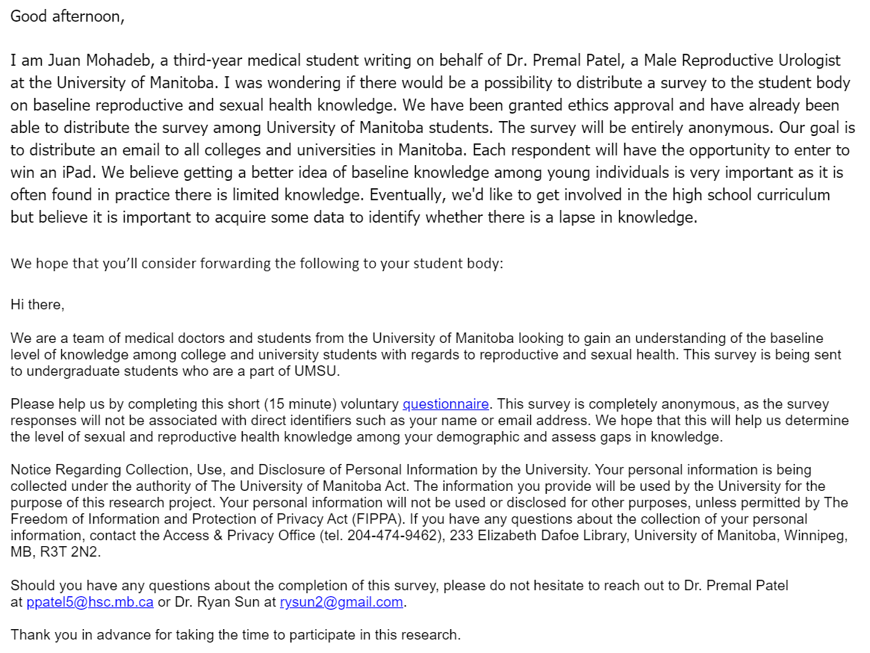
  - Email was sent to deans for discussion

- Elections have started
  - Current councillors cannot endorse anyone running, must remain neutral and unbiased
  - Any questions regarding the election process can be brought to CRO’s attention (Matt)

Executive Committee motions to go into CLOSED SESSION.
- By-Laws
- Nothing to report

- Other Business
- Important Dates/Notes

- Dismissal
motions for dismissal at PM, seconds; Motion passed.

Motions
Month Date, 2021

Motion Regarding: | Category:
Motion:
Status: Passed

Moved By:
Seconded By:

Motion Regarding: | Category:
Motion:
Status:

Moved By:
Seconded By:

