Science Student’s Association Meeting Attendance
June 11th, 2020

Position | Name | Present

President | Eric Vasas | Yes
Vice President | Jaime McNicholl | Yes
Chairperson | Anika Khan | Yes
Secretary | Jasmine Tingey | Yes
Senator | Dustin Erickson | Yes
Senator | Emily Kalo | Yes
Senator | Serena Phillips | Yes
UMSU Representative | Bryan Kwak | Yes
UMSU Representative | Chloe McElheron | Yes
UMSU Representative | Katelyn Casalla | Yes
UMSU Representative | Riley Shannon | Yes
Accessibility Representative | Tristan Rohatynsky | Yes
Indigenous Students’ Representative | Zoe Quill | Yes
International Students’ Representative | N/A | N/A
LGBTTQ* Representative | N/A | N/A
Women’s Representative | Kyra Cebula | Yes

Treasurer | Justin Cruz | No (Regrets)
Director of Academics | Tooba Razi | Yes
Director of Communications | Zachary Hiebert | Yes
Director of Special Events | Rashawna Blair | Yes
Director of Student Services | Natalie Ngu | Yes
Executive Assistant | Stuti Gupta | Yes
Academic Programmer | Ethan Lin | Yes
Academic Programmer | Fares Hossain | Yes
Communications Programmer | Sem Perez | Yes
Lounge Programmer | Aishat Bello | No (Regrets)
Special Events Programmer | Andrea Warzel | Yes
Special Events Programmer | Demi Andromidas | Yes
Special Events Programmer | Sion Yi | Yes
Special Events Programmer | Tiffany Tantakoun | Yes
Student Services Programmer | Dana Segal | Yes
Student Services Programmer | Kanso Alaka | Yes
Student Services Programmer | Selina Audino | Yes

Science Student’s Association Meeting Minutes
June 11th, 2020
- Acknowledgement to use of Treaty Land
Anika Khan acknowledges that we are meeting on treaty land.
Called to Order: 8:34 PM
- Approval of Agenda
Eric motions to approve the agenda, Jaime seconds; Motion passed.

- Approval of Minutes
Anika Khan motions to approve the previous meeting minutes from the meeting held on April 6th, 2020 and the changeover meeting held on April 28th, 2020, _____ seconds; Motion passed. ** idk how to set this up b/c Anika couldn’t do it **

- Council Reports
- (Vice) President
Eric Vasas & Jaime McNicholl reports:
- Introductions
- Everyone introduced themselves – states position, stated year they are in, degree they are taking and fun fact
- Faculty Updates
- Talked about the courtyard – was supposed to get plants in this summer – now its going to be done next year – and looking at the furniture is for the courtyard – 5 tables -20 chairs - $1300 for that
- Vestibule quote is ~ $150,000 dollars from the endowment fund – Eric has to double check, but it is the most up to date number they have, Eric will put in a motion next meeting to get the money from the Endowment fund
- Science scholarships are now closed and only had only about 7 applicants – not too high but makes the selection process easier
- Having more prep online courses for first-year students
- A video tour for the first-year students – if you want to be involved message Eric on slack – to give students a tour of campus for first year students because they will not be able to go into the campus during the fall
- VW rates for first year courses, Faculty of Science is trying to figure out a way too decrease those VW Rates
- Problem where at least last semester where there was trouble getting a deferred exam due to time differences
- COVID relief fund for science students have been approved, unsure if the cheque has been sent out yet, and the money is also in the process of being sent out to students
- Changes have been made to co-op programs for 3rd year students – just has to go through senate
  - If students doing a co-op program, and if they are unable fully finish because of COVID – they can finish with 2 work terms, or finish their work term another time, they have to end on an Academic term
- Committees
- By-laws
  - Propose bylaw amendments for the by laws
  - Committee consists of the: Chairperson, Vice President and 3 councillors
  - Secretary – always updates the bylaws and keeps the current version of the bylaws
  - Final Committee – Anika Khan (Chairperson), Jaime McNicholl, Jasmine Tingey (Secretary), Stuti Gupta (Executive Assistant) and Serena Phillips (Senator)
- Executive
  - Eric Vasas (President) and Jaime McNicholl (Vice President) and Justin Cruz (Treasurer) as Chair
  - Chloe put herself forward for applying for the Executive Committee – wants to be involved, has a lot of experiences on council wants to be more involved in the executive side
  - Katelyn – was on executive committee last year, has an all-round view of council, well rounded person, being in an appointed position and on an elected position
  - Dustin – 2nd year on council – chairperson on the executive committee last year, already knows the ins and outs of the Executive committee
  - Final Committee – Eric Vasas (President), Jaime McNicholl (Vice President), Justin Cruz (Treasurer), Katelyn Casalla (UMSU Representative) and Dustin Erickson (Senator)
- By-Law Changes
*NEXT MEETING, WE WILL VOTE ON THE BYLAWS*
- WHEREAS the current bylaws do not include executive assistant under “Appointed Councillors”
- BE IT RESOLVED that in accordance with Article V section 2 subsection b “Executive Assistant” be added
- WHEREAS the director of communications is currently the chair of the Board of Student Groups Meetings and this duty does not properly reflect their role on council
- BE IT RESOLVED that in accordance with Article X Section 6 Subsection bi “Director of Communications as Chair” is removed
- BE IT RESOLVED that in accordance with Article X Section 6 Subsection bi “Executive Assistant as chair”
- BE IT RESOLVED that in accordance with Article XI Section 2 Subsection b it be added under Executive Assistant “Act as chair for Board of Student Groups”

- WHEREAS the director of communications currently does not have a programmer
- BE IT RESOLVED that in accordance with Article XI Section 2 Subsection b the role “Communications Programmer” be added with the following duties:
1. Assist the Director of Communications in the completion of their duties.
- BE IT RESOLVED that in accordance with Article XI Section 2 Subsection b under Executive Assistant the duty “Assist the Director of Communications in the completion of their duties” be removed

- WHEREAS there are 30+ SSA councillors including the programmers
- WHEREAS directors present the reports in council meetings
- BE IT RESOLVED that in accordance with Article XI Section 1 Subsection c the duty of “attend council meetings” be replaced with “attend respective group meetings and Summer council meetings”
- BE IT RESOLVED that in accordance Article VII section 1 Subsection I be changed too “Members required to attend council meetings must attend 75% of council meetings, all members of council must attend all of their respective group meetings (if applicable ), all members of council must attend 75% of scheduled office hours. Councillor attendance will be recorded, and any issues must be reported to the Executive Committee.”
- BE IT RESOLVED that in accordance with Article XI Section 2 the duty “attend council meetings” be added to the following roles: President; Vice President; Senators; UMSU Representatives; Indigenous Student’s Representative; International Student’s Representative; Accessibility Representative; LGBTTQ* Representative; Women’s Representative; Treasurer; Secretary; Director of Communications; Executive Assistant; Director of Student Services; Director of Academics; Director of Special Events; Lounge Programmer.
- BE IT RESOLVED that in accordance Article XI Section 2 subsection b the duties “Lead group meetings” and “report group meeting attendance to the executive committee” be added to the following roles: Director of Communications; Director of Student Services; Director of Academics; Director of Special Events.
  - Reasoning behind this motion is to reduce the amount of people during Council meetings, and other committees will have smaller meetings before the council meeting to create their reports
  - For in person and in Zoom Meetings
  - Main Council meetings – President, VP, Chairperson, Secretary, and Directors of different committees to present their reports
  - Mimic how Asper holds their meetings efficiently
  - Demi asked how many people CSA has on council – Emily said 60 total, 9 on an Executive team – the other members of council follow under those 9 categories
  - Dana said that it was nice to be in council
  - Are programmers required to say their reports if the director of their group doesn’t attend the General Meeting – Fares asked – Eric said that programmers can fill in for their Director
  - Demi – thinks that a larger group meeting compared to smaller meeting would be better as opposed to smaller groups
  - All councillors are supposed to attend all councillor meetings during the summer – in the Fall this is when the smaller group meetings will start/aim to start
- WHEREAS in the past partnerships and contracts between SSA and companies/groups/individuals have been signed without council approval
- BE IT RESOLVED that Article XVII “SSA Partnerships” be added and state:
  - “any agreement, partnership or contract between SSA and another UMSU/Faculty Student Group, or an External group must be brought to the attention of the Executive Committee and approved by the Executive Committee and at council meetings”
  - “agreements, partnerships or contracts may be signed by the respective directors or members of council that are requesting the partnership after executive and council approval”
- Orientation/LabTrek
- Science Orientation Committee
  - Organized by: Eric and Jaime (morning) Special Events (afternoon)
  - Using zoom or Cisco WebEx to do this
  - Do one giant call for the orientation – will still have a panel and have then an online scavenger hunt – participants would take screenshots of academic calendar, webpages etc.
- Plan moving forward may change
  - Sponsorship:
  - Had 2 sponsorships in the past – special events past a list of where we get sponsorships from – get in touch with companies, getting in touch with companies for online packages (gift cards etc)
  - Special event programmers are also involved with sponsor ships but help out special events more
  - Sponsorship Volunteers: Sem Perez & Kanso Alaka
- Additional (2) for organizing volunteers:
  - Goal is to give the list of the online scavenger hunts and they will lead the groups
  - Figuring out how to put groups together and lead them
  - Organizing Volunteers: Tristan Rohatynsky & Emily Kalo
- Additional (2) for organizing panel discussion and scavenger hunt:
  - If you have different ideas we can discuss during the orientation meetings
  - Panels – usually consist of professors, alum, councillors
  - Panel Discussion and Scavenger Hunt Volunteers: Serena Phillips and Stuti Gupta
- Afternoon - run by Special events
  - Special events programmers will have more of their time spent doing the roles given to them by the Special events Directors for the afternoon activities
- Science LabTREK Committee stuti, serena, Chloe, Jaime, Katelyn
- Organized by: Academics
  - Few more people to help – had 2 or 3 more people to help
  - Allowing students to see what labs are like, what research is ongoing by profs
  - Had grad students present their research to students, and students would go in blocked off time, to see a lab and to hear a speech from grad students
  - IDEA: can have a student with a webcam show their workspace and their lab, a 5-minute thesis – where they talk about their research and what is currently ongoing – 5-10-minute presentations
- Additional:
- Nimbus Tutoring Partnership
- Looking to have a partnership – perks would be as of rn they have their own system like how we keep track of our system – since we are part of UMSU it is free of charge, w/in the application there is an online video chat option through their program – safe for the tutors
- Weary about it because you can have the option to leave reviews for the tutors
- Stuti asked if the academic tutoring program would be replaced by NIMBUS – Eric said no, the Academics committee would work together with Nimbus
  - Nimbus can keep track of how many hours the tutors do
  - Stuti asked about the amount of tutors needed, and how many would be science/SSA tutors
  - Eric informed us that the tutors that are SSA tutors – would be shown as an SSA Tutor – with the logo etc.
  - Stuti concern – students would come to the window to ask about tutors – some didn’t know about tutors or nimbus – asking Nimbus about advertisements etc,
  - Tutors would have the SSA logos on their profile to ensure the people getting tutoring that they have a tutor in Science not Asper etc.
- Motions/Reimbursement
- Moved by Eric Vasas (President)
- Motion to be reimbursed $239.69 for the SSA Website Subscription
- SSA Apparel
- Usually order sweaters for council – through the bookstore
- Did green hoodies last year, maroon the year before, and grey two years ago
- Have Black, white, navy blue
- If we get approved 50% of the cost – getting reimbursed half of the cost we paid
- Zach said that he could provide the apparel through his company cost would be significantly cheaper
- Final decision – go through Zach’s company
- Senate
Dustin Erikson, Emily Kalo & Serena Philips Reports: May 13th Meeting
- 17.1 million dollar reduction to U of M's operating budget for 2020-2021due to province cutting 5% of their support
- Fall 2020 will be primarily remote and online (not all courses)
- Fall term will conclude January 15th (labs will be held in January)
- CHEM 1000, CHEM 1030, CHEM 1300, CHEM 1310, and CHEM 1320 are being removed from the recommended intro course list effective fall 2021
  - Motion passed
- CHEM 1100 (Intro chem 1: Atomic and Molecular structure and Energetics), CHEM 1110 (Intro chem 2: Interaction, Reactivity, and Chemical Properties), CHEM 1120 (Intro to Chemical techniques), and CHEM 1130 (Intro to Organic Chem) are being added to the recommended intro course list effective fall 2021
  - Motion passed
- Senate Committee on curriculum and course changes report
  - Faculty of science is introducing Co-op for the B.Sc. (maj) in data science, B.Sc. (Jt. Hons.) in physics and astronomy, and B.Sc (Jt. Hons.) in Statistics and Mathematics
  - Option courses for Biochem honors student: deletion of MBIO 4010, MBIO 4600, and MBIO 4610. Introducing MBIO 3600, MBIO 4602, and MBIO 4612
  - Department of Biological sciences is proposing the introduction of 1 course: BIOL 2600 (Intro to Computational Biology)
  - Department of computer science is proposing the modification of 3 courses: COMP 1500 (Computing: Ideas and Innovation), COMP 1600 (Navigating Your Digital World), and COMP 4360 (Machine learning)
  - Department of computer science is removing the restriction on the number of credit hours of computer science, statistics and math courses that students getting a computer science degree can complete
  - Department of computer science is removing the list of required optional COMP courses and replacing it with a requirement of 15 credit hours of computer science at the 3000 or 4000 level (minimum of 6 credit hours at the 4000 level
  - Genetics optional courses for genetics major is being revised to reflect course changes in the department of microbiology
  - Department of mathematics is modifying 2 courses: MATH 1240 (Elementary Discrete Mathematics), and MATH 2720 (Multivariable Calculus)
  - Department of mathematics is introducing a co-op option to the B.Sc. In statistics and mathematics
  - Department of microbiology is deleting 4 courses effective fall 2021: MBIO, 2360 (Biochemistry 1), MBIO 2370 (Biochemistry 2), MBIO 2770 (Elements of Biochemistry 1), and MBIO 2780 (Elements of Biochemistry 2)
  - Department of microbiology is introducing 4 course effective fall 2021: MBIO 2700 (Biochemistry 1), MBIO 2710 (Biochemistry 2), MBIO 2730 (Elements of Biochemistry 1), and MBIO 2750 (Elements of Biochemistry 2)
  - Department of microbiology is modifying 1 course effective fall 2020: MBIO 4020 (Immunology)
  - Department of physics and astronomy is introducing 1 course: PHYS 4350 (The Physics of Fluids)
  - Department of physics and astronomy is modifying 1 course: PHYS 4676 (Honors thesis - Proposal and Preparation)
  - Department of physics and astronomy is introducing a co-op option to the B.Sc (Jt. Hons) in mathematics and physics and astronomy
    - Motion passed
- The department of chemistry put forth the following modifications and changes proposed to start fall 2021 to the senate
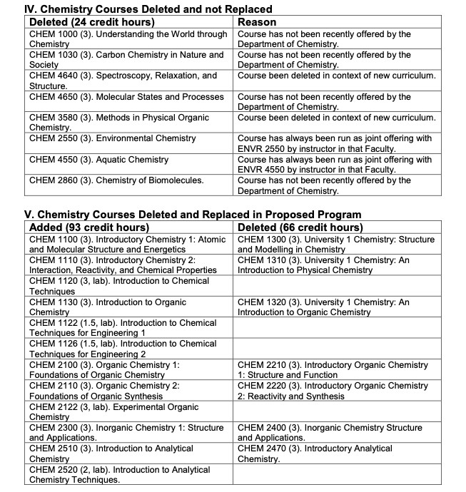
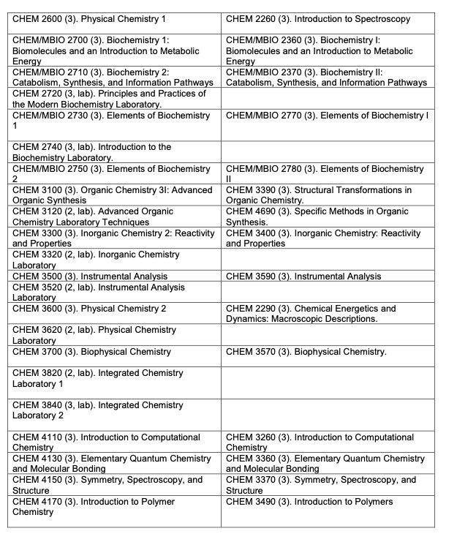
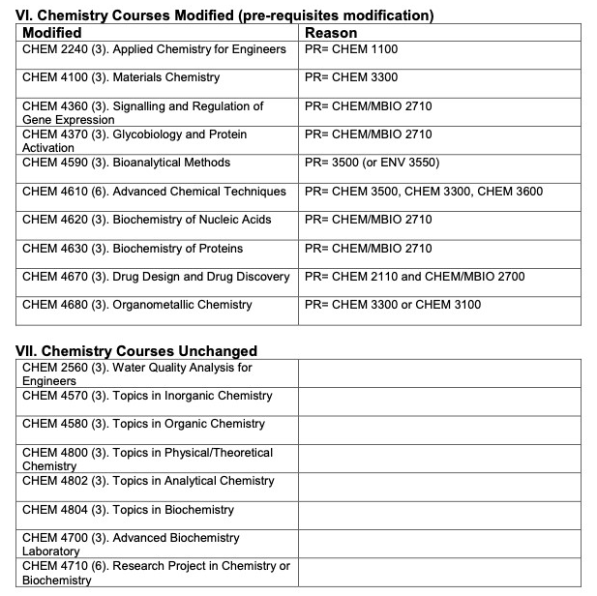
- The Department is proposing modifications to the following programs:
  - Bachelor of Science (General), with a focus in Chemistry
  - Bachelor of Science (Major) in Chemistry
  - Bachelor of Science (Major) in Chemistry, Co-operative Option
  - Bachelor of Science (Honours) in Chemistry
  - Bachelor of Science (Honours) in Chemistry, Co-operative Option
  - Minor in Chemistry
  - Bachelor of Science (Joint Honours) in Chemistry and Physics and Astronomy
- The department is closing the chemistry focus areas listed below (by closing focus areas they hope to provide students with a clear path to program completion
  - Bioanalytical
  - Biopharmaceutical
  - Biophysical
  - Environmental
  - Inorganic
  - Materials science
  - Organic
  - Physical
  - Quantum/Computational
- The department is eliminating 1000, 2000, and most 3000 level courses with embedded labs and introducing for-credit lab courses
  - Lab based courses will become formal courses with evaluation methods and workloads consistent with a traditional course
  - Lab based courses will have final exams and students will earn credit hours for the completion of these courses
    - Motion Passed
- The college of dentistry is modifying its admission requirements because of the changes the department of chemistry put forward
  - Students completing their pre-req courses at the U of M will now require 69 credit hours instead of 60 credit hours to be eligible for admission
  - This change will go into effect Fall 2022 intake
  - Motion passed
- The college of pharmacy is proposing that students be allowed to chose between STAT 1000 or STAT 1150 to satisfy the STAT requirement for admission
  - Motion passed
- The college of pharmacy is also changing their admission requirements so that students only need to take one lab CHEM 1120. (total credit hours required is still 60)
  - Motion passed
- It is proposed that SEEQ be replaced with a revised student rating of instruction instrument
  - Also proposing that the SRI be available for students to complete at times other than the end of the course. This will help provide early formative feedback for instructors
  - Motion passed
- For people who are still in it when the changes occur – they have a list of courses in the focus area – Eric asked if they will be grandfathered in – if youre changing from chemistry to another degree
- UMSU
Bryan Kwak, Chloe McElheron, Katelyn Casalla & Riley Shannon Reports:
- Motions
- MOTION 0480 – Approval for Meeting Dates for the 2020-2021 Year
  - Motion Status: Approved
- MOTION 0481 – U-Pass Contract Presentation Extension
  - Motion 0473 was passed that a contract would be presented by May 31, 2020
  - Extending the presentation of a U-Pass contract to the Board of Directors to June 30, 2020 due to Covid-19 delays
  - Motion Status: Approved
- Updates
- University Budget
  - Executives voted against tuition and course fee restructure and voted in favour of the general university budget
  - 3.75% average increase in tuition – voted in large opposition – was passed
  - Key items in the rest of the budget are good, voted in favour
  - UMSU’s asks that were honoured in the 2020/21 University Budget
    - $350,000 to Anti-Sexual Violence: This supports the expansion of the Sexual Violence Resource Centre outreach to the Bannatyne and William Norrie campuses, as well as growing educational workshops.
    - $300,000 to the Student Counselling Centre: Details on the allocation are still pending. However, Don Stewart will be in contact with UMSU as they become available.
    - $100,000 to the Office of Sustainability: This funding will go towards a feasibility study regarding the Net Zero by 2050 trajectory.
    - $500,000 to the International Student Hardship Relief Fund: This mirrors the University’s commitment last year in response to the international health care premium increases. This fund was fully utilized, with the help of UMSU, and we hope that it will get put to similar use this year.

- Provincial COVID-19 Advocacy
  - Advocating for resources to assist students during this time
    - International student healthcare premiums should be brought in line with domestic student rates
    - Reinstating the ACCESS program to assist mature/part-time students
    - Funding of Campus Manitoba's credit transfer database
    - High-speed broadband and internet access for rural Manitoban communities
- Social Media and Orientation
  - Look out for activities on UMSU social media
  - Looking into ways to have a fun and creative orientation with students
- If you have any question contact Chloe McElheron, Bryan Kwak, Katelyn Casalla or Riley Shannon
- Communications
- No Report

- Councillor Reports
- Special Events
- No Report
- Academics
- No Report
- Lounge Programming
- No Report
- Accessibility
Tristan Rohatynsky Reports:
- Contacts
- Currently looking at the following contacts to reach out to for this upcoming year:
  - UofM Resources
    - Accessibility Centre, Student Accessibility Services (SAS)
  - Student Clubs
    - UM Peace of Mind, Jack.org (UofM Chapter)
  - Student Representatives
    - Accessibility Representatives from other student groups in different faculties/departments
- If anyone knows of anyone else that would be good to get in touch with, please let Tristan know!
- Tristan is going to contact UofM resources and outside resources
- Looking at other departments and student groups b/c UMSU currently doesn’t have an accessibility representative
- Eric asked about Tristan’s campaign in incorporating subtitles for online videos for lectures – Tristan is willing to help
- LGBTTQ*
- No Report
- Women’s
Krya Cebula Reports:
- Possible Collaboration with ASBC on a Covid-19 relief project
- Was contacted by the Women’s Representative for the Faculty of Arts on possibly teaming up to contribute to a joint faculty Covid-19 relief project.
  - ASBC still hasn’t set a specific plan but described it as putting together various hampers for students who are having difficulty during this time, as well as having a large focus on International Students.
- I am still waiting on more information from the Women’s rep as to what exactly they plan on doing as well as what our role would be.
- After I gather more information, I will bring it back to council and we can discuss whether this is a realistic option
- Eric Vasas asked if they described their relief project in their first initial email – Kyra said they were going to have a meeting this past Monday and they were going to update Kyra but haven’t responded
- Sem Perez asked if Kyra had any other COVID 19 programs they were working with, Kyra said she had no other organization she was working with, Sem informed her that she did and will contact Kyra with the information
- Indigenous
Zoe Quill Reports:
- Indigenous Initiatives’ Committee
- June 5th, 2020 Meeting: planning an activity or gift for graduating Indigenous students in science
  - Congratulations virtual e-card with Indigenous artwork?
  - Going to discuss the long-term options
- June 8th, 2020: student representatives virtual visit to Children of the Earth High School
- Presentation and questionnaire on first year of university at U of M and pathways to graduate studies and medicine
- Participants included a small number of grade 12 students
  - Some graduates will be joining Faculty of Science in the fall
- International
- No Report
- Student Services
- No Report
- Treasurer
- No Report

- Committee Reports
- Executive
- No Report
- By-Laws
- No Report

- Other Business
- Important Dates/Notes
- No Report

- Dismissal
Eric Vasas motions for dismissal at 10:02 PM, Chloe McElheron seconds; Motion passed.

Motions
June 11th, 2020

Motion Regarding: Appointed Councillor | Category: By-Laws
Motion: WHEREAS the current by laws do not include executive assistant under “Appointed Councillors”
- BE IT RESOLVED that in accordance with Article V section 2 Subsection b “Executive Assistant” be applied
Status: will vote next meeting

Moved By:
Seconded By:

Motion Regarding: Board of Student Groups Meetings (Director of Communications) | Category: By-Laws
Motion: WHEREAS the director of communications is currently the chair of the Board of Student Groups Meetings and this duty does not properly reflect their role on council
- BE IT RESOLVED that in accordance with Article X Section 6 Subsection bi “Director of Communications as Chair” is removed
- BE IT RESOLVED that in accordance with Article X Section 6 Subsection bi “Executive Assistant as chair”
- BE IT RESOLVED that in accordance with Article XI Section 2 Subsection b it be added under Executive Assistant “Act as chair for Board of Student Groups”
Status: will vote next meeting

Moved By:
Seconded By:

Motion Regarding: Director of Communications - Programmer | Category: By-Laws
Motion: WHEREAS the director of communications currently does not have a programmer
- BE IT RESOLVED that in accordance with Article XI Section 2 Subsection b the roll “Communications Programmer” be added with the following duties:
- Assist the Director of Communications in the completion of their duties.
- BE IT RESOLVED that in accordance with Article XI Section 2 Subsection b under Executive Assistant the duty “Assist the Director of Communications in the completion of their duties” be removed
Status: will vote during next meeting

Moved By:
Seconded By:

Motion Regarding: Council meetings | Category: By-Laws
Motion: WHEREAS there are 30+ SSA councillors including the programmers
- WHEREAS directors present the reports in council
- BE IT RESOLVED that in accordance with Article XI Section 1 Subsection c the duty of “attend council meetings” be replaced with “attend respective group meetings and Summer council meetings”
- BE IT RESOLVED that in accordance Article VII Section 1 Subsection l be changed too “Members required to attend council meetings must attend 75% of council meetings, all members of council must attend all of their respective group meetings (if applicable), all members of council must attend 75% of scheduled office hours. Councillor attendance will be recorded, and any issues must be reported to the Executive Committee.”
- BE IT RESOLVED that in accordance with Article XI Section 2 the duty “attend council meetings” be added to the following roles: President; Vice President; Senators; UMSU Representatives; Indigenous Student’s Representative; International Students Representative; Accessibility Representative; LGBTTQ* Representative; Women’s Representative; Treasurer; Secretary; Director of Communications; Director of Student Services; Director of Academics; Director of Special Events
Status: will vote next meeting

Moved By:
Seconded By:

Motion Regarding: SSA Partnerships | Category: By-Laws
Motion: WHEREAS in the past partnerships and contracts between SSA and companies/groups/individuals have been signed without council approval
- BE IT RESOLVED that Article XVII “SSA Partnerships” be added and state
    - “any agreement, partnership or contract between SSA and another UMS/Faculty Student Group, or an External Group must be brought to the attention of the Executive Committee and approved by the Executive Committee and at council meetings”
    - “agreements, partnerships or contracts may be signed by the respective directors or members of council that are requesting the partnership after executive and council approval”
Status: will vote next meeting

Moved By:
Seconded By:

Motion Regarding: SSA Website | Category: Reimbursement
Motion: to be reimbursed $239.69 for the SSA Website subscription.
Status: Approved

Moved By: Eric Vasas (President)
Seconded By: Jaime McNicholl

