Science Student’s Association Meeting Attendance
July 16th, 2020

Position | Name | Present

President | Eric Vasas | Yes
Vice President | Jaime McNicholl | Yes
Chairperson | Anika Khan | Yes
Secretary | Jasmine Tingey | Yes
Senator | Dustin Erickson | Yes
Senator | Emily Kalo | Yes
Senator | Serena Philips | Yes
UMSU Representative | Bryan Kwak | Yes
UMSU Representative | Chloe McElheron | Yes
UMSU Representative | Katelyn Casalla | Yes
UMSU Representative | Riley Shannon | Yes
Accessibility Representative | Tristan Rohatynsky | Yes
Indigenous Students’ Representative | Zoe Quill | Yes
International Students’ Representative | N/A | Yes
LGBTTQ* Representative | N/A | Yes
Women’s Representative | Kyra Cebula | Yes

Treasurer | Justin Cruz | Yes
Director of Academics | Tooba Razi | Yes
Director of Communications | Zachary Hiebert | Yes
Director of Special Events | Rashawna Blair | Yes
Director of Student Services | Natalie Ngu | Yes
Executive Assistant | Stuti Gupta | No
Academic Programmer | Ethan Lin | Yes
Academic Programmer | Fares Hossain | Yes
Communications Programmer | Sem Perez | No
Lounge Programmer | Aishat Bello | Yes
Special Events Programmer | Andrea Warzel | Yes
Special Events Programmer | Demi Andromidas | No
Special Events Programmer | Sion Yi | Yes
Special Events Programmer | Tiffany Tantakoun | Yes
Student Services Programmer | Dana Segal | Yes
Student Services Programmer | Kanso Alaka | Yes
Student Services Programmer | Selina Audino | Yes

Science Student’s Association Meeting Minutes
July 16th, 2020
Called to Order: 7:00 PM
- Acknowledgement to use of Treaty Land
Zoe Quill acknowledges that we are meeting on treaty land.

- Approval of Agenda
Anika Khan motions to approve the amended agenda, Jaime McNicholl seconds; Motion passed.

- Approval of Minutes
Anika Khan motions to approve the previous meeting minutes from the meeting held on Month Date, 2020, Eric Vasas seconds; Motion passed.

- Council Reports
- President/Vice President
Eric Vasas (President) & Jaime McNicholl reports:
- Previous By-Law Changes
- WHEREAS the current bylaws do not include executive assistant under “Appointed Councilors”
- BE IT RESOLVED that in accordance with Article V section 2 subsection b “Executive Assistant” be added
  - Motion passed
- WHEREAS the director of communications is currently the chair of the Board of Student Groups Meetings and this duty does not properly reflect their role on council
- BE IT RESOLVED that in accordance with Article X Section 6 Subsection bi “Director of Communications as Chair” is removed
- BE IT RESOLVED that in accordance with Article X Section 6 Subsection bi “Executive Assistant as chair”
- BE IT RESOLVED that in accordance with Article XI Section 2 Subsection b it be added under Executive Assistant “Act as chair for Board of Student Groups”
  - Motion Passed
- WHEREAS the director of communications currently does not have a programmer
- BE IT RESOLVED that in accordance with Article XI Section 2 Subsection b the role “Communications Programmer” be added with the following duties:
  - Assist the Director of Communications in the completion of their duties.
- BE IT RESOLVED that in accordance with Article XI Section 2 Subsection b under Executive Assistant the duty “Assist the Director of Communications in the completion of their duties” be removed
  - Motion passed
- WHEREAS there are 30+ SSA councilors including the programmers
- WHEREAS directors present the reports in council meetings
- BE IT RESOLVED that in accordance with Article XI Section 1 Subsection c the duty of “attend council meetings” be replaced with “attend respective group meetings and Summer council meetings”
- BE IT RESOLVED that in accordance Article VII section 1 Subsection I be changed too “Members required to attend council meetings must attend 75% of council meetings, all members of council must attend all of their respective group meetings (if applicable ), all members of council must attend 75% of scheduled office hours. Councilor attendance will be recorded, and any issues must be reported to the Executive Committee.”
- BE IT RESOLVED that in accordance with Article XI Section 2 the duty “attend council meetings” be added to the following roles: President; Vice President; Senators; UMSU Representatives; Indigenous Student’s Representative; International Student’s Representative; Accessibility Representative; LGBTTQ* Representative; Women’s Representative; Treasurer; Secretary; Director of Communications; Executive Assistant; Director of Student Services; Director of Academics; Director of Special Events; Lounge Programmer.
- BE IT RESOLVED that in accordance Article XI Section 2 subsection b the duties “Lead group meetings” and “report group meeting attendance to the executive committee” be added to the following roles: Director of Communications; Director of Student Services; Director of Academics; Director of Special Events.
  - For meetings all can attend a meeting if all of council needs to attend
  - Programmers can still attend if they wish – Tristan asked if programmers can attend the council meetings, Eric said they can, but the programmers need to attend their smaller respective group meetings
    - Motion Passed
- WHEREAS in the past partnerships and contracts between SSA and companies/groups/individuals have been signed without council approval
- BE IT RESOLVED that Article XVII “SSA Partnerships” be added and state:
  - “any agreement, partnership or contract between SSA and another UMSU/Faculty Student Group, or an External group must be brought to the attention of the Executive Committee and approved by the Executive Committee and at council meetings”
  - “agreements, partnerships or contracts may be signed by the respective directors or members of council that are requesting the partnership after executive and council approval”
    - Motion Passed
- Orientation/LabTrek
- Update:
  - Eric is waiting to meet with the Dean about orientation
  - Big thing they talked about was the afternoon portion and the scavenger hunt
  - Talked about a discord group
  - Can use it as a video, and sharing their screen with different channels
  - Scavenger hunt – Emily had an idea
    - Trivia night idea – and had separate Zoom rooms, and had all of the questions on an excel spreadsheet online where people can share their screens, and everyone can look at the questions at the same time
  - If you have any ideas feel free to talk to Eric or Jaime
- Nimbus Tutoring Partnership
- The partnership between Nimbus and UMSU has been put on hold for this year/semester
  - Because of the fire at UMSU they are putting the partnership on hold
- This results in changes in the deal we had previously discussed
  - Primarily we will need to contribute funds for our partnership
- When Jaime Eric and Tooba all met with them – they think that its good to put in some money for the contract
- Standard pricing - $2000 dollars per year
- The plus package - $3000 dollars per year including paid social media marketing by Nimbus
- One year contract until August 2021
  - Motions Passed
- Prep101
- Jaime and Eric have met with Prep101 & discussed concerns that were brought to them during the past year
- Prep101 was able and okay to increasing the discount – contract is written for 1 year not 2 years because we don’t know next years council etc
- Attached below is the previous contract, after further discussions we have decided:
  - To change the contract to be held for 1 year;
  - To increase the $250 discount to SSA members (Science Students) to $350; and
  - To change the 50% discount to all SSA executives to a few $700-$800 coupon codes that can be used for giveaways
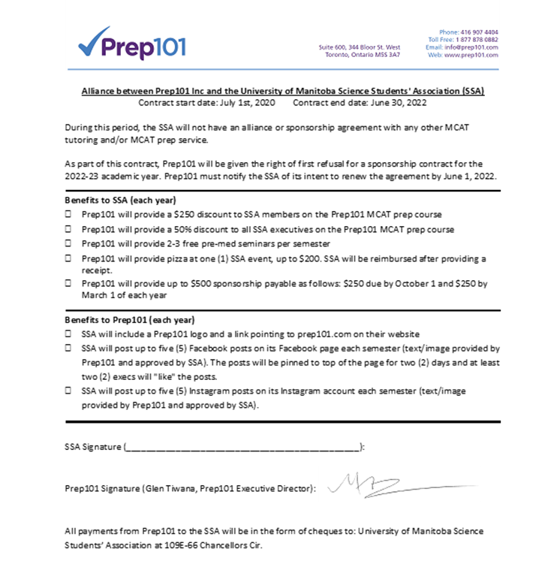
- Senate
Emily Kalo Reports:
- Sexual Violence Policy Changes
  - Clarification of Purpose
  - Changes to procedure
    - Trauma informed practice
    - Limitation period for filing complaint has been removed
    - No disciplinary action if alcohol or substance abuse is involved
  - Disclosure Confidentiality Clarification
  - Path forward recommendations
    - Will be brought to the board of governors in September for approval
    - Senate approves the revised method (using the new instruments outlined in the above)
- Request for extension of suspension of intake program
- Extension of intake by 1 year
- Students currently in programs would be grandfathered and not affected
  - Biotechnology Major
  - International educated agrologists Post-Baccalaureate Program - 0 current students
  - Bachelor of music/Bachelor of Education program - replaced
  - Post-Baccalaureate Certificate in Applied Leadership
    - SENATE APPROVES
- Modification of Program Requirements and Academic Regulations for the Post-Baccalaureate Diploma in Education
- Proposal put forward from the Faculty of Education to create higher quality program and address advanced practices not currently being taught
- Effective September 1, 2020
- Proposing:
a. the minimum number of credit hours of 5000 level courses taken from the Faculty of Education would be increased from 12 to 18 credit hours
b. the maximum number of credit hours below the 5000-level taken from the Faculty of Education would be reduced from 18 to 12 credit hours
c. the maximum number of credit hours taken outside the Faculty, would be reduced from 18 to 12 credit hours
- SENATE APPROVES
- Delivery of the Bachelor of Nursing Program to a Collaborative University College of the North Cohort
- Purpose of the proposal is to define the delivery of the UofM Bachelor of Nursing Program to students studying on site at the UCN Thompson and The Pas campuses (referred to as the “Collaborative UCN Cohort”).
- effective for the Fall 2021 intake
- The Program Would…
- mirror the requirements for the regular category for the Bachelor of Nursing program
- one exception: Applicants must have completed a minimum of 18 credit hours of the year 1 Bachelor of Nursing program requirements at UCN while physically residing in northern Manitoba.
- Any unused spaces in this category will be redistributed to the general application pool.
- SENATE APPROVES
- Revised Direct Entry Admission Requirements, Faculty of Science
- The Faculty of Science is proposing a modification to their direct entry admission requirements to align with the institutional direct entry framework.
- Effective for Fall 2022 intake
- Specifically:
  - Minimum eligibility moved from 70% to 80%
  - The minimum eligibility for admission will be an 80% average over the four academic courses with no less than 60% in any one course
    - English 40S
    - Pre-Calculus Mathematics 40S or Applied Mathematics 40S
    - One of Biology, Chemistry, Physics or Computer Science 40S
    - One additional (academic) 40S course
- Whereas before, the policy was:
  - A minimum 70% average over the following, with no less than 60% in each course:
    - English 40S (Grade 12)
    - Mathematics 40S (Grade 12)
    - Two additional 40S courses (Grade 12)
- SENATE APPROVES
- Revised Admission Requirements, Bachelor of Social Work
- modification ensures alignment with other academic requirements within the Faculty of a grade of C or higher
- To be approved Fall 2021
- Under the proposed model...
- only incoming grades of C or higher can be applied to the Bachelor of Social Work degree program
- The only exception is for courses that satisfy the institutional mathematics requirement.
- SENATE APPROVES
- Revisions to Requisite Skills and Abilities, Bachelor of Nursing
- Students would be required to meet and demonstrate progression of the requisite skills and abilities or be required to withdraw from the program.
- Students requesting reasonable accommodations would be required to register with Student Accessibility Services and follow the University Student Accessibility Procedure.
- Skills and Abilities are categorized as follows:
- Cognitive
- Communication
- Behavioural
- Sensory
- Physical
- SENATE APPROVES following discussion on how students’ rights can be protected during evaluations and potential bias in assessments.
- Academic Regulations, Bachelor of Social Work
- Currently, the Faculty uses a “Subject Grade Point Average” which is not compliant with the University’s Grade Point Averages Policy.
- The Faculty is proposing...
- use the Degree Grade Point Average as the only method of student evaluation in requirements for the Bachelor of Social Work concentrated program.
- Social Work courses would be valid for nine years from the date the student completed the course (including courses taken prior to admission)
- Students would be required to repeat any expired courses, in order to meet the degree requirements of the program.
- In order to meet graduation requirements, students would be required to complete 48 credit hours of non-social work courses to make up the elective requirements of the Bachelor of Social Work program.
- students from the Fort Garry, Northern Program and the Inner-city campuses would be permitted to obtain up to 6 credit hours of required social work courses by Distance Delivery.
- A student with more than one Voluntary Withdrawal from SWRK 3150 or SWRK 4120 would be required to withdraw from the Faculty.
- SENATE APPROVES following discussion on it would affect students who have already started their degrees. Specifically, when “Continuous Learning” is such a widespread culture within the faculty and field of social work.
- UMSU
Bryan Kwak, Chloe McElheron, Katelyn Casalla & Riley Shannon Reports:
- Motions
- 0482
- Campaigns Working Group
  - Planning upcoming UMSU campaigns with student input
  - Looking to structure campaigns to reach students online
  - Any student can reach out the them and work with them
- 0483
- Deadline to present UPASS contract to BOD (previously May 31st, 2020) has been eliminated as Winnipeg Transit has not given a response as to whether they will accept/reject the contract.
  - Exec does not want to pay legal fees to draft contract until they know Transit will accept.
  - New deadline is before 2021 Winter sem.
- Updates
- UMSU membership & UPASS Fall 2020 Fee
  - Collecting UMSU fees but not UPASS fee this Fall
    - Will find a way to provide students with this feature for those who still need it
  - Executive is negotiating with administration regarding recreation, library and other fees
    - If the gym is open, students will probably have to pay the recreation fee – Since the gym did say it was reopening students will most likely have to pay for the recreation fee
    - Library is in the process of digitizing their collection
- Organizational Human Resources Plan for Diversity and Inclusion
- Internal audit of diversity of current UMSU staff
  - Are we advertising and recruiting in a wat that reaches the marginalized population?
  - Are we doing all we can so that once in position, BIPOC feel safe
- Study Accommodations
  - UMSU members survey has shown that only 37% of student feel that their home environment is conducive to learning.
    - Looking at possibility to have bookable study area that is socially distanced for fall.
    - University is resistant.
- Convocation is virtual
- President and VP advocacy met with the Minister of Economic Development and Training and Minister of Finance in Joint meeting
  - Help students who don’t have access to wifi, and other services students need in order to complete their studies at home
  - 3 priorities presented:
- Help Women & Marginalized Students Regain Access to Higher Education
- Support a robust expansion of online learning
- International Student Healthcare
- Community Engagement
- UMSU Website – message from Tino
  - Currently being worked on
    - Any and all feedback can be sent to Tino
    - Asking use to make sure our contact information is up to date on the website
- Students of UMSU Instagram page
  - Helpful platform for student groups/students to share events
- University of Manitoba Black Students’ Association
  - Recruiting has begun and applications can be found in Tino’s Instagram Bio
- UMFU wants to start and UMSU podcast with Brendan and Tino as Co-Hosts
  - Platform for students to advertise clubs and events
  - can be a way to promote SSA events
- Finance
- Businesses are closed for the summer, may open in the fall if there is adequate foot traffic
- Expecting up to 20% decrease in student enrollment, VP finance is planning for all options
- Student Life
- REES (Respect Educate Empower Survivors)
  - Survivor centered platform specifically made for university students
  - Completely confidential but data can be used to pinpoint specific areas around campus for improvement/prevention

- Sexual Violence Steering Committee
- Fall semester orientation – Tino and Savannah on UMSU are working on this
  - Online portal “UM Commons” – exploring if this would be a good opportunity for students to use
  - Orientation Package and video
  - May reach out to external companies like Playfair or COCA for orientation programming
- Nimbus Learning
  - UMSU is re-evaluating if it is financially feasible to continue their partnership in the upcoming year
- Student Clubs Guide
- Communications
Zachary Hiebert Reports:
- SSA Hoodies
- Currently figuring out the cost and final details for the custom hoodies
  - Need to finalize the numbers for each design
  - Need to choose what council would like on the sleeves of the hoodies
    - Name?
    - Position?
    - Both?
  - Need to choose what colour camo for the hoodies
    - White Camo or Black Camo
- Zach will put up a poll for the hoodies in terms of colour choice for the camo hoodies & what people would like embroidered onto the sweaters – whether it be just a name, position or both
- Eric suggested that SSA cover the whole cost of the hoodies instead of 50% of the cost of the hoodies
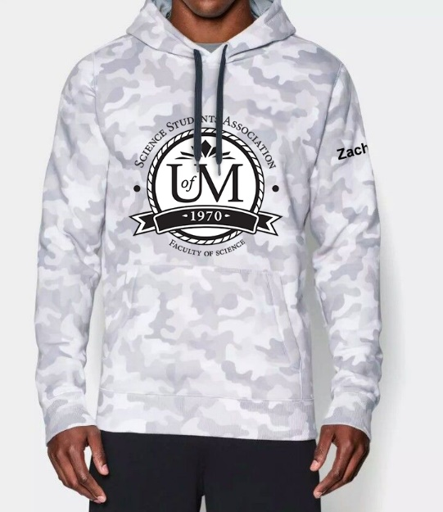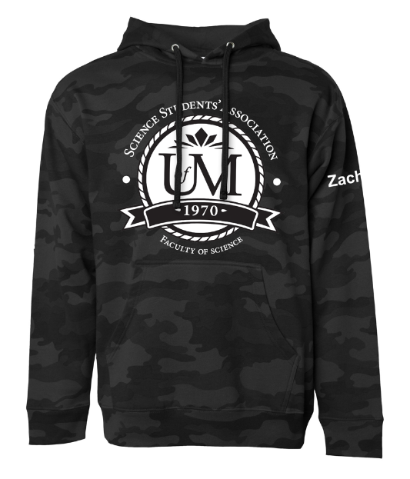

- Councillor Reports
- Special Events
Rashwana Blair, Demi , Tiffany Tantakoun, Andrea, Sion Reports:
- Orientation
- Item 1: Student Club Facts for scavenger Hunt
  - In process of receiving facts from student clubs
  - Who is responsible to scavenger hunt/planning send facts to?
  - Will post the facts etc. into the orientation group
- Item 2: Approval from Faculty on sending a list of 1st year resources?
  - Hope to send 1st year students list of helpful resources
- Item 3: Using Discord for afternoon portion of orientation
  - Streaming a movie
  - Eric said you would have to have the movie on disc
  - If you use Netflix, Disney plus etc Discord blocks the website
  - Eric also said to double check the rules to streaming a movie
- Eric asked for approval from Faculty on sending the resource list
  - Said to write out a constructive email with the full list of resources to be sent out
- Academics
Tooba Razi Reports:
- Nimbus Tutoring Partnership
- Had 2 meetings w/ Nimbus Tutoring with Eric and Jaime to discuss partnership with them (June 25th, July 7th)
  - UMSU will not be renewing contract with Nimbus for 2020-2021 school year, so it is likely SSA will have to pay. UMSU will likely be renewing their contract with Nimbus for 2021-2022 school year.
    - Possibility of previous UMSU tutors to tutor for SSA this year through Nimbus
    - Estimated price for the year: $2000
      - This is a heavily reduced cost considering Nimbus usually charges $1.50 - $2.50 per student that the student organization represents
  - Advertisements/Promotions
    - Nimbus has a multitude of promotional materials (flyers, social media posts, etc) that will be branded with SSA logos, which can be shared to promote the program
    - Several email templates available which can be used to recruit new tutors and invite UMSU tutors to join SSA tutoring program
  - Contract
    - Nimbus has a multitude of promotional materials (flyers, social media posts, etc) that will be branded with SSA logos, which can be shared to promote the program
    - Several email templates available which can be used to recruit new tutors and invite UMSU tutors to join SSA tutoring program
  - Nimbus App/User Experience
    - Nimbus has a multitude of promotional materials (flyers, social media posts, etc) that will be branded with SSA logos, which can be shared to promote the program
    - Several email templates available which can be used to recruit new tutors and invite UMSU tutors to join SSA tutoring program
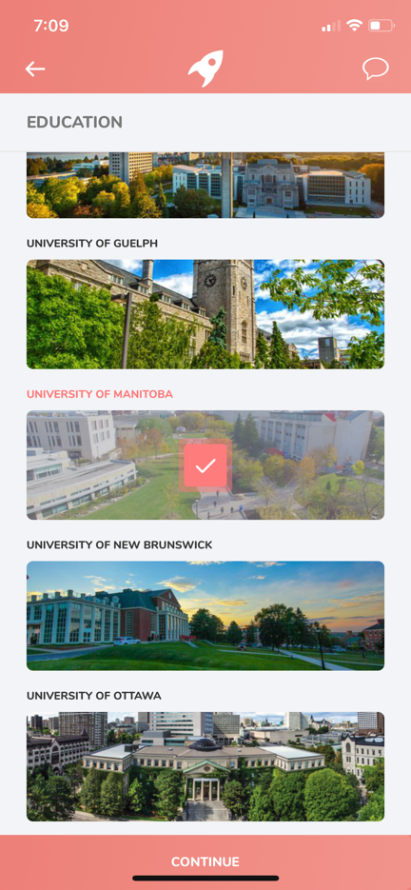
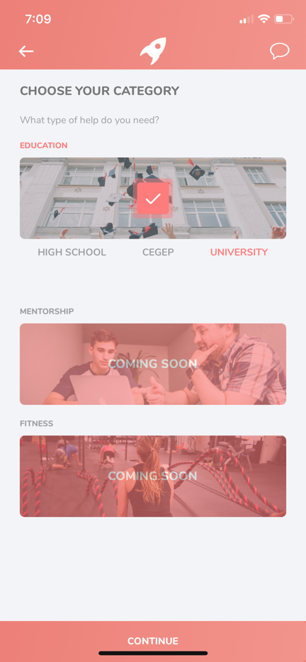
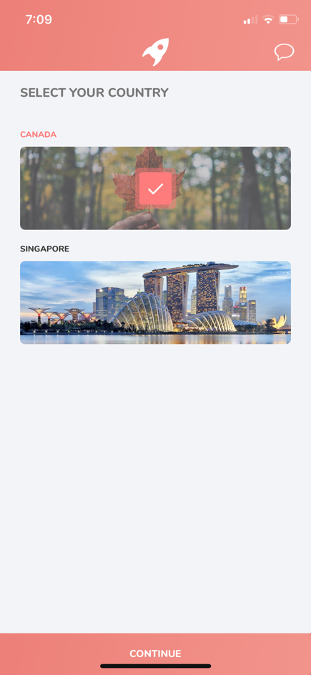
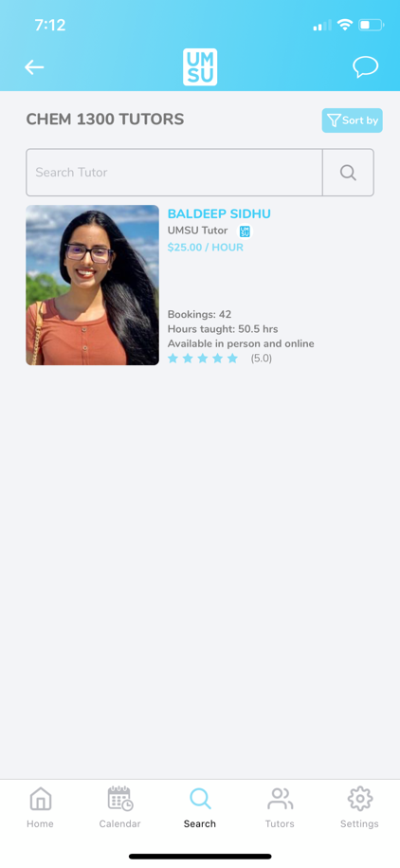
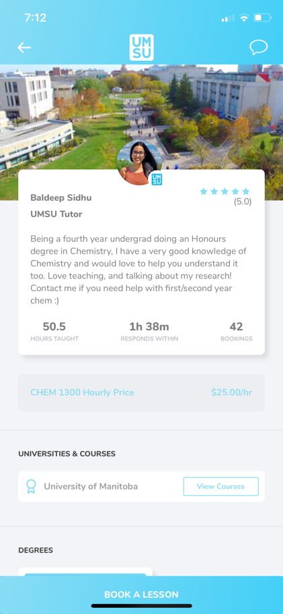
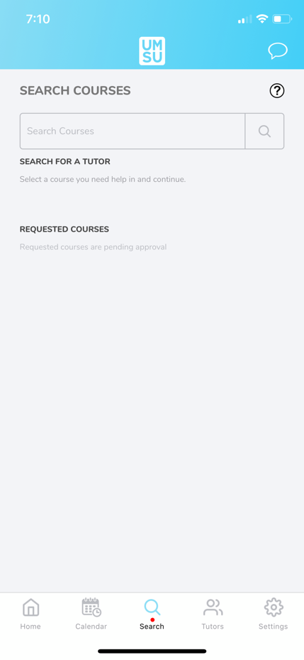
- LabTrek
- Met with Academics team on Jun 30th
- For the purpose of giving new science students a behind the scenes look of actual research labs, and meet the scientists working in them
- Gain insight into undergraduate research opportunities and careers in science available to you
  - Date: Saturday, Sept 12th, 2020 (tentative)
  - Time Frame: Open zoom link at 9:30, start at 10:00 am – 2:00 pm (give a 30 minute “break” in between)
    - Interested students should sign up through a registration link (i.e google forms)
  - 2 main zoom “groups” students will be sent 2 links and the times they should join which link
    - Students will be randomly assigned either group 1 or 2. For the first 1.5 hour, students in group 1 will get to experience research labs through tours, Q and A with the prof, while getting a quick synopsis of the potential research opportunities available to them in the scope of a summer student/co-op student/honours student
      - 4 labs, can be from FoS or RFHS
    - Students in group 2 will hear from undergraduate students about the research they have done. This will also go on for about 1.5 hour. Instead of doing traditional poster presentations, students can present their research in PowerPoints through screensharing.
      - 3-5 students presenting
    - After 1.5 hour, students attending labtrek will get a 30 minute “break” – and they can switch groups (by clicking on the other link provided to them)
    - Following the break, students will join other zoom call, and will engage in the other activity (Group 1 will be listening to presentations and Group 2 will see lab tours)
    - To promote an interactive experience, each activity will be designated a Q and A period to ensure students get a chance to interact with student researchers and professors.
- Touring labs may be difficult/cannot happen – Eric suggested having a back up plan as well
- Lounge Programming
- No report
- Accessibility
Tristan Rohatynsky Reports:
- Update on Contacts
- Established a point of contact at Student Accessibility Services (SAS)
  - Carolyn Christie, Director of SAS
  - Tristan will be meeting with her online sometime in August
    - Prior to the meeting, Eric, Jaime, and Tristan will be meeting to discuss accessibility within the Faculty of Science – being subtitles in the videos as one of the topics being discussed
    - If anyone has thoughts or has heard anything from other students regarding accessibility within the Faculty, feel free to contact Tristan regarding any concerns you may have
- LGBTTQ*
- No report
- Women’s
Kyra Cebula Reports:
- Reaching out to contacts
- Beginning to reach out to various contacts to discuss roles/expectations for this upcoming year
- Contacts include the following:
  - Student Representatives
    - UMSU Womyn’s Representative
    - Womyn’s representatives from other student groups in different faculties
  - Student Clubs
    - Womyn’s center
    - Justice for Women (JFW)
    - University of Manitoba’s Consciousness-Raising Association of Feminists (UMCRAFT)
    - U of M Women in Chemistry (UMWIC)
    - U of M Women in Computer Science (UMWICS)
- Feel free to let Kyra know of any other groups/individuals that would be great to get into contact with
- Indigenous
- No report
- International
- No report
- Student Services
Natalie Ngu Reports:
- Grad Photo Retakes
- Email sent on June 22 Lifetouch grad photo retakes at studio Unit #3 1410 Mountain Ave
- Book appointment @ www.lifetouch.ca/wpgsales
- Locker Clean Out
- Handled by the Faculty
- Monday July 20th – 24th 2020, 9 am – 4 pm
- No sign up required & mask is optional
- July 21st for Science Students
  - Sign in at Armes Link
  - Parking in Q lot
- Treasurer
Justin Cruz Reports:
- June 2020 Bank Statement
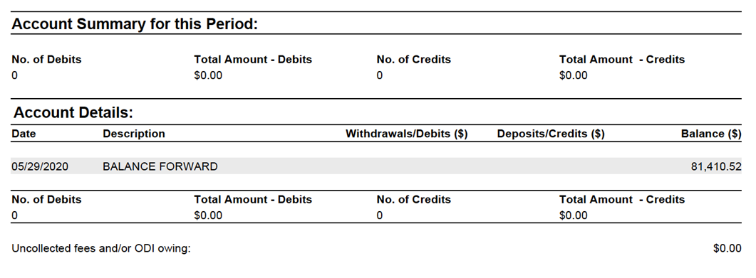
*NOTE: up to the discretion of the councillor if they would like to include charts, images etc. or any pre-written motions in their report (Secretary will add in any information to the report as needed)
- No new transactions – but still have to write a cheque to the Faculty and as well as writing cheques to scholarship recipients

- Committee Reports
- Executive
- No report
- By-Laws
- No report

- Other Business
- Important Dates/Notes
- No report

- Dismissal
Eric Vasas motions for dismissal at 7:58 PM, Jaime McNicholl seconds; Motion passed.

Motions
July 16th, 2020

Motion Regarding: Appointed Councillor | Category: By-Laws
Motion: WHEREAS the current by laws do not include executive assistant under “Appointed Councilors”
- BE IT RESOLVED that in accordance with Article V section 2 Subsection b “Executive Assistant” be applied
Status: Motion Passed

Moved By: Eric Vasas and Jamie McNicholl
Seconded By: No second needed

Motion Regarding: Board of Student Groups Meetings (Director of Communications) | Category: By-Laws
Motion: Motion: WHEREAS the director of communications is currently the chair of the Board of Student Groups Meetings and this duty does not properly reflect their role on council
- BE IT RESOLVED that in accordance with Article X Section 6 Subsection bi “Director of Communications as Chair” is removed
- BE IT RESOLVED that in accordance with Article X Section 6 Subsection bi “Executive Assistant as chair”
- BE IT RESOLVED that in accordance with Article XI Section 2 Subsection b it be added under Executive Assistant “Act as chair for Board of Student Groups”
Status: Motion Passed

Moved By: Eric Vasas and Jaime McNicholl
Seconded By: No second needed

Motion Regarding: Director of Communications – Programmer | Category: By-Laws
Motion: WHEREAS the director of communications currently does not have a programmer
- BE IT RESOLVED that in accordance with Article XI Section 2 Subsection b the roll “Communications Programmer” be added with the following duties:
- Assist the Director of Communications in the completion of their duties.
- BE IT RESOLVED that in accordance with Article XI Section 2 Subsection b under Executive Assistant the duty “Assist the Director of Communications in the completion of their duties” be removed
Status: Motion Passed

Moved By: Eric Vasas and Jaime McNicholl
Seconded By: No second needed

Motion Regarding: Council meetings | Category: By-Laws
Motion: WHEREAS there are 30+ SSA councillors including the programmers
- WHEREAS directors present the reports in council
- BE IT RESOLVED that in accordance with Article XI Section 1 Subsection c the duty of “attend council meetings” be replaced with “attend respective group meetings and Summer council meetings”
- BE IT RESOLVED that in accordance Article VII Section 1 Subsection l be changed too “Members required to attend council meetings must attend 75% of council meetings, all members of council must attend all of their respective group meetings (if applicable), all members of council must attend 75% of scheduled office hours. Councillor attendance will be recorded, and any issues must be reported to the Executive Committee.”
- BE IT RESOLVED that in accordance with Article XI Section 2 the duty “attend council meetings” be added to the following roles: President; Vice President; Senators; UMSU Representatives; Indigenous Student’s Representative; International Students Representative; Accessibility Representative; LGBTTQ* Representative; Women’s Representative; Treasurer; Secretary; Director of Communications; Director of Student Services; Director of Academics; Director of Special Events
Status: Motion Passed
Moved By: Eric Vasas and Jaime McNicholl
Seconded By: Jaime McNicholl
Motion Regarding: SSA Partnerships | Category: By-Laws
Motion: WHEREAS in the past partnerships and contracts between SSA and companies/groups/individuals have been signed without council approval
- BE IT RESOLVED that Article XVII “SSA Partnerships” be added and state
    - “any agreement, partnership or contract between SSA and another UMS/Faculty Student Group, or an External Group must be brought to the attention of the Executive Committee and approved by the Executive Committee and at council meetings”
    - “agreements, partnerships or contracts may be signed by the respective directors or members of council that are requesting the partnership after executive and council approval”

Status: Motion Passed
Moved By: Eric Vasas and Jaime McNicholl
Seconded By: No second needed

Motion Regarding: Nimbus Tutoring & SSA Partnership | Category: Partnerships
Motion: To approve a partnership between SSA and Nimbus Tutoring & corresponding funds toward the partnership
Status: Motion Passed

Moved By: Eric Vasas (President), Jaime McNicholl (Vice-President) and Tooba Razi (Director of Academics)
Seconded By:

Motion Regarding: Nimbus Tutoring and SSA Partnership | Category: Funding
Motion: To approve up to 2000 dollars for the partnership between SSA and Nimbus Tutoring
Status: Passed

Moved By: Eric Vasas (President), Jaime McNicholl (Vice-President) and Tooba Razi (Director of Academics)
Seconded By: No second needed

Motion Regarding: Prep 101 | Category: Partnerships
Motion: to approve the partnership between SSA and Prep101
Status: Passed

Moved By: Eric Vasas
Seconded By: Jaime McNicholl

Motion Regarding: | Category:
Motion:
Status:

Moved By:
Seconded By:

