Science Student’s Association Meeting Attendance
February 3rd, 2021

Position | Name | Present

President | Eric Vasas | Yes
Vice President | Jaime McNicholl | Yes
Chairperson | Anika Khan | Yes
Secretary | Jasmine Tingey | Yes
Senator | Dustin Erickson | Yes
Senator | Emily Kalo | Yes
Senator | Serena Philips | Yes
UMSU Representative | Bryan Kwak | Yes
UMSU Representative | Chloe McElheron | Yes
UMSU Representative | Katelyn Casalla | Yes
UMSU Representative | Riley Shannon | No (regrets; proxy: Stuti)
Accessibility Representative | Tristan Rohatynsky | No (regrets; proxy: Kanso)
Indigenous Students’ Representative | Zoe Quill | Yes
International Students’ Representative | Juanita Garcia | Yes
LGBTTQ* Representative | N/A
Women’s Representative | Kyra Cebula | Yes

Treasurer | Justin Cruz | No
Director of Academics | Tooba Razi | Yes
Director of Communications | Zachary Hiebert | Yes
Director of Special Events | Rashawna Blair | Yes
Director of Student Services | Natalie Ngu | Yes
Executive Assistant | Stuti Gupta | Yes
Academic Programmer | Ethan Lin | No
Academic Programmer | Fares Hossain | Yes
Communications programmer | Sem Perez | No
Lounge Programmer | Aishat Bello | Yes
Special Events Programmer | Andrea Warzel | Yes
Special Events Programmer | Demi Andromidas | No
Special Events Programmer | Sion Yi | Yes
Special Events Programmer | Tiffany Tantakoun | Yes
Student Services Programmer | Dana Segal | Yes
Student Services Programmer | Kanso Alaka | Yes
Student Services Programmer | Selina Audino | Yes

Science Student’s Association Meeting Minutes
February Wednesday 3rd, 2021
Called to Order: 7:16 PM
- Acknowledgement to use of Treaty Land
Zoe Quill acknowledges that we are meeting on treaty land.

- Approval of Agenda
Jaime McNicholl motions to approve the amended agenda, Eric Vasas: Motion passed.

- Approval of Minutes
Chloe McElheron motions to approve the previous meeting minutes from the meeting held on January 20th, 2021, Emily Kalo second; Motion passed.

- Council Reports
- President & (Vice) President
Eric Vasas & Jaime Report:
- Deans meeting
- Last year SSA sponsored some students for the URA – looking at doing it again – this year wanted to expand the program for more research opportunities
- Want to do three per faculty instead of just one per faculty
- $94,500 – out of the endowment fund
- Vestibules – in the armes link – connects armes to the Buller greenhouse area and the chemistry parker link – coming from the referendum fund - $230,000
  - This includes installation as well as furniture
- More study space for students, better furniture b/c it’s a cold place to study in the winter
- New networking areas, more help centers and more spaces for student groups – still in the works/discussing it $275,000 in total to supply these spaces
  - Renovations in Allen for student study/help center spaces
- Do we see an issue for students applying for our funding services for financial help for services such as textbooks etc?
  - Serena said should we separate the funds – so that its different from the forum that clubs use for funding
  - Jaime said it wouldn’t be necessary to make another emergency fund
  - Eric – if there are students who cant get these resources rn or even outside COVID-19
  - Jaime said there is no problem keeping it to the same forum but just depends on what the specific needs are etc
  - Katelyn said that we ended up using a significant amount of the fund for clubs etc
  - Eric said for funding requests we either use all or most of it for clubs etc
  - Eric said that students could rent or borrow a textbook if they were in the SSA lounge
- Since this is n issue – coming up with way to help students get the textbooks that they need etc will further discuss next meeting
- Student emergency fund
  - Science students – complaining about the price of textbooks or complaining about how the system is
  - Don’t like how the wiley code – and how you cant buy just the code and not the textbook
  - Some profs teach a lot of textbook etc
  - Jaime said it could be how the company works and not how the prof functions – possibly just how the companies work
  - Something like – profs choose what textbooks they choose etc
  - If student are complaining about it and having to buy the textbook along with the code – maybe talk to the dean to see if there is a way to purchase the codes w/out purchasing the textbooks
  - Katelyn said – force you to buy the textbook and the code – if you’re buying both but not using the textbook is kind of pointless
  - Juanita – said that on an Instagram story (from Savannah) saying that students can apply for the emergency fund (UMSU) about school related issues
- Student emergency fund – what is being done about it
  - Different from how the covid emergency fund works
  - This fund just specifically relates to school, textbooks etc
  - Possibly SSA partnering with the faculty to work on this fund together
  - All councilors approved of this
- Eric and Tristan talked about Art w/ impact with UMSU and other councils
  - Brought up with the faculty about resources etc
- If anyone hears any concerns for students etc – let Jaime and eric know!
- Microbio wants to use some of the lockers – wondering if they need to rent them from SSA – Natalie doesn’t know whether students cleaned out their lockers – see if we should sell them?
  - Difficult because after everything is over and how to get into contact w/ them etc
  - Eric suggested – that students can claim a locker for free etc – for certain hours etc
  - Put it in a google forum – so that students fill in the forum and wed have everyone’s contact information etc
  - Or have students just use it etc
  - Having to organize it in a way that follows covid guidelines
  - Natalie – said we could coordinate something with the profs
- Senate
- Nothing to Report
- UMSU
Bryan Kwak, Chloe McElheron, Katelyn Casalla & Riley Shannon Reports:
UMSU meeting January 28th, 2021
- Presentations
  - Governance Committee
    - Governance Committee laid out calendar to when changes to the board structure will be taking place. Important to note all changes being made will not take effect until May 1st, 2022.

- Updates
  - President
- University budget process starting, put out a student survey and hope to have budget recommendations ready for the incoming Executive to carry over the finish line.
- Training UMSU staff in sexual violence prevention and sensitivity.
- Met with University President, Dr. Benarroch, and Vice-Provost Students, Laurie Schnarr regarding many issues including negotiations with UMFA.
  - Advocacy
- University budget process starting, put out a student survey and hope to have budget recommendations ready for the incoming Executive to carry over the finish line.
- Preparing GOTV campaign for possible snap spring federal election, planning to use CASA & UCRU materials.
- MAPSS held meeting with the new Advanced Education & Skills Minister, mostly regarding incoming Bill 33 & Provincial budget submissions. Also met with status of women secretariat regarding FIPPA/WHSA changes.
- Progress on UMSU Legal Clinic, could have service provided through StudentCare (Health & Dental providers) but that would be an additional $9.33 per student. Referendum would have to be held to raise fees.

  - Community Engagement
- Black History Month programming being held with BSU & UMBA. There will be different workshops and a guest speaker
- University sustainability committee updated them on the implementation of new waste management practices on Bannatyne Campus. This update is specifically related to the collection of waste PPE as well as ground level composting on that campus. Education materials will be created and placed near waste collection sites in order to encourage proper waste disposal.

  - Finance & Operations
- Surveying students on both possible added costs for the Legal Aid program as well as the UPass and the Health & Dental plan.
- GPAs and service centre reopened, other UMSU Businesses staff laid off.
- Participatory budgeting process to start in March.

  - Student Life
- Sexual Violence Steering Committee update: considering the removal of an appeals process for those who are found to have contravened the RWLE policy in instances of sexual violence. Appeals are often a tool used by perpetrators to retraumatize survivors/intimidate them out of filing a complaint.
- Sav & Tino provided a welcome week presentation to incoming students for the Winter term.
- Healthy Sexuality Campaign happened; they gave away air pods.
- Communications
- Nothing to Report

- Councillor Reports
- Special Events
- Nothing to report
- Academics
- Nothing to report
- Lounge Programming
- Nothing to report
- Accessibility
- Nothing to report
- LGBTTQ*
- Nothing to report
- Women’s
Kyra Cebula Reports:
- Fall 2020 Community Scholarship Recognition
  - Had a meeting with the other community representatives to discuss the recognition that will be given to the community scholarships recipients
    - Will be providing the winners with recognition for their achievement by congratulating them on the SSA’s Instagram page.
      - I created the Instagram story that congratulates this year’s Womxn’s Community Scholarship recipient.
      - The Instagram story will be posted during this week and recipients have been notified ahead of time as well as given their own copy of the post.
- Upcoming collaboration with SSA indigenous Representative Zoe Quill
  - In an effort to create a sense of community as well as promote wellbeing for Indigenous students within the Faculty of Science, we will be teaming up to host bi-weekly sharing circles.
    - The first sharing circle will be held on Thursday February 11th at 4:30pm CST.
      - Dates are subject to change based on student feedback.
      - Further event details continue to be discussed but will be finalized in the upcoming week.
Promotion on Instagram will begin later this week and up until the day of the event.

- Indigenous
Zoe Quill Reports:
- Indigenous Initiative’s Committee
- Recruit students to the Wawatay program by building connections with High School students
  - Student representatives on this committee to visit high schools virtually (through some kind of sharing circle gathering) to help build this connection
- Community Reps Team
- All five communities (Womxn’s, LGBTTQ*, Indigenous, International, and Accessibility) has a recipient for Fall 2020 Community Scholarships
  - Details have been sent to Treasurer to mail out cheques
- Created an Instagram story to recognize Fall 2020 Community Scholarship recipients
  - Planning to post this on Instagram sometime this week or early next week
- Collaboration with UMISA and UMSU Indigenous Representative
- A Night of Indigenous Laughs: Indigenous-themed trivia night on February 19th @ 6pm via Zoom
  - Prizes in the form of SkipTheDishes gift cards will be awarded to the first three places (1st place - $25, 2nd place - $20, and 3rd place - $10)
  - Poster posted on social media through both Indigenous and Science channels
- Collaboration with Womxn’s Representative
- Planning biweekly sharing circles via Zoom
  - Dates and times may vary as we learn what works through these gatherings
    - Providing feedback questionnaires to figure out schedule and layout of event
  - Themes will be included to help guide the conversation
  - Purpose to connect with other students and provide a comfortable space to talk about anything

- International
- Nothing to report
- Student Services
- Nothing to report
- Treasurer
- Nothing to Report

- Committee Reports
- Executive
SSA Executive Report
February 3rd 2021
- Plans for special events/gala, putting money towards a different event altogether?
  - Gala most likely won’t be able to happen this year, but funds have already been allocated for it in the budget→ we should do something else.
  - Give Rashawna and team more flexibility to plan another big event.
    - Hard to plan an online event for an online gala
    - Trying to find a balance – and to find something that is worthwhile for students
    - suggest that we could do an escape room?
    - Do we do a physical gala or explore different options??
    - Exploring options – special events team will ultimately decide what to do
    - Suggestions of an online gala, an events day, booking local artists etc live streams
- Changes needed to be made to the current office hour set up- should we bring back discord hours? Should we assign a different task for 1 hour per week?
  - No one is using the Book Me method - leave the Book Me as is
  - No one showed up on Discord either (which is why we moved to Book Me)
  - Emphasis on during your hour do stuff for SSA → monitor Facebook, Insta, Discord (add messages/memes)
    - Serena suggested doing like a weekly “Ask SSA”
- Changes that need to be made to the website
  - the councillor page hasn't been updated; we’re going to ask everyone to send a photo in so that it can be updated.
  - Make sure councillor’s page, funding form, nimbus is all up to date
  - Make a post about the website being updated → include that the funding form is up.
  - Photos → wear black/neutral tones, solid-colour plain wall if possible
- Update on PAC science – interested to if anyone has suggestions for internal candidates for the new dean of science?
  - Presidential Advisory Committee - looking for a new dean.
  - Confidential process otherwise
    - If you have any recommendations let Katelyn know!!
FUNDING
- STEM Fellowship
Reimbursement of Fall Expenses
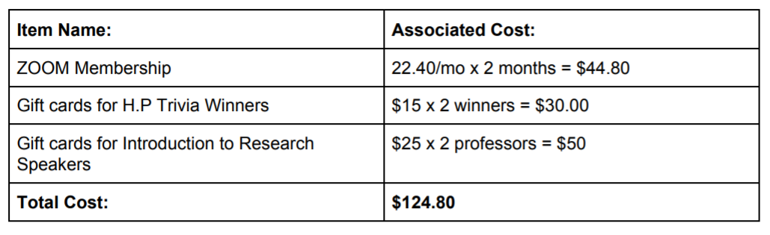
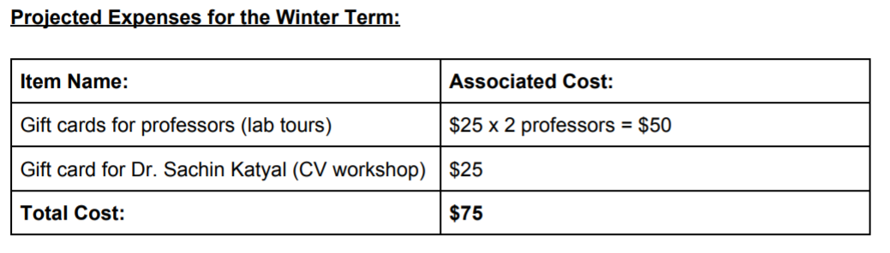
- Total: $199.80
- Recommended to be approved by Exec.
- Student Clubs
  - OPUS
Alan Nguyen
28 Monticello Rd.
Winnipeg, MB
R3Y 1L4
and pay to the order of the Organization of Physics Undergraduate Students
Note:
Regarding student club funding, our motion regarding providing student clubs with 2000$ in funding does not have a current deadline for requests
March meeting → we’d like to make a motion that if they don’t get the info sent to us before the changeover period then it won’t carry over to next year.
ELECTIONS
- Nominations
  - SSA requires signatures for nominations and those running for senate require more.
  - Senate hasn’t said shared information about how they expect to receive signatures.
  - Idea 1
    - Electronic signatures with student numbers
    - UMSU general election nominations being done online (umsu.formstack.com)
    - 25-30 signatures
  - Idea 2
    - Personal paragraph
    - Not the best option when the purpose of signatures is to have others want you in the position
  - Idea 3
    - Have someone else vouch for you (can’t be on a slate with you or running)
    - ^ has to be a FoS prof or student
    - Reference letter - paragraph style cover letter
“Why they would be good in ___ position
- Don’t have a CRO, UMSU CRO has to choose ours (Eric has emailed her)
- Form for CRO
  - Name
  - Email
  - Faculty
  - 250 words - Why you think you would be good at the position
  - Resume + cover letter
  - Email back @ SSA
- Timeline
  - Email UMSU CRO on Jan. 29 → they choose our CRO
  - Have a form out till Feb. 5th by 4:30pm
  - Pick CRO by the 12th
  - March 1-5: Nominations
  - March 8-12: Campaigning
  - March: 11-12: Voting
- Information Session - March 1
- Nominee Session with CRO - March 5
- SSA will create a highlight for each slate/person running
  - Instagram
  - Facebook
  - Discord
  - Have to determine the amount of photos/etc that go on the highlight
  - For slates 4-15 photos
- CRO needs to be on top of making the voting forums – for nominees etc
- Come to the conclusion that Idea 1 is the best option – preferred option
- Motion to move into closed session
- Eric motions to move out of closed session, Chloe seconds; Motion passed
- By-Laws
- Nothing to report

- Other Business
- Important Dates/Notes

- Dismissal
Eric motions for dismissal at 8:40 PM, seconds Juanita ; Motion passed.

Motions
Motion Regarding: Vestibule | Category: Funding
Motion: to approve $230,000 for new furniture for the vestibules from the referendum fund
Status: Passed

Moved By: Eric Vasas
Seconded By: Emily Kalo
February 3rd, 2021
Motion Regarding: URA Awards | Category: Awards/Funding
Motion: to approve $94,500 dollars from the endowment fund to fund URA awards
Status: Passed

Moved By: Eric Vasas
Seconded By: Jaime McNicholl
Motion Regarding: Vestibule – Allen Building | Category: Funding
Motion: to approve $275000 for new study spaces in Allen as well as other spaces in Allen
Status: Passed

Moved By: Eric Vasas
Seconded By: Chloe McElheron
Motion Regarding: STEM Fellowship | Category: Funding
Motion: to approve the recommended $199.80 for the expected winter term
Status: Passed

Moved By: Katelyn Casalla
Seconded By: N/A

