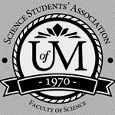
Science Student’s Association Meeting Attendance
February 24th, 2021

Position | Name | Present

President | Eric Vasas | Yes
Vice President | Jaime McNicholl | Yes
Chairperson | Anika Khan | Yes
Secretary | Jasmine Tingey | Yes
Senator | Dustin Erickson | Yes
Senator | Emily Kalo | Yes
Senator | Serena Philips | No (regrets; proxy: Kanso)
UMSU Representative | Bryan Kwak | Yes
UMSU Representative | Chloe McElheron | Yes
UMSU Representative | Katelyn Casalla | Yes
UMSU Representative | Riley Shannon | Yes
Accessibility Representative | Tristan Rohatynsky | No (regrets; proxy: Selina)
Indigenous Students’ Representative | Zoe Quill | Yes
International Students’ Representative | Juanita Garcia | Yes
LGBTTQ* Representative | N/A
Women’s Representative | Kyra Cebula | Yes

Treasurer | Justin Cruz | No
Director of Academics | Tooba Razi | Yes
Director of Communications | Zachary Hiebert | Yes
Director of Special Events | Rashawna Blair | Yes
Director of Student Services | Natalie Ngu | yes
Executive Assistant | Stuti Gupta | Yes
Academic Programmer | Ethan Lin | No
Academic Programmer | Fares Hossain | No
Communications programmer | Sem Perez | No
Lounge Programmer | Aishat Bello | Yes
Special Events Programmer | Andrea Warzel | Yes
Special Events Programmer | Demi Andromidas | No
Special Events Programmer | Sion Yi | No
Special Events Programmer | Tiffany Tantakoun | No
Student Services Programmer | Dana Segal | No
Student Services Programmer | Kanso Alaka | Yes
Student Services Programmer | Selina Audino | Yes

Science Student’s Association Meeting Minutes
February 24th, 2021
Called to Order: 7:11 PM
- Acknowledgement to use of Treaty Land
Zoe Quill acknowledges that we are meeting on treaty land.

- Approval of Agenda
Eric Vasas motions to amend the agenda to add a motion from associate dean and a motion for reimbursement for Eric; Chloe McElheron seconds; Motion passed
Eric Vasas motions to approve the amended agenda, Chloe McElheron seconds; Motion passed.

- Approval of Minutes
Eric Vasas motions to approve the previous meeting minutes from the meeting held on February 3rd, 2021 seconds Jaime McNicholl; Motion passed.

- Council Reports
- President & (Vice) President
Eric Vasas Reports
- Krystyna talked to Eric and wanted us to talk about our thoughts about Fall 2021, if students would want to be on campus etc, or if there was a hybrid of being in person and online – and what activities would be happen etc.
- “I do not know when /how but I would like to discuss your thoughts on Fall 2021 semester- do students want to be on campus- if hybrid model what are the “must activities “?
  - Selina said most students wants to be in person maybe suggesting smaller classes be in person etc
  - Selina said that if a class happens 3 times a week to divide the class into 3 so that one section of the class
Motion to approve $359.4 reimbursement for zoom membership and the SSA website subscription
- Senate
Dustin Erickson Reports:
- Closure of Concentrations in Computer Science
- Motion was passed at the meeting on December 2nd, 2020
- Update that these concentrations will no longer be available beginning Fall 2021.
- Revised Admissions Requirements for the Pharm.D. Program (College of Pharmacy)
- Changes to required courses resulting in a net reduction in prerequisite course requirements of 12 credit hours.
- Modification of the full-time academic course load requirement
  - From a min. of 2 Regular Fall/Winter sessions, to a min. of 1 Regular Fall/Winter session.
- Change to the minimum GPA requirement
o from 3.5 to 3.00
- Elimination of the critical skills essay
- Elimination of the Pharmacy College Admissions Test (PCAT)
  - The UM Pharm.D. is the only remaining (English) program in Canada still utilizing PCAT®
- Addition of the Casper test
o This is a situational judgement test which has been adopted in the majority of other Canadian Pharmacy programs.
o It is also utilized by the UM College of Medicine.
- Change to the adjusted grade point average (AGPA) calculation
o Will now require that all course attempts contribute to calculation of
this average
A lot of the revisions were for safety precautions etc
- If you have any questions you can as Dustin – he can send the agenda and the minutes your way
- Katelyn asked how many concentrations were there – Dustin now said the concentrations are closed – so it is just a general computer science degree
- UMSU
Chloe McElheron, Bryan Kwak, Katelyn Casalla, and Riley Shannon Reports:
UMSU Report for the meeting held on February 11, 2021
- MOTION 0500: Revising the UMSU Act
- The UMSU ACT governs UMSU at the highest level.
- Why and what are we revising?
- The Act was last amended in 2018 but they did not pick up on discrepancies between the UMSU act and by-laws. By-laws read differently but best capture the intended message.
- One discrepancy “hinders the union’s ability, autonomy and efficiency to join an external organization.”
- They’re asking for BOD approval to petition to board of governors for approval, so they can petition to amend the act.
- Motion passed.

- Stats Canada: Gender-Based Violence
- Jelynn attended a presentation by Stats Canada on research surrounding gender-based violence in the post-secondary environment. If you’d like to see the presentation, email Jelynn at pres@umsu.ca Some observations she included in her report:
- The most common reasons for disclosure and speaking to someone at school include receiving mental health support, receiving informal mediation. It was observed that the desire for formal interventions were less frequent.
- Students who witnessed unwanted sexualized behaviours in a post-secondary setting in the past 12 months did not take action for many reasons including: they did not feel it was serious enough, they felt uncomfortable, and they felt worried for their own safety. Respondents who identified as men were more likely to be unable to assess gravity of unwanted encounters than those who identified as female.
- 65.4% of those who reported sexual assault to a school’s official were seeking mental health support. 48.4% who reported unwanted sexual behavior similarly were also seeking mental health support.
- PAC Affairs
- Vice President Administration Search
- Provost & Vice President Academic Search
Advocacy
- Intimate relationships between students and academic staff
Advisory committee tasked with reviewing recommendations 18-20 of the Path Forward Report (a report commissioned by past-president David Barnard). It is a comprehensive review of sexual violence, harassment and discrimination issues affecting the university of Manitoba.
The recommendations in summary: The UM Board of Gov. should ban intimate and sexual relationships between teaching staff (anyone who delivers any component of an academic program, librarians, coaches/coaching assistants) and any student (undergraduate, professional or graduate) they supervise.
- Committee has requested a legal review from a third party to determine if we have the authority to dictate the relationship of two consenting adults and to what extent.
- Considering if it is within the best interest of our community to implement a ban over having provisions that allow the relationship if it is declared.
- If permitted, how can the university reduce the predatory nature and possible coercion associated with these relationships.
- Further questions: university wide or within same faculty? Does it matter if the staff is teaching the student? Pre-existing relationships?
- UMSU Fees
- A recent review of our fees has revealed key items that need further investigation into the history, current usage and process to potentially cease charging these fees.
- Stay tuned!
- University Budget Submission
Reviewed the findings of the recent survey to see which items students would like to see funding go towards in 2021-2022.
- Most students noted the support of adoption of free digital textbooks (59%), enhanced online learning (48%), more financial aid for students (46%) and increased mental health supports (34%).
- UMSU’s budget submission will feature four asks: student counselling centre funding, renewal of international student’s hardship fund, OER introduction, consolidated sexual violence training program to all first years and Bison’s athletes
- MAPSS (Manitoba Alliance of Post-Secondary Students)
“This Bill amends The Advanced Education Administration Act to enable the minister to issue guidelines concerning tuition fees and student fees charged by universities. ... The guidelines and regulations may limit a fee increase or require a fee to be decreased. They may also prohibit compulsory student fees.”
- Bill 33 strategy- MAPPS met to discuss how they were going to advocate and what they were going to ask the government to do?
- The bill is going to pass due to the Pallister’s majority doesn’t mean it’s legal or credible.
- MAPSS wants their approach to be meaningful: Instead of fighting against a bill that is probably going to pass, they want to use their resources to advocate for the government to amend the Bill’s definition of “student fees” to exclude fees collected by representative student groups. The amendment would protect the mandatory nature of student union fees even while making others (like the recreational fee) voluntary.

Community Engagement
- Black History Month
- Virtual workshops and keynote speakers
- Mindful Minutes
- You may have already seen this on the IG, but the executive team is taking turns sharing some simple and wholesome content.
- Start Up Fest
- Panel of local business leaders to be held in April, geared towards entrepreneurial students on campus and in the community.
Sustainable week to start on March 15th – about recycling
Finance Updates:
- Full time dentist will be leasing some UC space, U of M students would receive discount and dental students would be able to practice alongside.
- GPA’s and Service Centre opened, fresh food now being served for students who need to be on campus.
- UMSU Trivia, 4 more coming up!
- U of M providing 3 ply masks at service center
Student Life Update:
- Working Group on Mandatory Disclosures
- If a student were to come forward and disclose an incident of sexual violence to a staff/faculty member, the staff member would be mandated by the university to report that student’s disclosure. The goal of this would be so that the university is better able to track what’s happening on campus.
- Obvious problems:
- it contradicts a survivor centered culture/culture of consent on campus
- greatly reduce the number of disclosures made by students on campus in fear that their incident will be reported without their consent, consequently making the survivor feel more isolated.
Eric asked if the mandatory disclosure is what is working rn – Katelyn said no and that they are thinking of implementing it

- Communications
- Nothing to Report

- Councillor Reports
- Special Events
Rashawna Blair Reports:
- Item 1- Gala alternatives
- Possible scholarships
- Small portion for year-end council appreciation
- Academics
- Nothing to report
- Lounge Programming
- Nothing to report
- Accessibility
Selina Audino on behalf of Tristan Rohatynsky Reports:
- Progress Report
- Summarized progress report can be seen in the table below:

Event/Initiative | What/When | Status
Community Scholarships | - Collaboration with all the community reps to put together scholarship applications and select recipients for the Fall 2020 Community Scholarships (each community scholarship had a recipient which is super amazing!!)  - Prepping for the Winter 2021 Community Scholarships is currently in progress | - Completed (Fall 2020 Scholarships)  - In progress (Winter 2021 Scholarships)
Health and Wellness Posts | - Monthly Health and Wellness Posts on SSA Instagram account regarding tips and a giveaway  - Due to COVID, the giveaways have been e-gift cards only  - Overall response to the posts is incredibly positive  - Will be continuing the posts for the rest of the semester | - Completed (September – January)  - In progress (February – April)
Bell Let’s Talk Day | - Bell Let’s Talk Day: January 28th, 2021  - Collaborated with other SSA members and put together a post to help raise awareness about mental health and ending mental health stigma | - Completed
Movies for Mental Health Workshop | - Partnership with Art With Impact, non-profit organization, as well as UMSU, UMES, and CSA  - Currently prepping for the workshop and getting everything ready  - Workshop date is: Monday, March 22nd @ 6:30 – 8:30 PM | - In progress

- LGBTTQ*
- Nothing to report
- Women’s
Kyra Cebula Reports:
*like Zoe really hoping that most of us attend the Sharing circles to encourage other students within the faculty of science to participate in the events in the future
- Fall 2020 Community Scholarship Recognition
  - Instagram story recognizing the recipients of the Fall 2020 Community Scholarships was posted!
    - Recipients were very thankful for this recognition, and us community reps will continue to acknowledge this achievement for the Winter 2021 Scholarships as well.
- Collaboration with SSA Indigenous Representative Zoe Quill
  - Zoe and I have teamed up in an effort to create a sense of community as well as promote wellbeing for all students within the Faculty of Science.
  - We are hosting bi-weekly sharing circles.
    - Our first sharing circle was on Wednesday February 10th at 6:30pm CST over Zoom.
      - In preparation for this event Zoe and I had several meetings and a lot of effort was put into respecting the traditional protocol of the sharing circle.
        - We created a slideshow to educate our participants on the tradition of sharing circles.
          - In our slide show we touch on why it is important to us that SSA hosts these sharing circles, background information on what a sharing circle is, as well as the traditional rules of a sharing circle.
          - We also created discussion topics that were relevant to students to help guide the conversation.
            - Students were given the opportunity to voice what topics they would like to discuss during the sharing circle when they RSVP’d to the event, and those suggestions will always be incorporated into the event.
        - Promotion took place over social media such as on Instagram and Facebook.
          - Both Zoe and I created the poster, RSVP Form, and Feedback form.
        - Resources and supports were also provided during the event if any participants needed and chose to access them.
      - The night of the event we had no participants show up which is a big problem; instead of cancelling the event Zoe and I chose to stay in case anyone decided to come late and continued on with our sharing circle between the two of us.
        - It is very evident that Faculty of Science seems to lack Indigenous involvement and due to this Zoe and I wish to change the narrative and continue to build up the Indigenous community in Faculty of Science so that Indigenous students feel more welcome to participating in events held by student groups in Faculty of Science.
          - We are committed to bridging the gap between Indigenous students and nonindigenous students
            - In an effort to do this our sharing circle events have been and always will be open to all students/ staff/ community members in Faculty of Science.
        - Zoe and I wish to receive more support from our SSA council members in our effort to create more involvement in the Indigenous community in Faculty of Science.
          - This can be done by attending our sharing circles to show that you support Indigenous students
          - Reposting events that Indigenous rep Zoe Quill is hosting to your Instagram to help reach more students.
    - Zoe and I know the importance of sharing circles and understand how beneficial they can be to students, so we have decided to continue to host this event.
      - The sharing circle will be on February 26th at 6:30pm CST over zoom; All will be welcome to join
        - Promotion for the event has already begin, poster was uploaded to social media on February 18th.
        - We encourage all SSA council members to attend this event to show their support for the Indigenous community.
- International Day of Women and Girls in Science
  - This is a very important day acknowledging the amazing contributions of women in STEM as well as promoting the inclusion of women and girl’s in science.
    - It was important to me that we celebrate this day by celebrating all the inspiring women in Faculty of Science.
    - To do this I chose to do an Instagram giveaway.
      - Giveaway details:
        - Prize was two $25 skip the dishes gift cards
        - To win the giveaway participants needed to tag a woman in the Faculty of Science who inspires them for a chance to win the gift card. The Friend they also tagged would also receive a giftcard.
        - Had to be in the Faculty of Science to be eligible to win.
      - Two winners were decided by using a random generator to unsure the decision was fair.
      - Winners were announced on the SSA Instagram story and contacted directly with instructions to receive the prize.
        - They had to email the community reps gmail stating that they won the giveaway and provide proof to confirm they were in the faculty of science.
        - Both winners failed to prove they were in the faculty of science and admitted to being in another program making them ineligible for the giveaway prize.
        - New winners needed to be redrawn, so the random generating was used again and selected two new winners
          - The new winners have been contacted and given the information to receive their prize.
- Collaboration with UMSU Women’s Representative Judith Oviosun, the Women’s Center and several women’s reps from other faculties
  - I am parting with the Women’s center and several Women’s representatives from various faculties to celebrate International Women’s Day on March 8th.
    - We will be hosting an awards night to celebrate the amazing women that go to the University of Manitoba.
    - Nominations forms I have created will be made available to students soon so that they can nominate women for various categories for a chance to win that award!
      - There will be various categories involving excellence and achievements that are worthy of being recognized.
      - Winners will be chosen by us women’s representatives and they will receive a certificate as well as some sort of prize.
    - I have also created the RSVP form that will be distributed sometime next week.
    - The event will be in the evening and will be a huge celebration consisting of announcing the winner’s, entertainment, and more.
    - Goody bags will be given out as well for attending.
    - Further details are being discussed
    - SSA is expected to contribute some money to this event, I am open to discussing how much we would like to contribute.
- Upcoming Collaborating with UMCRAFT and ASBC Women’s Rep
  - I will be participating in an event hosted by UMCRAFT
    - The event will be a panel discussion about what it’s like to be a woman in your field
    - There will be several women from various faculties participating and I will be there as a representative of the Faculty of Science.
    - Further details of the event are still being discussed.
  - UMCRAFT CANCELLED EVENT FEB 24th, 2021 – WILL RESCHEDULE
- U1 Student Council Instagram Take-Over
  - I will be doing an Instagram take over on the U1 Student council Instagram page on Thursday February 25th.
    - This is a chance for students to see what it’s like to be in the faculty of science and help give them beneficial information before choosing which faculty to enter.
    - The takeover will cover my experience in the faculty of science, answering students’ questions, and my volunteering/ participation in various groups on campus.
    - I will be highlighting my role on SSA as women’s rep
      - This is great opportunity to continue my duty to advocate for women in science and show everyone how amazing it is to be in this faculty.
    - I will be reposting my take-over content to the SSA Instagram page so that more students can access this and benefit from it.

- Indigenous
Zoe Quill Reports:
- ‘A Night of Indigenous Laughs: Trivia Night
- Collaboration with UMISA and UMSU Indigenous Representative
- Took place February 19th @ 6pm via Zoom
- Trivia Quiz over Kahoot about Indigenous-theme topics
  - Prizes of SkipTheDishes gift cards was awarded to the first three places (1st place - $25 and UMISA Sweater, 2nd place - $20, and 3rd place - $15)
    - Used $50 from my own budget
- Great turnout of 10 people, all who commented that they enjoyed it!
- SSA Sharing Circles
- Collaboration with Womxn’s Representative
- Biweekly meetings (varying dates and times) held over Zoom
  - 1st Sharing Circle on February 10th @ 6:30pm
    - Participant issues – brainstorming to encourage people to drop by
  - Upcoming 2nd Sharing Circle on February 26th @ 6:30pm
- Ongoing promotion for sharing circles on social media (Instagram and Facebook)
Zoe hopes for more non-indigenous support to help bridge the gap between indigenous students and non-indigenous students
As one of Zoe’s policies is to close the gap, it would be great for us and other students to participate in these events to create a safe space etc
A great way to do this is to share events via social media – attend the sharing circles!!
Juanita said that Zoe could ask Jennifer to put it in the email we get sent out so that way it reaches more students
- International
Juanita Garcia Reports:
- Recent loss in the international student’s community
- Four international students have passed away in the last weeks. All the families have requested their bodies be taken home and UMBSA/MSA is taking care of that with help of MPI and other organizations. Currently have everything covered and are in no need of donations.
- Anika said that there is a GoFund me page set up in the name of those who passed away – to reach out to her if we would like to help out
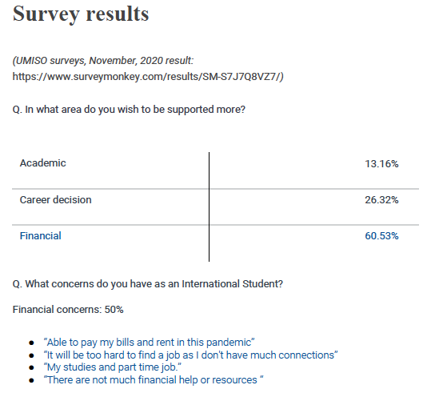
- International Students’ Representatives group
- Meeting held on Sunday Feb 21 to talk about initiatives that we can do together to help international students
- Trying to plan events that are more inclusive – between all faculties
- Student Support initive by UMISO (UofM Internatinal students organization)

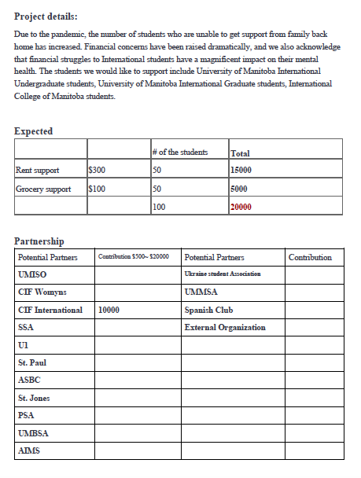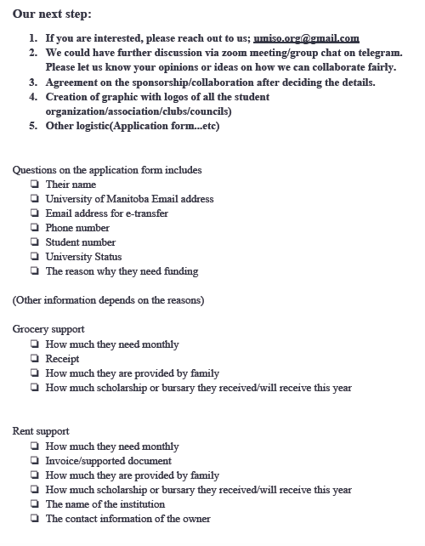project would be a one time payment – idea is to reach out to students and faculty to see if they can donate to help with this project
What ever a students groups donate – will go towards an international student in the faculty – SSA would donate and it would go to an international student in the science students association
Juanita wanted to bring this up with us to get our opinion
Eric asked when Juanita would like this done – there is an exec meeting on Wednesday – this would be done within 2 weeks possibly
Juanita said that there is no strict timeline they are good to go whenever they hear back from exec.
With this project – students would fill out an application to see if they are eligible for this
Eric said for Juanita to send the proposal as well as to see what other students groups are doing for this project as well – Juanita will do so
- Student Services
Natalie Ngu Reports:
- Grad photos
  - Contacted Lifetouch to ask about if they’re planning to reopen with the lifted code red restrictions and they said they are short of staff so we will hear back from them once they have something in place
- Motion to reimburse student services members for $275 from December Exam Cram Giveaway
- Treasurer
- Nothing to report
- Committee Reports
- Executive
- Nothing to report
- By-Laws
By-Laws Committee Reports:
Motion: First Years’ Representative
- WHEREAS first year students are not represented on council.
- WHEREAS there is a large amount of incoming direct entry science students.
- BE IT RESOLVED that in accordance with “Article V Section 2. Subsections a.v.” the role of “First Years’ Representative” be added.
- BE IT RESOLVED that in accordance with Article IX Section 2. Subsections
- 2. Viii. 4. The First Years Planning report be added to the regular meetings routine items.
- BE IT RESOLVED that in accordance with Article X Section 5. Subsection b. The role of First Years’ Representative be a member of the Board of Directors.
- BE IT RESOLVED that in accordance with Article XI Section 2. Subsection a. The role of First Years’ Representative be added with the following duties:
- Present concerns of First Year Students within the Faculty of Science to Council.
- Ensure programs, services, and initiatives within SSA and the Faculty are inclusive to first year students and are accessible.
- Lead relevant campaigns and opportunities directed towards first year students within science.
- Maintain contact and be aware of initiatives of on-campus groups and services related to First Year Students including, but not limited to, UMSU and other First Year representatives (i.e., commerce, engineering, etc.).
- The First Years’ Representative will be in communication with the U1 Council and lead relevant campaigns and specific events tailored to first year’s students.
- BE IT RESOLVED that in accordance to Article XIV. Section 9. the First Years’ Representative be an elected position that will be filled during the regular election period.
- BE IT RESOLVED that individuals will run for the position in their first year, and be a part of council during their second year at the University of Manitoba.

- Other Business
- Important Dates/Notes
- Nothing to report

- Dismissal
Eric Vasas motions for dismissal at 8:10 PM, Jaime McNicholl seconds; Motion passed.

Motions
February 24th, 2021

Motion Regarding: First Years’ Representative | Category: SSA Elected Position
Motion: to implement a new position for council – First Years’ Representative
- WHEREAS first year students are not represented on council.
- WHEREAS there is a large amount of incoming direct entry science students.
- BE IT RESOLVED that in accordance with “Article V Section 2. Subsections a.v.” the role of “First Years’ Representative” be added.
- BE IT RESOLVED that in accordance with Article IX Section 2. Subsections
- 2. Viii. 4. The First Years Planning report be added to the regular meetings routine items.
- BE IT RESOLVED that in accordance with Article X Section 5. Subsection b. The role of First Years’ Representative be a member of the Board of Directors.
- BE IT RESOLVED that in accordance with Article XI Section 2. Subsection a. The role of First Years’ Representative be added with the following duties:
- Present concerns of First Year Students within the Faculty of Science to Council.
- Ensure programs, services, and initiatives within SSA and the Faculty are inclusive to first year students and are accessible.
- Lead relevant campaigns and opportunities directed towards first year students within science.
- Maintain contact and be aware of initiatives of on-campus groups and services related to First Year Students including, but not limited to, UMSU and other First Year representatives (i.e., commerce, engineering, etc.).
- The First Years’ Representative will be in communication with the U1 Council and lead relevant campaigns and specific events tailored to first year’s students.
- BE IT RESOLVED that in accordance to Article XIV. Section 9. the First Years’ Representative be an elected position that will be filled during the regular election period.
- BE IT RESOLVED that individuals will run for the position in their first year, and be a part of council during their second year at the University of Manitoba.
Status: Passed

Moved By: Jaime McNicholl
Seconded By: N/A

Motion Regarding: Zoom Membership | Category: Reimbursement
Motion: to approve $359.4 reimbursement for zoom membership and the SSA website subscription

Status: Passed

Moved By: Eric Vasas
Seconded By: Jaime McNicholl

Motion Regarding: Exam Cram giveaway | Category: Reimbursement
Motion: to reimburse student services members for $275 from December Exam Cram Giveaway

Status: Passed

Moved By: Selina Audino
Seconded By: Eric Vasas

