Science Student’s Association Meeting Attendance
December Friday 4th, 2020

Position | Name | Present

President | Eric Vasas | Yes
Vice President | Jaime McNicholl | Yes
Chairperson | Anika Khan | Yes
Secretary | Jasmine Tingey | Yes
Senator | Dustin Erickson | Yes
Senator | Emily Kalo | Yes
Senator | Serena Philips | No
UMSU Representative | Bryan Kwak | Yes
UMSU Representative | Chloe McElheron | Yes
UMSU Representative | Katelyn Casalla | No
UMSU Representative | Riley Shannon | No
Accessibility Representative | Tristan Rohatynsky | Yes
Indigenous Students’ Representative | Zoe Quill | Yes
International Students’ Representative | Juanita Garcia | Yes
LGBTTQ* Representative | N/A | N/A
Women’s Representative | Kyra Cebula | Yes

Treasurer | Justin Cruz | No
Director of Academics | Tooba Razi | No
Director of Communications | Zachary Hiebert | No
Director of Special Events | Rashawna Blair | Yes
Director of Student Services | Natalie Ngu | Yes
Executive Assistant | Stuti Gupta | Yes
Academic Programmer | Ethan Lin | No
Academic Programmer | Fares Hossain | No
Communications programmer | Sem Perez | No
Lounge Programmer | Aishat Bello | No
Special Events Programmer | Andrea Warzel | Yes
Special Events Programmer | Demi Andromidas | No
Special Events Programmer | Sion Yi | Yes
Special Events Programmer | Tiffany Tantakoun | Yes
Student Services Programmer | Dana Segal | Yes
Student Services Programmer | Kanso Alaka | No
Student Services Programmer | Selina Audino | Yes

Science Student’s Association Meeting Minutes
December Friday 4th, 2020
Called to Order: 6:01 PM
- Acknowledgement to use of Treaty Land
Zoe Quill acknowledges that we are meeting on treaty land.
- Approval of Agenda
Dustin Erickson motions to approve the amended agenda, Chloe McElheron : Motion passed.
- Approval of Minutes
Chloe McElheron motions to approve the previous meeting minutes from the meeting held on seconds; Jaime McNicholl; Motion passed.

- Council Reports
- President & (Vice) President
- Nothing to report
- Senate
- Nothing to report
- UMSU
- Nothing to report
- Communications
- Nothing to Report

- Councillor Reports
- Special Events
- Nothing to report
- Academics
- Nothing to report
- Lounge Programming
- Nothing to report
- Accessibility
- Nothing to report

- LGBTTQ*
- Nothing to report
- Women’s
- Nothing to report
- Indigenous
- Nothing to report
- International
- Nothing to report
- Student Services
- Nothing to report
- Treasurer
- Nothing to Report

- Committee Reports
- Executive
Executive reports
Funding Request:

Department of Computer Science

Amount requested: $500
Exec Recommends: $500

Request:

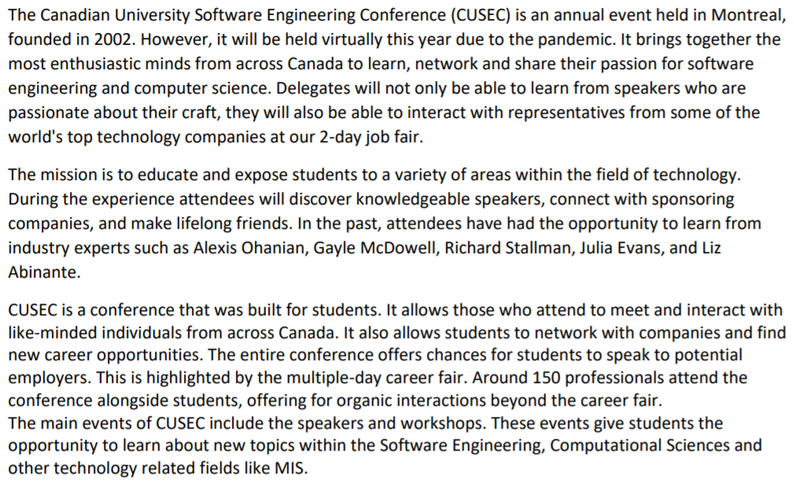
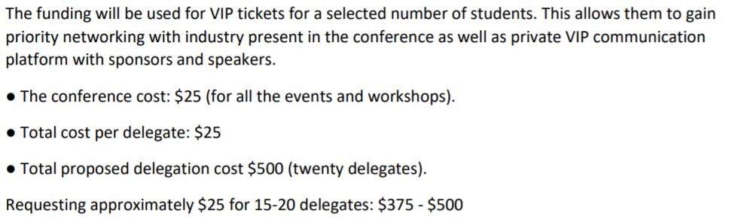
- free event funding goes towards to membership to delegates that are going and all the VIP things going
- By-Laws
- Nothing to report

- Other Business
- Important Dates/Notes
- Dismissal
Eric motions for dismissal at 6:05 PM, Jaime seconds; Motion passed.
Motions
December 4th, 2020

Motion Regarding: | Category:
Motion: executive motions to approve $500 in funding for the Canadian University Software Engineering Contest
Status: Passed

Moved By: Dustin
Seconded By: no second needed

Motion Regarding: | Category:
Motion:
Status:

Moved By:
Seconded By:

