Science Student’s Association Meeting Attendance
August Thursday 13th , 2020

Position | Name | Present

President | Eric Vasas | Yes
Vice President | Jaime McNicholl | Yes
Chairperson | Anika Khan | Yes
Secretary | Jasmine Tingey | Yes
Senator | Dustin Erickson | Yes
Senator | Emily Kalo | Yes
Senator | Serena Philips | No (regrets; proxy: N/A)
UMSU Representative | Bryan Kwak | Yes
UMSU Representative | Chloe McElheron | Yes
UMSU Representative | Katelyn Casalla | No (regrets; proxy: Justin)
UMSU Representative | Riley Shannon | Yes
Accessibility Representative | Tristan Rohatynsky | Yes
Indigenous Students’ Representative | Zoe Quill | Yes
International Students’ Representative | N/A
LGBTTQ* Representative | N/A
Women’s Representative | Kyra Cebula | Yes

Treasurer | Justin Cruz | Yes
Director of Academics | Tooba Razi | No (regrets)
Director of Communications | Zachary Hiebert | Yes
Director of Special Events | Rashawna Blair | Yes
Director of Student Services | Natalie Ngu | Yes
Executive Assistant | Stuti Gupta | Yes
Academic Programmer | Ethan Lin | Yes
Academic Programmer | Fares Hossain | No (regrets)
Communications programmer | Sem Perez | Yes
Lounge programmer | Aishat Bello | Yes
Special Events Programmer | Andrea Warzel | Yes
Special Events Programmer | Demi Andromidas | No
Special Events Programmer | Sion Yi | Yes
Special Events Programmer | Tiffany Tantakoun | Yes
Student Services Programmer | Dana Segal | Yes
Student Services Programmer | Kanso Alaka | Yes
Student Services Programmer | Selina Audino | Yes

Science Student’s Association Meeting Minutes
August Thursday 13th, 2020
Called to Order: 7:09 PM
- Acknowledgement to use of Treaty Land
Zoe Quill acknowledges that we are meeting on treaty land.

- Approval of Agenda
Eric Vasas motions to approve the amended agenda with updated parts, Jaime McNicholl seconds; Motion passed.
Eric Vasas motions to approve new agenda, Jaime McNicholl seconds. Motion passed

- Approval of Minutes
Dustin Erickson motions to amend previous meeting minutes from the meeting held on July 16th, 2020. Amendments made; change in Dustin’s last name, Kyra’s first name and switching Andrea Warzel and Aishat Bello to their correct positions.
Emily Kalo motions to approve the previous meeting minutes from the meeting held on July 16th, 2020, Jaime McNicholl seconds; Motion passed.

- Council Reports
- (Vice) President
Eric Vasas & Jaime McNicholl Reports:
- Online video tour fully finished
- Vicky said there will be more opportunities for filming
- Email/message Eric after the meeting privately if youre interested
- Orientation Meeting with Faculty
- Day Layout
  - U1 presentation (most likely 8:45 - 9:30 AM)
  - Panel (maybe 9:45 - 11 AM)
  - Scavenger Hunt + Prizes - Breakout + Kahoot
  - No lunch
  - Games (Jackbox, etc) on Discord
- Panel
  - Emails have been sent – students asking prof questions
  - August 31 - Sept. 4 first year profs will introduce stuff (?)
  - Didn’t catch all the details about this
  - Krystyna
    - There is a session being led by the first year center
    - Then students move to home faculty
    - Potentially wants to change panel
    - 8:45 - 9:30 = President message + Alumni
    - If consent culture and academic honesty are covered in the ^ session then we will convert panel to a town hall
    - Will connect with Brandy and let us know more about how the U1 presentation is going to be
  - Zoom link for first years could be sent out.
  - Privacy issue with asking students to send a screenshot of Aurora account.
- Scavenger Hunt – need 5 councilors to run the zoom rooms and the kahoot
  - Breakout rooms in Zoom
  - 5 councillors lead the rooms
  - Presentation
  - Kahoot quiz based on presentation
  - Questions will be based on student clubs and other faculty information
  - Eric - email Trevor to get educational licenses
  - Prize options – looking into what prizes can be given out to students
    - Skip or Doordash coupon codes
    - FoS sweaters that they can pick up
- After we can open discord, play games if people want to join
- Let Eric or Jaime know if you have any concerns etc.
- Senate
Dustin Erickson Reports: Meeting on Aug 5th
- COVID-19 PowerPoint
- Explained measures that have been taken since the start of the pandemic, as well as proposed measures for the upcoming semester
  - 205 classes will offer in person classes in the Fall 2020 Semester
  - 2020 convocation drew attendance of 5000 viewers
  - 31st Annual Graduation Powwow celebrated over 60 indigenous graduates
    - This presentation can be found on the senate website
- Group of senators presented on this – talked about the safety measures for COVID-19 that are going to be taken place throughout the year to ensure the safety of the faculty and the staff
- Science Co-op Revisions
- SENATE APPROVES motion to amend the requirement of students who were not able to fulfill their final work term in Summer 2020.
  - Two options available for these students are:
  - Graduating with two work terms completed and graduating in Spring 2021
OR
  - Completing their final work term in Summer 2021 and graduating in Fall 2021
- Trouble in summer 2020 for fulfilling Co-op term because of funding
- Medicine Revisions
- SENATE APPROVES motion to amend the promotion and failure of Undergraduate Medical Education (UGME) students.
  - This motion is aimed
- UMSU
Riley Shannon reports:
- Motions
- 0485
- Kristine Jimenez was appointed as the 2020/2021 CRO
- Running elections and helping with SSA
- Updates
  - President
- Working on re-opening UMSU offices safely
- “Provincial Post-Secondary Advocacy Coalition” renamed “Manitoban Alliance of Post-Secondary Students” (MAPSS). Working on formalizing bylaw structure, meetings start in August, first action is putting together a Provincial budget lobby week.
- Mental Health Month & Indigenous Students’ Month
- International Student Healthcare: Costs likely increasing, a decreasing enrollment could increase costs further and due to its universal nature even international students studying abroad could be required to pay premiums.
- Green Projects
  - Advocacy
- Time Zone concerns for International Students
- Privacy concerns with ‘Lockdown browsers’
- Safe changerooms at ALC
- Study accommodations: bookable study space will be available this Fall
- Minister Eichler & Fielding ignoring emails
- Meeting with Climate Minister Sarah Guillemard regarding sustainability initiatives.
- UCRU: Five Federal recommendations including:
  - $15 Million to expand undergraduate research awards
  - Defer student loans & double student grants
  - $20 Million for integrated learning programs
  - $100 Million for reconciliation initiatives (Indigenous languages)
  - Ensure high speed internet access to everyone by 2030 and reduce cellular costs by 25%
- Internet sticks: Manitoba Gov rejected ask so working to partner with private company to provide ~2000 internet sticks to students
- Legal services
  - Community Engagement
- Orientation: Virtual Fall orientation through UMCommons, welcome packages sent out to students
- Hampers: Instead of typical Holiday Hampers may do Spring Hampers
- UMSU1020: Brendan and Tino still have a podcast
- uniSkedual
- 365 Tenant Merge: Email outage from Aug 21 – 24
- Students for Black Lives Campaign: Applications to join available
- Students of UMSU: Available to advertise events etc.
- UMSU Website: Almost done being updated
d. Finance & Operations
- Prepared for possible budget cuts – hopefully won’t have to lay off staff
- Student Care contract negotiations
- Smoke Free campus: University’s decision to go smoke free, a later board will have to decide whether or not to sell cigarettes in GPA’s
- Working on reopening service center to distribute bus passes
- UPass negotiations: Transit still unwilling to budge, UPass may not return until Fall 2021 semester
- UPASS won’t be likely to be used in the Winter as well
e. Student Life
- Orientation (See Community Engagement)
- Get Involved!: Campaign to highlight student clubs
- UMSU Does That: Campaign to highlight UMSU services
- Healthy Sexuality Month: Virtual Expo with skype sessions and information
- Hampers (See Community Engagement)
- REES: Online sexual violence reporting platform, UMSU advocating for university to sign up as we are currently the only university in Manitoba to have not done so yet
- Communications
- No Report

- Councillor Reports
- Special Events
Name: Rashawna, Demi, Tiffany, Andrea, Sion
Item 1: Orientation
Each Councillor gives Powerpoint presentation on student clubs followed by Kahoot quiz on Zoom. Prizes for top scorer in each breakout room
Reached out to clubs to get them to send some information for their club
Working on a list of important services on campus – list will be sent out to students with the contact information about each of the services .

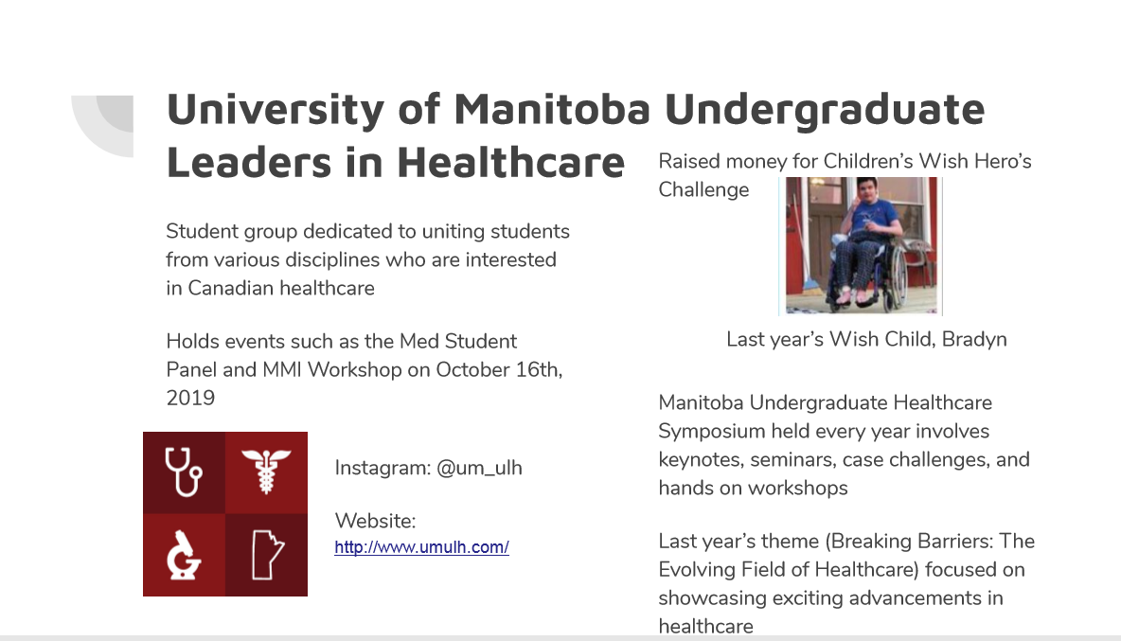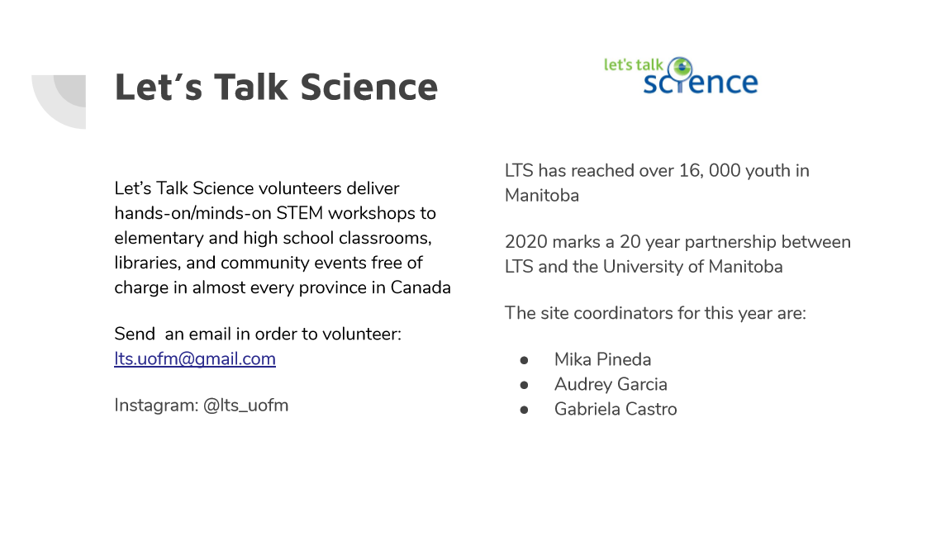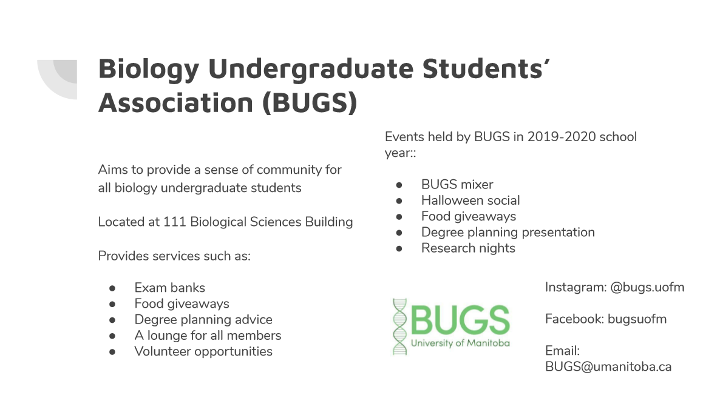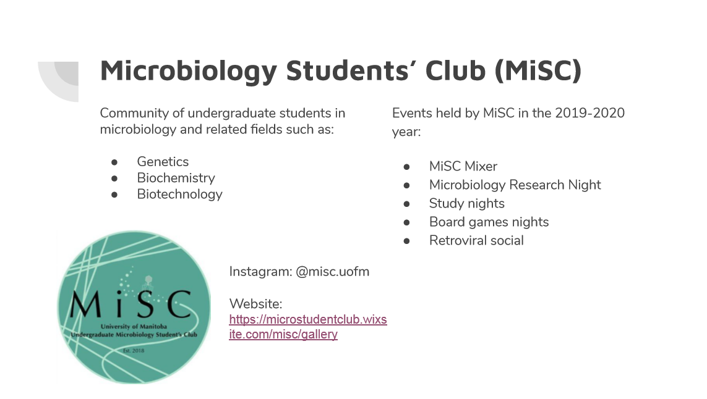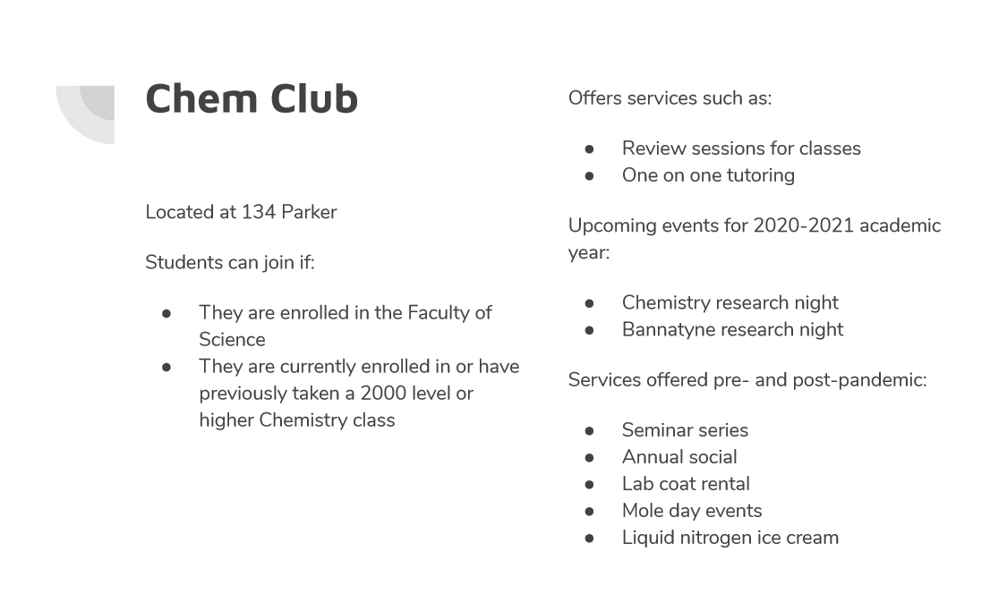
- Academics
Tooba Reports:
- Nimbus Tutoring Partnership
- Moving forward with standard plan with Nimbus
  - Approved by Council and Executive Team
- Waiting to sign Proposal Contract
- Lab Trek
- Date: Saturday, Sept 12th, 2020 (tentative)
- Time Frame: Open zoom link at 9:30, start at 10:00 am – 2:00 pm (give a 30 minute “break” in between)
  - Interested students should sign up through a registration link (i.e google forms)
- One main “call” students will be sent link and the times to join
  - Open to discussion: Zoom vs. BlueJeans?
  - Still deciding about what platforms to use – decided on Zoom – seems to be a better platform than BlueJeans
- Dr. Kirk McManus and Grad Students (Dept. of Biochemistry and Medical Genetics) have agreed to take part in lab tour and interview portion of LabTrek
  - Waiting to hear back from Professors in Dept. of Mathematics, Dept. of Chemistry.
  - Will be reaching out to professors in Biology
    - *If anyone has suggestions regarding any potential professors who they think would be willing to participate, let someone on the Academics team know*
Also looking for undergraduate students (4-5) to give brief (7-10 min) PowerPoint presentations on their research
If anyone has any suggestions of profs to use for interviews – some listed: Steve Whyard – for bio profs to present

Also looking at undergrad students who are willing to present a vdideo about their undergrad research
- Lounge Programming
- No Report

- Accessibility
- No Report
- LGBTTQ*
- No Report
- Women’s
Kyra Cebula Reports:
- Reached out to contacts and planned 2 upcoming meetings
- Have reached out through email to various Student Clubs and Representatives
  - Such as:
  - Student Representatives
- UMSU Womyn’s Representative
- Women’s representatives from other student groups in different faculties
  - Student Clubs
- Womyn’s Centre
- Justice for Women (JFW)
- University of Manitoba’s Consciousness-Raising Association of Feminists (UMCRAFT)
- U of M Women in Chemistry (UMWIC)
- U of M Women in Computer Science Council (UMWICS)
- Planned to have meetings with the UMSU Womyn’s Representative and Justice for Women (JWF) to discuss possible collaborations as well as roles and expectations for the upcoming year
- Have yet to receive a response from the other Clubs listed.
- Indigenous
- No Report
- International
- No Report
- Student Services
- No Report
- Treasurer
- July 2020 Bank Statement
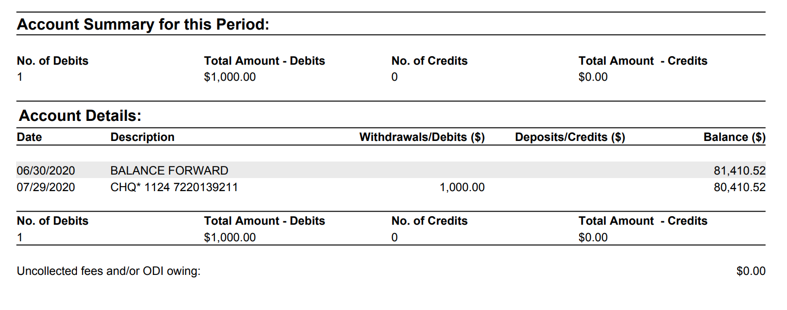
*Note: up to the discretion of the councillor if they would like to include charts, images, etc., or any pre-written motions in their report (Secretary will add in any information to the report as needed)

- Committee Reports
- Executive
- Budget
- Total Executive Committee Budget: $54,000
  - Council Activities budget decreased to $1000
  - Advertisement Budget decreased to $1000
  - SSA hoodies budget increased to $2000 to cover the full cost for each councilor
  - Ski trip money re-allocated to student funding requests
- Total Special Events: $93,000
  - Science orientation budget $2,000
  - Social/Events – Leaving $1,000 for online events and winter semester (last yea used $900 total)
  - SSA Gala – leaving $90,000
- Total Student Services: $3,600
  - Expenses were decreased due to online format
  - Exam Cram - $1000
  - Food Giveaways - $2500 (possible Skip or DoorDash Gift cards)
- Total Academics: $12,500
  - LabTrek - $200
  - Test Night Prizes - $300
  - Tutoring gift cards - $1000
  - Tutoring Contracts (including Nimbus) - $4,000
  - Tutoring Scholarships - $3,000
  - End of year awards - $4,000
- Lounge: $500
- Community Rep Budgets: $1,500
  - Events - $250
  - Scholarships - $1250
- Expenses Overview
  - Total Spent Year 2019/2020 - $115,000 (rough estimate)
  - Total Money at the start of Sept 2019 - $65,000
  - $20,000 not yet sent from UMSU
  - $62,000 getting sent to faculty
  - Starting off Sept 2020, with - $30,000 (in line with our goals)
- Total Budgeted for 2020/2021: $171,000
  - We have budgeted less than the total we have (still have to hear back from UMSU)
- Talked about this years budget – in the report a more detailed account of where the budget is being sent
- Made some changes - $54000 – decreased funding for council meeting expenses to just $1000 from $3000 to $1000 – because most meeting last year were all in person as opposed to this year
- Advertising budget decreased – because we didn’t
- SSA budget hoodies increased because we are covering the whole cost
- Ski trip budget allocated else where to student funding requests
- Approve spending from last year from $3000 to $2,500
- Special events – science orientation budget decreased, b/c a majority of the orientation will be online
- Social budget decreased down to $1000 dollars because everything will be online due to COVID-19
- Year end gala budget – at the moment has not been touch because unsure whether it is still happening
- Student services - $3600 dollars – brought down the budget for exam cram from $5000 to $1000
- A MAJORITY OF THE BUDGET DECREASES ARE DUE TO COVID-19
- Labtrek budget – remains the same
- Test night prize – remains the same
- Tutor gift cards – increased budget from $500 to $1000
- Tutoring contract – has $400 allocated to it b/c of nimbus we’d spend less
- Aren’t getting advertisements from Nimbus – communications team can help make the advertisements to help let students know about the tutoring program with nimbus
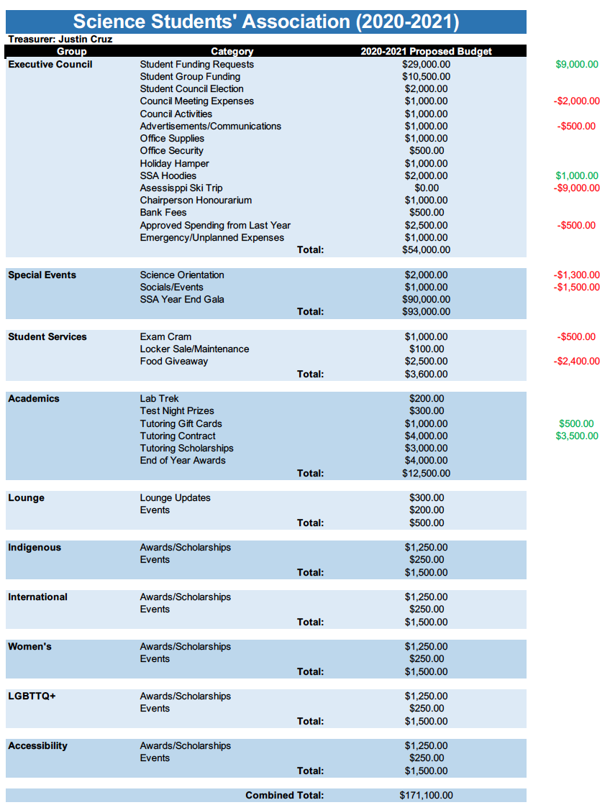
- Contracts
- Nimbus Contracts
  - Motion was passed in Council meeting to sign with Nimbus
  - Choosing between Standard ($2000) or Plus ($3000) packages
  - The Standard package was chosen since advertising can be done by SSA themselves
  - Contract was approved
- PREP 101
  - Contract changed to 1 year from the previous 2 years
  - Haven’t gotten the contract yet
  - Changes were approved
- By-Laws
- No Report

- Other Business
- Important Dates/Notes
Katelyn Reports:
- Community engaged learning (CEL) a part of student engagement and success reached out. They are wondering if SSA/FoS has developed a resource/information document for the upcoming semester regarding remote learning, labs, etc. CEL has a mutual aid community where they can share resources and they think students would find it useful
- General FAQ geared towards first year students starting online?
  - Some questions they’ve been asked
    - “How will lab requirements be fulfilled?”
    - “How can we gain access to library resources?”
    - “What is the difference between remote courses and distance courses?”
    - How can we connect with faculty members and find research opportunities?” – important for science
    - “Will our tuition increase/decrease?”
    - “UPASS?”
  - FoS information should be covered at orientation
  - Hopefully more information will be provided first day of classes
  - Will be brought up at upcoming meeting with Vicky
  - Email UMSU to see what they are planning to do
Asked if ssa or FoS – to create a doc about FAQ’s for new students

- Dismissal
Eric motions for dismissal at 7:45 PM, Jaime seconds; Motion passed.

Motions
August Thursday 13th , 2020

Motion Regarding: Updated Agenda | Category: Agenda
Motion:
Status:

Moved By:
Seconded By:

Motion Regarding: | Category:
Motion:
Status:

Moved By:
Seconded By:

Motion Regarding: | Category:
Motion:
Status:

Moved By:
Seconded By:

Motion Regarding: | Category:
Motion:
Status:

Moved By:
Seconded By:

Motion Regarding: | Category:
Motion:
Status:

Moved By:
Seconded By:

