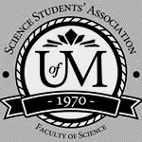
Science Student’s Association Meeting Attendance
November Monday 16th, 2020

Position | Name | Present

President | Eric Vasas | Yes
Vice President | Jaime McNicholl | Yes
Chairperson | Anika Khan | Yes
Secretary | Jasmine Tingey | Yes
Senator | Dustin Erickson | Yes
Senator | Emily Kalo | Yes
Senator | Serena Philips | Yes
UMSU Representative | Bryan Kwak | No (excused)
UMSU Representative | Chloe McElheron | Yes (came late; proxy; Selina)
UMSU Representative | Katelyn Casalla | Yes
UMSU Representative | Riley Shannon | Yes
Accessibility Representative | Tristan Rohatynsky | Yes
Indigenous Students’ Representative | Zoe Quill | Yes
International Students’ Representative | N/A | N/A
LGBTTQ* Representative | N/A | N/A
Women’s Representative | Kyra Cebula | Yes

Treasurer | Justin Cruz | No (regrets)
Director of Academics | Tooba Razi | Yes
Director of Communications | Zachary Hiebert | Yes
Director of Special Events | Rashawna Blair | Yes
Director of Student Services | Natalie Ngu | Yes
Executive Assistant | Stuti Gupta | Yes (after exam)
Academic Programmer | Ethan Lin | No
Academic Programmer | Fares Hossain | No
Communications programmer | Sem Perez | No
Lounge Programmer | Aishat Bello | Yes
Special Events Programmer | Andrea Warzel | No
Special Events Programmer | Demi Andromidas | No
Special Events Programmer | Sion Yi | Yes
Special Events Programmer | Tiffany Tantakoun | Yes
Student Services Programmer | Dana Segal | No
Student Services Programmer | Kanso Alaka | Yes
Student Services Programmer | Selina Audino | Yes

Science Student’s Association Meeting Minutes
November Monday 16th, 2020
Called to Order: 6:46 PM
- Acknowledgement to use of Treaty Land
Zoe Quill acknowledges that we are meeting on treaty land.

- Approval of Agenda
Eric moves to amend the agenda for when stuti comes in to talk about election.
Jaime McNicholl motions to approve the amended agenda, Eric Vasas: Motion passed.

- Approval of Minutes
Emily Kalo motions to approve the previous meeting minutes from the meeting held on October 26th, 2020, Eric Vasas seconds; Motion passed.

- Council Reports
- President & (Vice) President
- Nothing to report
- Senate
Dustin Erickson reports:
- Code Red Adjustments:
- Reduction of maximum capacity
- Closing of pool
- Closing of library
- COVID case reports will be released on the UManitoba website.
- Two apps that are encouraged to use:
  - COVID alert app
  - UMSafe app
- Drive-in testing center open on 1 Research Road
  - Open from 7am-7pm
- International Student Visa
- Readiness plan is a plan that allows international students to enter Winnipeg and quarantine off of campus.
  - This will likely be located at a nearby hotel.
- Faculty of Science Highschool Dual Credit Program
- This was originally handled through the Faculty of Extended Education
- Modification of the English Language Proficiency Requirements
- An increase in the minimum score requirement for the IELTS test.
- Modification of the countries exempt from having to take this test prior to studies.
- It was found that some international students have been struggling academically due to the language barrier
- Amendment of the Fall Academic Schedule
- This amendment allows for the writing of final examinations during the January extension period
6. Faculty of Arts Indigenous Course Requirement
- all new students in the upcoming years will be required to take this couse
- only concern is for the safety of indigenous students in the class
- UMSU
UMSU Meeting November 5, 2020
Bryan Kwak, Chloe McElheron, Katelyn Casalla & Riley Shannon Reports:
- Motions
- 0495
- Direct Governance Committee to carry out changes laid outlined in the Susan Roger Report
  - UMSU Reps from Faculty Councils may still attend, just as non-voting members to provide representation for their respective faculty
  - 11 elected undergraduate students from the University of Manitoba in a campus wide election
  - From these 11 elected directors, 1 will be voted to be the chair for the year
  - Quorum will be 6 directors
  - The absence of more than 5 meetings in the year, or 3 meetings in a row, will require resignation from the board.
  - No proxies permitted
- 0496
- Establish a Black Students’ Representative on the UMSU Board
- Wont sit on the actual board but will sit on the UMSU council – will till get a voice to share any issues that they may have
Anika asked a question about community reps and voting power – riley said that they will still voice their opinions but the council will deal with student issues and concerns and the board will be more towards UMSU
- Updates
  - President
- UMFA: Supporting call for binding Arbitration. Negotiating deadline was set for 11:59pm November 13 with a strike to commence on November 16. Can update more during meeting as it is a very fluid situation.
- Indigenous Students Month: Youth Panel on November 17, Womxn in Power Panel November 27 and Senator Murray Sinclair on November 26.
  - Advocacy
- COVID-19 Planning Committee: Aurora closed for maintenance (supposed to be adding more information on individual course structure for Winter term.), Stricter criteria for in-person classes to be held in Winter term
- UCRU #DebtFreeDegree Campaign
- UMSU Legal Services Centre: Working to find the most affordable way to provide legal services to students.
- Working on installment fee payments for international students, quality of online education, issues remain with Respondus
- MAPSS Lobby Week: Bill 33 timeline March 18th latest date to be read a second time, lobbying also around Performance Based Funding.
  - Community Engagement
- Sustainability working group working on several projects
- Student Leisure guide up and running
- Hamper donations accepted until November 30th
  - Finance & Operations
- GPAs and service center closed again due to Code Red
- Survey on Health & Dental plan
- Transit subsidy will return for the Winter term, since no UPass
- Interdisciplinary clinic to replace most of what was the Print Centre (Dentistry has signed on)
  - Student Life
- Community Assemblies hosted for the Community groups
- ACE/BOSS Meetings up and running
- Healthy Sexuality Campaign: Launching around January 18th (first day of winter term)
UMSU Report November 2, 2020 – 6:30pm – Emergency Meeting
- Bargaining Team Presentation Cancelled – Indefinitely

Strike Information for Students from UMFA:
- Presented by Jelynn
- See PowerPoint
  - UMSU directors can send this to anyone interested!
- Included details about:
  - History of UMFA/2016 bargaining and strike
  - 2020 bargaining with administration
  - Provincial government’s involvement and mandate
  - Issues contributing to 2020 bargaining and why they are holding a strike vote
  - What students can do to help
  - Counselling/mental health supports for students

Survey
- Overview and discussion of UMSU member survey findings
- If you would like to see the document reach out to any of the UMSU directors!
- Major Findings:
  - 14% of students were not aware of the status of the ongoing labour negotiations between UMFA and the university, 42% follow details
  - Top 3 biggest concerns if there was class interference due to a strike or lockout:
    - Exams running through winter break
    - A loss in quality of education due to having to self-educate amid a work stoppage
    - Mental health worsening because of added uncertainty

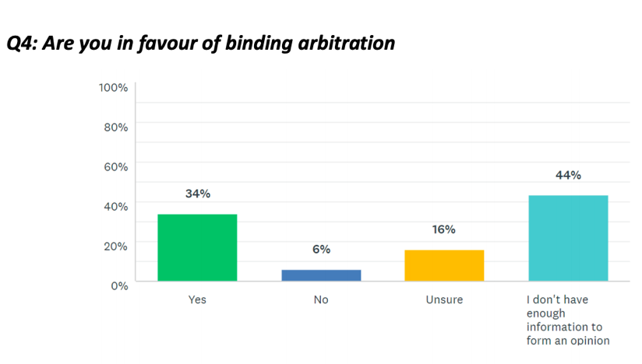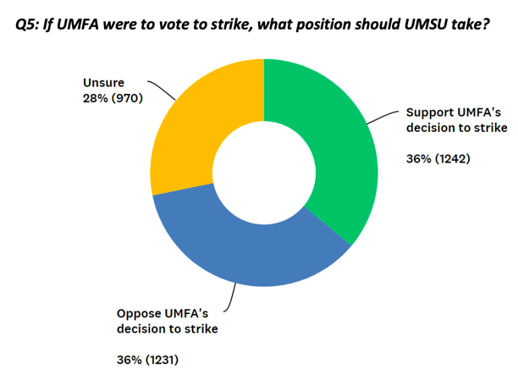
Questions
- Strategy for misinformation – information to circulate to faculty associations
  - Concerned about survey results detailing where students are getting most of their information (top response was “Fellow student/word-of-mouth”)

MOTION 0494 - PASSED
- UM & UMFA Collective Bargaining Agreement Negotiations
- UMSU in support of third-party binding arbitration
- Open letter communicating stance with the University community
Letter to Brian Pallister and Provincial Government condemning their continued involvement in University bargaining
- Communications
- Nothing to Report

- Councillor Reports
- Special Events
SSA Special Events Report: Rashawna, Sion, Demi, Tiffany, Andrea
Item 1: Planning online gift card giveaways
- $200 for 10 winners
- Gift cards to The Bay, Skip the Dishes, DoorDash, Verde Plants and Starbucks
- Sem is making poster
- Holiday Zoom get together?
- Tiffany wanted to do a team bonding events
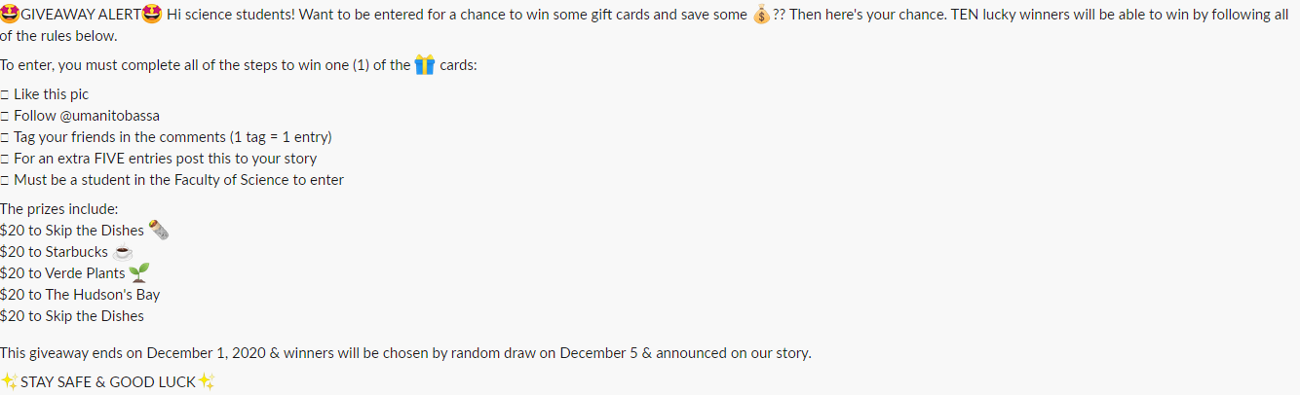
- Academics
Nimbus Tutoring Partnership
  - Nov 5th Meeting
- SSA Program Set-up with Nimbus is complete
- Moving into promotional and launch phase following reading week
  - Email FoS students
  - Social Media Posts
  - Website Update
- Sending email blast to FoS students about Nimbus, promoting both tutor and tutee recruitment for the program
  - Email drafted and ready to send out – waiting on confirmation from FoS communications
  - Includes list of all courses available currently with tutors
- Nimbus is also reaching out to FoS Departmental Student Groups for promotion of our program (BUGS, MISC, etc)
- Nimbus is still awaiting cheque from SSA
  - Cheque should’ve been sent Eric will message Justin
  - Nov 10th Meeting (Tutor Recruitment)
- Meeting mainly focused on Tutor Recruitment Strategies
- Updated the SSA tutor recruitment form, as well as got access to Nimbus’ tutor resources (handbook, code of ethics, etc).
  - Tutor handbook answers a lot of questions so removes the burden from SSA
- Drafted an email to send to successful tutor applicants
- Issue arising: No way to keep track of hours over a time frame; Nimbus’ Admin Portal only shows total hours completed by a tutor, may be hard to keep track of who gets CCR and who doesn’t
  - A suggestion eric made – tracking start of total hours at the beginning of the semester
- Apparently a lot of tutors said that they don’t have CCR’s yet, but the university is figuring things out for the CCR – eric mentioned to take note of all of the tutors who don’t have CCRs with all of their hours
- Can cross reference tutors/hours in the April file

- Lounge Programming
- Nothing to report
- Accessibility
Tristan Rohatynsky Reports:
- Community Reps Scholarships – Fall 2020 Semester
- Scholarships will be available in the following categories:
  - Women
  - LGBTTQ*
  - International
  - Accessibility
  - Indigenous
- Each scholarship will be valued at $500
- Any questions can be sent to ssacommunityreps@gmail.com
  - Zoe, Kyra, and I will be checking and answering the email on a consistent basis
- Poster and applications will go up on Monday, November 16th
  - Deadline is December 11th, 2020 @ 11:59 PM
- Applications for scholarships will be posted on the SSA website, Instagram, and Facebook Page
- Tell your friends and help spread the word!!
- Poster:

- LGBTTQ*
- Nothing to report
- Women’s
Kyra Cebula Reports:
Event with Justice for Women (JFW)
- I had reached out to Justice for Women to collaborate on an event that fostered a supportive and welcoming environment for those identifying as womxn in the Faculty of Science as well as highlight the importance of consent culture education in a fun and exciting way
- Advertising for the event took place on Monday November 9th, 2020
  - Event poster I created was posted to the SSA Instagram account as well as the Justice for Women Instagram account.
  - Event was advertised as a Wine Night and disclaimer of “18+ Please drink responsibly” was included on the poster being advertised on social media.
- The event took place Friday November 13th, 2020 at 7pm over Zoom.
- The Justice for Women Co-Event Directors and I hosted the event titled “Women and Wine: A Consent Culture Trivia Night”
  - Night was focused around playing a game of Kahoot which entailed various trivia questions focused on consent culture which were created by the Justice for Women Co-Event Directors.
  - Winners of the Kahoot game were awarded a Starbucks Gift Card coming out of my Womyn’s Representative Budget
    - 1st place was awarded a $25 Starbucks Gift Card
    - 2nd place was awarded a $15 Starbucks Gift Card
    - 3rd place was awarded a $10 Starbucks Gift Card
  - Added another fun element to the night by encouraging everyone to wear a funky hat!
  - Due to the subject of the trivia it was acknowledged that it may be sensitive for some and support was made available if needed as well as a list of resources sent out in the zoom chat for all attendees to access.
  - Event turned out very well and received positive feedback from all who participated!
Kyra asked to be reimbursed $50, she messaged Justin and Jaime for refund!

Community Scholarships
- Met with Community Representative Team; Tristan (Accessibility Rep) and Zoe (Indigenous Rep) to discuss the upcoming community scholarships for science students
  - Agreed upon one scholarship of $500 for each community for the Fall 2020 Term.
  - Updated and edited the Women and LGBTTQ* application forms for this year
  - Looked over the poster made by Tristan which will be uploaded to the SSA Instagram, Facebook page and SSA website on November 16th, 2020
  - Scholarship deadline was decided to be December 11th, 2020 at 11:59pm
- Indigenous
Zoe Quill reports:
- Summer Research Information Session
- Information session about NSERC/USRAs for Indigenous students on Tuesday, December 1st from 3:00-3:30 pm via Zoom
- Collaborating with David Hebert (Chemistry Professor) and Justin Rasmussen (Student advisor at ISC)
- Community Scholarships
- Met with all community representatives to discuss Fall 2020 Community Scholarships
Sending out November 16th with a deadline on December 11th at 11:59 pm
- International
- Nothing to report
- Student Services
Natalie Ngu Reports:
Student Services Report
- November Lifetouch Grad Photo appointments cancelled due to code red restrictions
- Food giveaway on Instagram
  - Post a photo of something you love to do/something that makes you happy on your story and tag SSA for an entry
  - 1 entry per person
  - $25 skip gift card, 3 winners (science students only) $75 total
  - Post Wed, Nov 25 at 10am, will DM winners on Fri, Nov 27 at 4 pm
  - Need SSA Instagram password to keep track of the entries
- Treasurer
- Nothing to Report

- Committee Reports
- Executive
Executive Meeting – UPDATED Jaime reports
Thursday, Nov. 5
- Funding – UMAC (email attached below)
  - Exec agreed for funding – confirming details via email to determine how much
  - Asking $900 ($30 for registration, $15 for tees)
  - Sent an email in terms of funding and if they have any other funding
- Student Clubs
  - Justin - we have approval of $2000 for clubs
- Student Concerns
  - Kristin from UMSU brought up concerns from Science Students’
  - Kristin brought similar concerns from town hall at UMSU too
    - Deans can bring up concerns in Faculty Meetings
  - Kristin can bring up some limitations in place (i.e. bring motions forth to senate)
  - Jaime and Eric will keep in touch with Kristin about concerns science students have had
- UMBlood
  - Science adopts a week where we encourage the students to donate blood
  - Discuss with council about supports to Canadian Blood Services
- By-elections
  - Extended nominations to next Friday, Nov. 13
  - Extended until last night (November 15th)
  - One person applied – on Wednesday possibly to get them to send in a paragraph to put on their story to get voting done by the weekend potentially
  - Extending to next week so that campaigning starts on Monday (November 23) next week
  - For emailing candidates – depending on the number of people if you create three separate highlights for them if they are comfortable people can reach out to them
- Dr. Schrouder Memorial
  - Got messaged on instagram to have a memorial post
  - Asked to consider having something named after her (similar to Hilton Memorial Room)
  - Bring up to the Dean at next meeting
- Council Activity – Discuss at meeting
  - Ideas: Among Us, Kahoot, JackBox
- Approving money for holiday hampers
  - $1100 – up to $1200 3 group c 2 group b 1 group
- By-Laws
- Nothing to report

- Other Business
- Important Dates/Notes
- doing like a holiday card and posting it on SSA
Finding a day to do the holiday zoom meeting

- Dismissal
Eric motions for dismissal at 7:33 PM, Emily seconds; Motion passed.

Motions
November Monday 16th, 2020

Motion Regarding: Reallocation of gift cards | Category: Giveaway
Motion: To transfer the 4 $25 dollar door dash gift cards from the Halloween giveaway to the student services giveaway
Status: Passed

Moved By: Eric Vasas
Seconded By: Jaime McNicholl

Motion Regarding: Student Clubs | Category: Funding
Motion: to approve funding for $16,000 for departmental student group funding (~$2000 per departmental student group)

Status: Passed

Moved By: Eric Vasas
Seconded By: Jaime McNicholl

Motion Regarding: Holiday hampers | Category: Funding
Motion: to approve up to $1200 for holiday hampers

Status: Passed

Moved By: Eric Vasas
Seconded By: Jaime McNicholl

