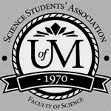
Science Student’s Association Meeting Attendance
November 5th, 2019

Position | Name | Present

President | Justin Lin | Yes
Vice President | Eric Vasas | Yes
Chairperson | David Chamberlain | Yes
Secretary | Tristan Rohatynsky | Yes
Senator | Jaime McNicholl | No (Regrets, Proxy: Tyler Szun)
Senator | Katelyn Casalla | Yes
Senator | Kristine Macalinao | Yes
UMSU Representative | Brendan Scott | Yes
UMSU Representative | Chloe McElheron | Yes
UMSU Representative | Dani Stackiw | Yes
UMSU Representative | Matt Rakar | Yes
Accessibility Representative | Madison Morrow | No (Regrets, Proxy: Tristan Rohatynsky)
Indigenous Students’ Representative | Gillian McIvor | Yes
International Students’ Representative | Juanita Garcia | No (Regrets, Proxy: Selina Audino)
LGBTTQ* Representative | Pending | N/A
Women’s Representative | Emily Kalo | Yes

Treasurer | Justin Cruz | Yes
Director of Academics | Tyler Szun | Yes
Director of Communications | Savannah Szocs | Yes
Director of Special Events | Serena Phillips | No (Regrets)
Director of Student Services | Mrittika Deb | No (Regrets)
Executive Assistant | Dustin Erickson | Yes
Academic Programmer | Stuti Gupta | Yes
Academic Programmer | Tino Dogo | No (Regrets)
Lounge Programmer | William Kong | Yes
Special Events Programmer | Dana Segal | Yes
Special Events Programmer | Demi Andromidas | No (Regrets)
Special Events Programmer | Selina Audino | Yes
Student Services Programmer | Kanso Alaka | Yes
Student Services Programmer | Shelly Lam | No (Regrets)

Science Student’s Association Meeting Minutes
November 5th, 2019
Called to Order: 6:04 PM
- Approval of Agenda
David Chamberlain motions to approve the agenda, Emily Kalo seconds; Motion passed.

- Acknowledgement to use of Treaty Land
Gillian McIvor acknowledges that we are meeting on treaty land.

- Approval of Minutes
David Chamberlain motions to approve the previous meeting minutes from the meeting held on October 29th, 2019, Eric Vasas seconds; Motion passed.

- Council Reports
- (Vice) President
- No report
- Senate
- No report

- UMSU
- No report
- Communications
- No report

- Councillor Reports
- Special Events
- No report

- Academics
- No report
- Lounge Programming
- No report
- Community Representatives
- No report
- LGBTTQ*
- No report
- Women’s
Emily Kalo Reports:
- Update on Community Scholarship
- All of the community reps met
- Discussed how much money that they want allocated to the scholarships
- Will have applications in the office to be distributed once printed
- Total money approved towards scholarships $1000
- Money allocated for Fall 2019 Community scholarship $500
- Scholarship is to be distributed in full amount to one individual or in split amounts to more than one individual
- Scholarship application will be in the office and can be handed out to any students looking for it
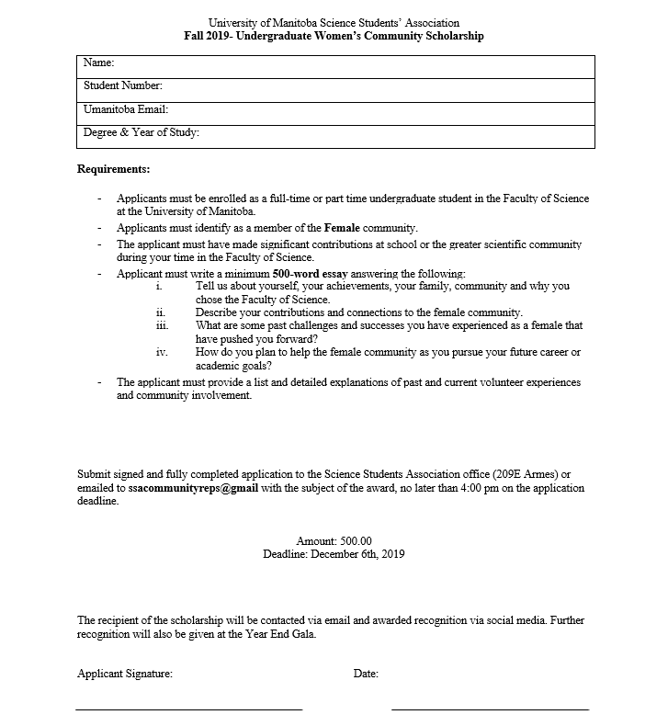
- Scholarship graphic has been designed using Canva (Free trial) and printed (will be posted around sciences this week)

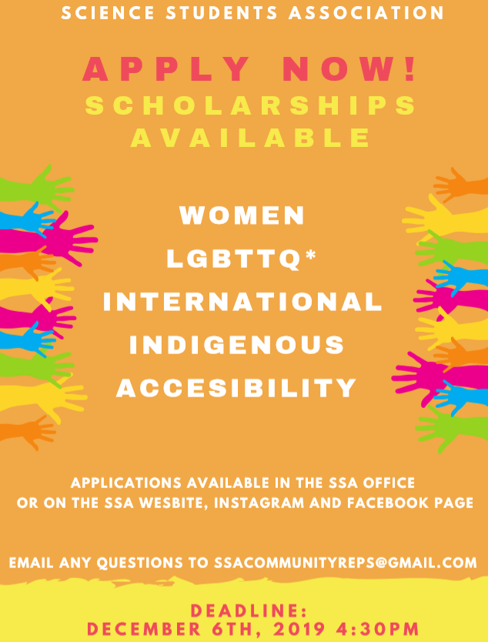
- These posters will be put up around campus
- Emily will send Savannah the graphic so she can post on social media
- Will be approving money later for the scholarships

- Update on Collaboration with UMSU Womyn’s Rep
- Have attended two meetings with Sia (UMSU Womyn’s Rep)
- According to Sia, the Womyn’s Resource Center currently cannot run any events because since they do not have a treasurer, they cannot finance anything
- Emily agreed to be treasurer for the center in UMSU for the rest of her term
- To celebrate newfound functionality Sia is hoping to hold an event in collaboration with our faculty and other faculties which have elected women’s representatives which would take place at the end of this semester or beginning of next
- Meeting to plan this collaboration is scheduled for the end of this week.
- Emily will update us on this meeting once it has occurred

- Update on Network of Empowered Women (NEW) Conference
- Takes place through the University of Manitoba
- The Network of Empowered Women is a student-run conference organized by undergraduate students at the University of Alberta School of Business. Running from March 12th – 15th, 2020 at Lake Louise
- “NEW aspires to be at the forefront of women empowerment within the narrative of today. Delegates leave the conference empowered, inspired, and driven to carve out their personal and professional futures”
- The theme for the 2020 conference is “Inspire: Lead With Purpose”
- Emily was encouraged to apply by Kyra Fanning, UMSU exec, who went last year and said it was one of the best experiences of her university career
- Emily is hoping attending the conference which will give her some more tools which she can use and can be handed down to future Women’s Reps as well as make connections with professionals within the field
- They only accept 80 students outside of the University of Alberta from all North America, but Emily applied last week and should be hearing by the end of the month.
- Looking for students who are interested in student government
- Emily is currently waiting to hear back from this group individually
- In the meantime, Emily has been reaching out to other conferences such as SheDay and Collision and seeing if they would be willing to donate any tickets for female delegates from our faculty to use.
- Tickets are more on the expensive side and unfortunately wouldn’t fit into the budget
- Emily will keep the council updated

- Indigenous Students Report
Gillian McIvor Reports:
- Treaty Land Acknowledgement: Adding into the By-laws

Moved by: Indigenous Students’ Representative (Gillian McIvor)
- WHEREAS according to ARTICLE IX Subsection 8 regular meetings shall begin with Approval of Agenda followed by approval of previous minutes
- WHEREAS it is essential that Treaty Land Acknowledgements are read directly after the Agenda is Approved before the Approval of Previous Minutes
- BE IT RESOLVED THAT the Treaty Land Acknowledgements will be included/read as a part of the agenda for each meeting after the approval of the agenda
Seconded by: Eric Vasas
Motion Status: Motion passed and carried unanimously

- AND INCLUDED IN WRITING IN THE AGENDA THE CHAIRPERSON SENDS OUT TO COUNCIL:
- Article IX: Meetings of the Council
- viii. Regular Meetings shall include the following routine items:
- 2. Changed to Treaty land Acknowledgement
- 3. Then 3rd would proceed with Approval of Previous

- Indigenous Initiatives Meeting; October 7th, October 15th, November 4th
- October 25th, 2019- Two eyed Seeing Circle
  - Mentorship
  - Major obstacles
  - Lots of Indigenous science students came and shared
  - Was nice because the deans were there to hear their perspectives
- Beginning stages of Wawatay Program
  - March 19th and 20th First Nations Science Fair
  - Targeting northern communities and enabling to stay in residence over the summer and experience what science is like
  - Beginning the pilot for this now
- December 10th- Children of the Earth Highschool Visit
- Talk to Indigenous youth there and talk about the barriers about coming into science and bridging gaps

- Indigenous Students’ Working Group; Meeting: November 4th
- Indigenous Students’ Month- November
- Various events posted on the website as well
- Indigenous Women in Leadership-November 19th
- Showing of Angelina Redsky film- November 21st
- Uniting Indigenous Rep positions
- Having bi-weekly meetings

- Community Reps Meeting
- Fall 2019 scholarships due December 6th, 2019
- Posters up this week

- Accessibility
Tristan Rohatynsky on behalf of Madison Morrow Reports:
- Undergraduate Scholarship
- Copy of application can be seen below:

University of Manitoba Science Students’ Association
Winter 2019- Undergraduate Accessibility Community Scholarship

Name:
Student Number:
Umanitoba Email:
Degree & Year of Study:

Requirements:
- Applicants must be enrolled as a full-time or part time undergraduate student in the Faculty of Science at the University of Manitoba.
- Applicants must identify as a member of the Accessibility community (or contributed to the accessibility community??). Documentation may be required.
- The applicant must have made significant contributions at school or the greater scientific community during your time in the Faculty of Science.
- Applicant must write a minimum 500-word essay answering the following:
- Tell us about yourself, your achievements, your family, community and why you chose the Faculty of Science.
- Describe your contributions and connections to the accessibility community.
- What are some past challenges and successes that have pushed you forward?
- What skills and knowledge have you acquired to ave helped you to remain committed to your studies?
- What are your future career or academic goals after completing your undergraduate degree?
- Why do you think accessibility is essential to education?
- The applicant must provide a list and detailed explanations of past and current volunteer experiences and community involvement.
- One reference letter.
  - Reference letter from a member of the Accessibility community is highly recommended.
  - Referee must be able to comment on the applicant’s accomplishments, abilities, experiences and personal qualifications.

Submit signed and fully completed application to the Science Students Association office (209E Armes) or emailed to ssacommunityreps@gmail with the subject of the award, no later than 11:59pm on the application deadline.

Amount: 500.00
Deadline: December 6th, 2019

The recipient of the scholarship will be contacted via email and awarded recognition via social media. Further recognition will also be given at the Year End Gala.

Applicant Signature: Date:

- International Students Report
- No report
- Student Services
Kanso Alaka Reports:
- Samosa Giveaway Update
- Total money approved was up to $250
- Actual Expenditure = $116.70

- Next Food Giveaway: Pizza Giveaway
- Date: Friday, November 22nd, 2019

Kanso Alaka motions to approve up to $700 for the November Pizza Giveaway, Tristan Rohatynsky seconds; Motion passed.
- Food giveaway breakdown:
- Veggie/Vegetarian: 5
- Cheese: 7
- Vegan: 3
- Gluten-free: 3
- Pepperoni: 6
- Chicken BBQ: 4
- Deluxe: 4
- Total: 32 pizzas

- Treasurer
- No report

- Committee Reports
- Executive
- No report
- By-Laws
- No report

- Other Business
- Important Dates/Notes
Sweater Update (Eric Vasas)
- Once Eric gets the money in his bank account, he will reimburse us the additional $9 and the 50% of the price of the sweaters
- Council just has to wait until Eric gets the money back
National Conference for Women in Science and Engineering (Eric Vasas)
- January 25-26th in Toronto
- National conference
- All costs covered
- Not for sure if flights are covered or not
- If you’re interested, let Justin L and Eric know by tonight

- Dismissal
David Chamberlain motions for dismissal at 6:22 PM, Emily Kalo seconds; Motion passed.

Motions
November 5th, 2019

Motion Regarding: Treaty Land Acknowledgment | Category: SSA Bylaws
Motion: WHEREAS according to ARTICLE IX Subsection 8 regular meetings shall begin with Approval of Agenda followed by approval of previous minutes
- WHEREAS it is essential that Treaty Land Acknowledgements are read directly after the Agenda is Approved before the Approval of Previous Minutes
- BE IT RESOLVED THAT the Treaty Land Acknowledgements will be included/read as a part of the agenda for each meeting after the approval of the agenda
Status: Motion passed

Moved By: Indigenous Students’ Representative (Gillian McIvor)
Seconded By: Eric Vasas

Motion Regarding: November Food Giveaway | Category: Student Services
Motion: To approve up to $700 for the November Pizza Giveaway
Status: Motion passed

Moved By: Kanso Alaka
Seconded By: Tristan Rohatynsky

