Science Student’s Association Meeting Attendance
October 29th, 2019

Position | Name | Present

President | Justin Lin | Yes
Vice President | Eric Vasas | Yes
Chairperson | David Chamberlain | Yes
Secretary | Tristan Rohatynsky | No (Regrets)
Senator | Jaime McNicholl | Yes
Senator | Katelyn Casalla | Yes
Senator | Kristine Macalinao | Yes
UMSU Representative | Brendan Scott | Yes
UMSU Representative | Chloe McElheron | Yes
UMSU Representative | Dani Stackiw | No (Regrets, Proxy: Justin Cruz)
UMSU Representative | Matt Rakar | Yes
Accessibility Representative | Madison Morrow | Yes
Indigenous Students’ Representative | Gillian McIvor | Yes
International Students’ Representative | Juanita Garcia | Yes
LGBTTQ* Representative | Pending | N/A
Women’s Representative | Emily Kalo | Yes

Treasurer | Justin Cruz | Yes
Director of Academics | Tyler Szun | Yes
Director of Communications | Savannah Szocs | Yes
Director of Special Events | Serena Phillips | Yes
Director of Student Services | Mrittika Deb | Yes
Executive Assistant | Dustin Erickson | Yes
Academic Programmer | Stuti Gupta | No (Regrets)
Academic Programmer | Tino Dogo | Yes
Lounge Programmer | William Kong | Yes
Special Events Programmer | Dana Segal | Yes
Special Events Programmer | Demi Andromidas | Yes
Special Events Programmer | Selina Audino | Yes
Student Services Programmer | Kanso Alaka | Yes
Student Services Programmer | Shelly Lam | Yes

Science Student’s Association Meeting Minutes
October 29th, 2019
Called to Order: 6:08 PM
- Approval of Agenda
Eric Vasas motions to approve the agenda, Chloe McElheron seconds; Motion passed.

- Acknowledgement to use of Treaty Land
Gillian McIvor acknowledges that we are meeting on treaty land.

- Approval of Minutes
Matt Rakar motions to approve the previous meeting minutes from the meeting held on October 15th, 2019, Eric Vasas seconds; Motion passed.

- Council Reports
- (Vice) President
Justin Lin and Eric Vasas Report:
- By-Election
- Emily talked to her sister who expressed interest in being our CRO
- President and Vice-President propose that:
  - Moved by: Eric Vasas
  - WHEREAS the SSA is missing an LGBTTQ* Representative
  - WHEREAS the position must be filled by December by a by-election or general assembly
  - BE IT RESOLVED that Steph Kalo hold the responsibility of being the Chief Returning Officer (CRO) for the 2019/2020 by-election with the help of the current counsel.
  - Seconded by: Juanita Garcia
  - Motion Status: Motion passes, and carried unanimously

Eric Vasas motions that November 20th – 22nd will be the nomination period for the by election, the 25th – 28th will be the campaign period, the 29th will be voting day. Justin Lin seconds; Motion passed and carried unanimously.

- Laser Tag
- What day do you want to do? During reading week?
- November 23rd will be the date set for council bonding events
- At 8:00pm

- Ideas for SIF?

- Doritos Dinamitas
----- Email to Kyra Fanning from Kelly on behalf of Doritos Dinamitas -----

Hi Kyra,

I was hoping to reach someone in student relations/partnerships – If I haven’t reached the correct department I would greatly appreciate it if you could direct me to the right person!

I’m reaching out to you on behalf of Doritos Dinamitas – we have a Halloween program running throughout several Canadian Colleges and Universities where we are providing the new Doritos Dinamitas to your campus in time for Halloween for any Halloween programming/parties you may have running on campus or in residence.

We’re not looking for anything in return – no ‘tricks’ just simply offering Doritos Dinamitas to schools as a Halloween ‘treat’! :)

We would take care of all of the logistics, and just ask that you distribute amongst campus!

If that Halloween timing doesn’t work for you we could schedule a date that does between October 24th – November 30th. We’re happy to be a part of any campus events during this time that you feel would work out well.

Let me know if the University would be interested! If so we can arrange a delivery of snack size bags of Doritos Dinamitas to the Winnipeg campus for you and your team to distribute where you see best fit!

Looking forward to hearing back!

Thanks,

Kelly

- Senate
- No report
- UMSU
Chloe McElheron Reports:
UMSU Meeting October 24th, 2019:
- Motions
- Motion 0459
- Be it further solved that Governance and Operations Manual Section IV, Subsection 10 be amended to include an additional clause entitled clause (k) that reads as follows:
- Advocating the Union’s interests as a voting ex-officio member of the Board of Trustees of the UMSU Scholarship and Bursary Fund and Endowment Fund, in conjunction with the President and Vice President Finance and Operations.
- Was always intended for VP Community Engagement to take over spot held by VP Student Services
- Motion Status: Motion Passed

- Motion 0460
- Be it further resolved that Susan Rogers, of Roger's Consulting, be appointed as the external consultant for the purposes defined in "External Review of Board Structure & Effectiveness – Project Overview and Request for Proposal"
- Where we’d like to see the union go
- Would better the union as a whole
- Susan Rogers falls under special (funding)
- There have been attempts of a review in the past and variations
- Evaluations of documents and bylaws, but no structural changes
- Has not been an external review in the past 5-7 years
- Have them take effect the 2020-2021 year
- Goal to complete in this board year
- Budget it is coming out of is separate from the main budget, wouldn't be “needed” for anything in the near future that could be more important
- Motion Status: Motion Passed
UMSU Executive Reports:
- UMSU President Report
- President Jakob Sanderson reported the following:
- Board of Governors - months of consultation and work led by Dr. Catherine Cook and her team, the University of Manitoba will soon initiate the position of Vice-President Indigenous – more information to come
- Presidential search committee close to finalizing its recommendation
- GOTV – over 1000 pledges

- UMSU VP Advocacy Report
- VP Advocacy Sarah Bonner-Proulx reported the following:
- GOTV winners announced soon
- Mental Health Working Group - in the process of planning a Success through Wellness 2.0 consultation (the University’s mental health and wellness plan)
- The strategy focuses on students, staff and faculty and identifies ways in which the UM can be more committed to overall health and wellness
- Faculty association is interested in joining the consultation or having your feedback heard, go to http://umanitoba.ca/student/mentalhealth/feedback.html or please let Sarah know and she can pass along the information

- UMSU VP Finance & Operations Report
- VP Finance & Operations Mbuli Matshe reported the following:
- GPAs grand opening Thursday October 31st at 1PM
- Started to work on our plans for Black history month - welcome everyone who wants to help organize the different events for black history month, if you know anyone ask them to email Mbuli: VPFO@UMSU.ca

- UMSU VP Community Engagement Report
- VP Community Engagement Kyra Fanning reported the following:
- Important posts to watch out for:
  - Laverne Cox!
  - OER Week
  - Wellness Week
  - Participatory Budgeting
  - Campus Clean-Up
- Foodbank Fridays
- Foodbank Friday Schedule (Fall Term)
Date | Time | Sport
October 4 | 18:30 | M Volleyball
October 18 | 19:00 | M Hockey
November 1 | 18:00 | M Basketball
November 1 | 20:00 | W Basketball
November 8 | 19:00 | W Hockey
November 15 | 18:00 | M Volleyball
November 15 | 20:00 | W Volleyball
November 22 | 19:00 | M Hockey
November 29 | 18:00 | M Basketball
November 29 | 20:00 | W Basketball

- Malpractice – SOLD OUT
- Holiday Hampers – Competition – Information and rules will be sent to Presidents and Senior Sticks
- Wellness week:
- November 4th –7th - there will be tabling by University groups, contests, interactive tabling with UMSU, and programming

- UMSU VP Student Life
- VP Student Life Jelynn Dela Cruz reported the following:
- The first round of CIF Town Hall meetings will be next week at the following times:
- Monday, October 28
- Womyn’s – 4 PM @ 190 Helen Glass (Womyn’s Centre)
- International Students’ – 5:30 PM @ Fletcher Argue Arts Lounge
- 2SLGBTQ+ - 7:30 PM @ 180 Helen Glass (RPM Lounge)
- Tuesday, October 29
- Accessibility – 4 PM @ 522 University Centre
- Please Note: Location will change for following:
- Accessibility Town Hall meetings
- Indigenous Students’– 5:30 PM @ Migizii Agamik
- Please continue to forward your Community Rep names and e-mail addresses to vpsl@umsu.ca
- Nimbus x Student Nights Against Procrastination – of we want the snack cart to visit out spaces let her know - Wednesday (Oct. 30th) to Friday (Nov 1st)
- Communications
Savannah Szoc’s Reports:
- Motion
- Savannah Szocs proposes that:
- WHEREAS SSA currently has a renewable subscription to the program PicMonkey.
- WHEREAS the design program PicMonkey does not allow for usable customized template dimensions and it is not possible to save finished projects in a quality resolution.
- BE IT RESOLVED that $9.95 per month be paid ($119.40) annually OR $12.95 per month for 8 months ($103.60) for a Canva subscription that will eliminate these issues that arise when using PicMonkey.
- Reasons:
- It’s been found that when saving finalized projects through PicMonkey, the image saved is really blurry
- We are paying upwards of $80.00 to have this subscription and it’s not very useful, the program itself works but if the final projects won’t save in a decent resolution, everything else is irrelevant
- Savannah will look into cancelling our PicMonkey subscription and getting a refund for the remaining portion of the year
- First image (on left) below is through PicMonkey, and second image (on right) below is using Canva

- Councillor Reports
- Special Events
Serena Phillips Reports:
- Replay Social
- Ticket spreadsheet
- Once you sell a ticket, put “sold” by ticket number in sheet
- Put $ from ticket in an envelope labelled “Social Ticket Money”
- If you are taking tickets for a friend, put your name beside the ticket number
- Tickets are $5
- Hub deposit: $230
- If 180 people come, we get our full deposit back, so SELL TICKETS <3
- Hub food: $478.40
- DJ: $200
- Prize: $25 Starbucks gift card and Hub swag
- Need a float
- Drink Specials
- $3.50 shots, $4 highballs, $4.75 jager bombs
- Tabling schedule
- TOTAL: $933.40

- Tabling schedule:

Arrive by: 9:00pm
Time | Councillor
9:00pm-9:30pm | Dustin + Gillian + Dani + Emily
9:30pm-10:00pm | Brendan + Matt + Juanita
10:00pm-10:30pm | Chloe + Justin Lin + Kristine + Jaime
10:30pm-11:00pm | Stuti + Justin Cruz + Tyler
11:00pm-11:30pm | William + Tristan + Kanso
11:30pm-12:00am | Tino + Shelly + Savannah
12:00am-12:30am | Eric + Madison + Kate

*If you need to switch slots for some reason find a replacement yourself and let us know*

- Science Gala
- RBC on April 25th, 2020
- Deposit: $5000
- Photo Booth: $2122.59
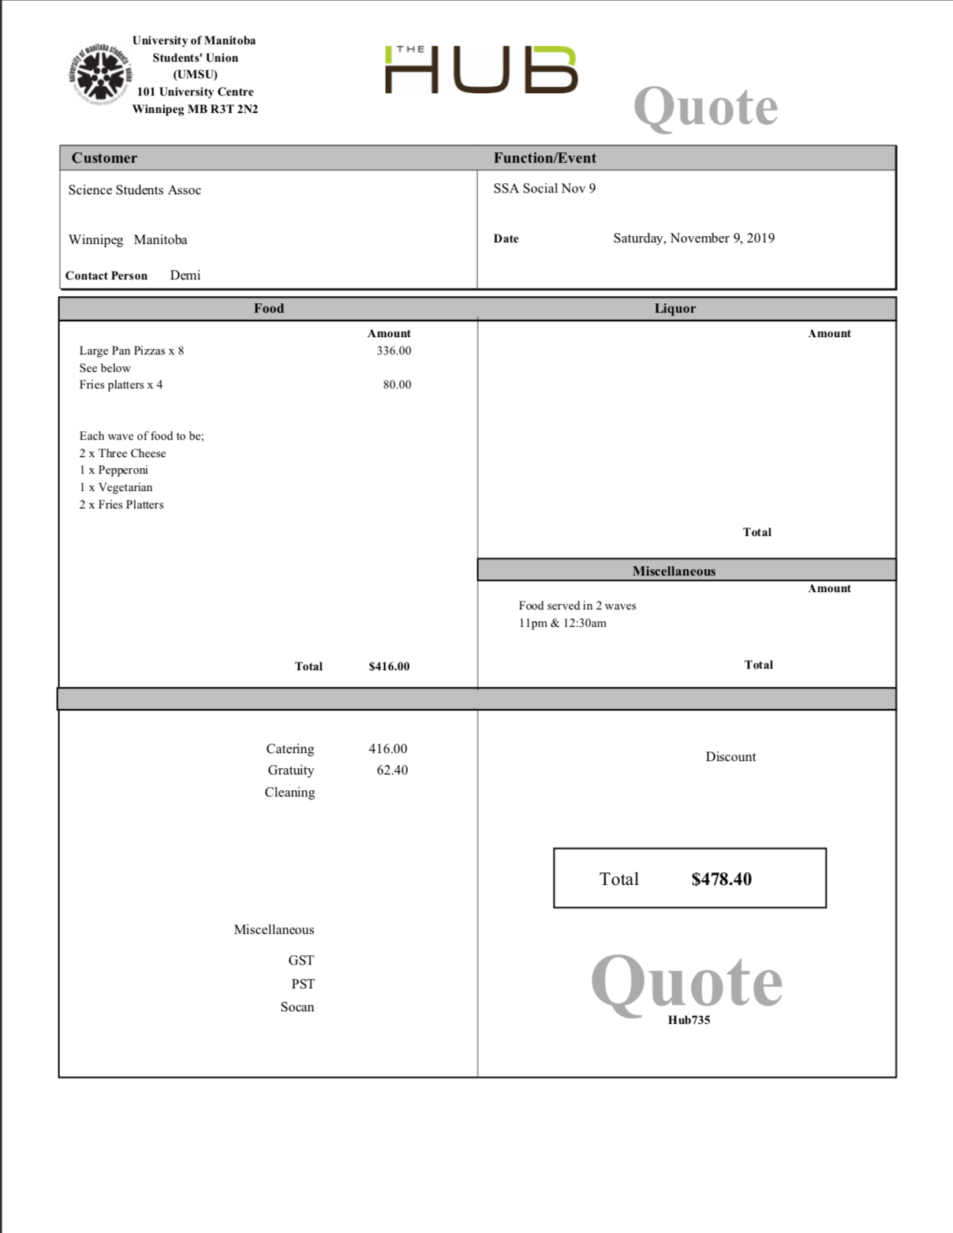

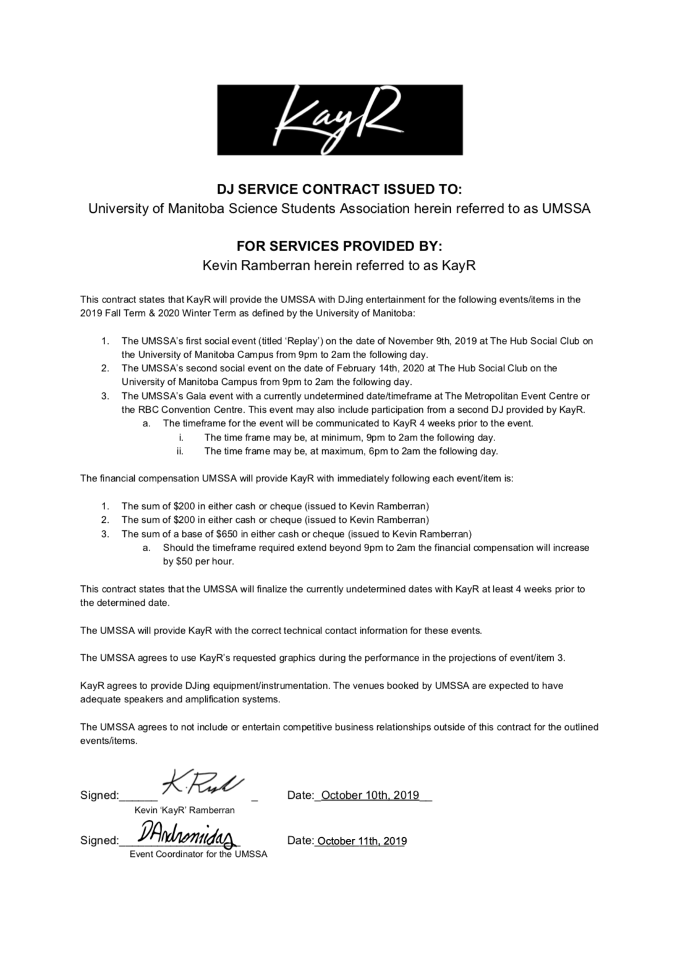
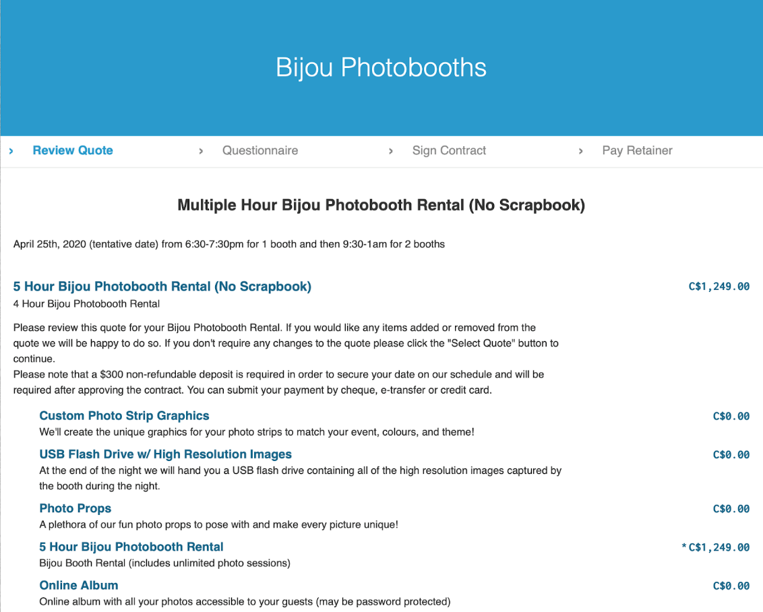
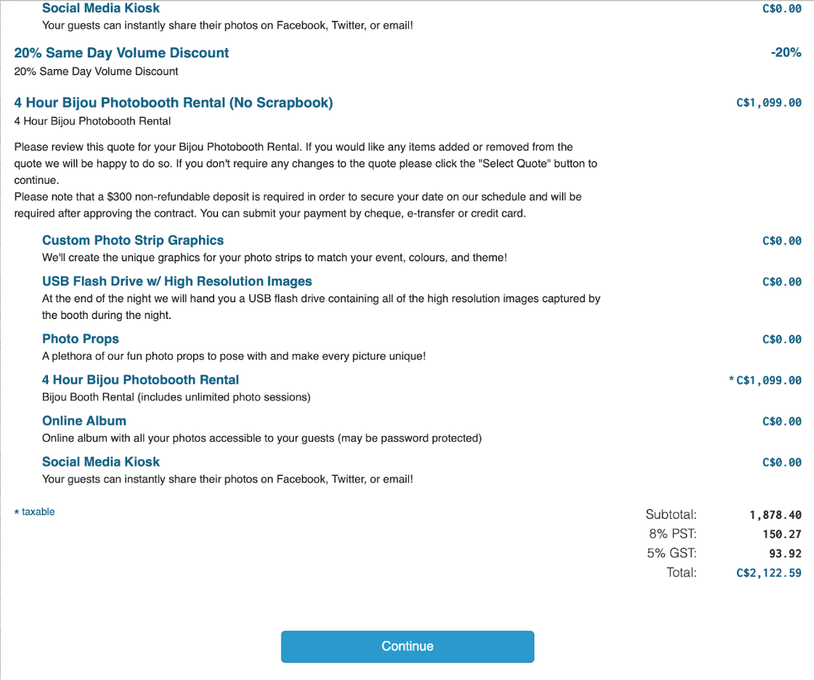

- Academics
- No report
- Lounge Programming
- No report
- Community Representatives
- No report
- LGBTTQ*
- No report
- Women’s
- No report
- Indigenous Students Report
- No report
- International Students Report
- No report
- Student Services
- No report
- Treasurer
- No report

- Committee Reports
- Executive
Justin Lin and Eric Vasas Report:
- Food Budget
- Discussed the proposal by Brendan Scott to increase the council meeting food budget by $1500.
- This brings the total budget from $1000 to $2500 in order to provide more food options for during meetings and making it easier to accommodate the council members with dietary restrictions.

Executive Committee moves to increase the food budget from $1000 to $2500. Second not needed, Motion passed.

- Coke Sponsorship
- Eric has sent an email to Coca-Cola inquiring about a possible sponsorship deal.
- Specific details about the sponsorship are still yet to be determined but we will provide update as they become available.

- SSA Research Grant
- Propose to council this week
- Members of the Science Students Association Council are not eligible for the research grant in order to avoid any conflict of interest.

- Weekly Cleaning/Office Cleanup
- Cleaning weeks are not being enforced therefore sometimes task that need to be completed are not being done.
  - Exec will come up with a list of cleaning tasks that must be done throughout the week.
  - This task list will be posted in the SSA office and after completing a task you must sign your name beside that task to indicate that It has been done.
- After almost two months in the office, no significant efforts have been made to clean and organize the office. Exec has come up with two possible ideas on how we can complete this. The list will be posted in Slack tomorrow.
  - We can divide the office into sections and councilors will be assigned to complete one section each week.
  - If there are any volunteers willing to help clean up the office, we can complete it in one day.

- SSA By-Election CRO

Executive Committee moves to approve Emily’s sister, Steph Kalo, as CRO for the upcoming by-election. Second not needed, Motion passed.

- Ski Trip
- Exec has been discussing possible dates for the annual Asessippi (https://asessippi.com/) Ski Trip but we need input from council members about which dates would work best.
- Eric as well as the other members of the committee in charge or planning the Ski Trip must meet in order to organize the trip.

- Funding Requests
- Executive Committee moves to approve the recommended amounts for the following funding requests, second not needed; Motion passed:
  - Sangeev Selvaratnam
- Requested: $500
- Exec Recommends: $150
  - Ceilidh Simon
- Requested: $47.11
- Exec Recommends: $47.11
  - Jordan Krenkevich
- Requested: $150
- Exec Recommends: $150
  - Gabrielle Fontaine
- Requested: $200
- Exec Recommends: $150
- Full funding request applications can be found below:
----- Funding Requests from Sangeev Selvaratnam -----
Name: Sangeev Selvaratnam
E-mail: selvaras@myumanitoba.ca
Funding Amount Requested: $500
Describe yourself or group/organization mandate: I’m an undergraduate student in the Department of Physics and Astronomy, and I’m in my final year. I have received the Undergraduate Research Award for the summer of 2018 and the UMSU Undergraduate Research Award for the summer of 2019. I want to present my research from the last two summers to a broader audience at the Canadian Undergraduate Physics Conference (CUPC).
Description of Event/Project: Canadian Undergraduate Physics Conference (CUPC) is an annual event organized by the Undergraduate physics students of different university every year. It is hosted by McGill University in 2019 and will be held from November 7th to 10th. Students present oral and posters presentations related to physics or astronomy during the conference and will be participating from various institutions that offer physics in Canada.
Please provide a detailed expense breakdown of where funding shall be allocated to. You may also attach a document of expenses below: Estimated Costs:
Registration fee (including accommodation): $414
Flight: $520
Taxi (to and from the airport): $80
Food (1 meal per day): $100-$120
Total: $1114-$1134
(All expenses are in CAD)
List other sources of funding you have applied to (include requested or amount from other sources): Other sources of funding:
Department of Physics and Astronomy: Approved ($250)
Faculty of Science: Approved ($250)
UMSU: Pending
Supervisor: Pending
How will your event accommodate or serve the Faculty of Science Students?: This is an excellent opportunity for me to represent my university, Faculty of Science and my research at a national level, and if I win any awards, it will bring the Faculty of Science more prestige, helping the students. I could also use my experience to help future students who are planning on attending similar conferences in the future as I'm an executive member of the Organization of Undergraduate Physics Students here at the University of Manitoba.
––––––––––––––––
----- Funding Request from Ceilidh Simon -----
Name: Ceilidh Simon
E-mail: simonc@myumanitoba.ca
Funding Amount Requested: $47.11
Describe yourself or group/organization mandate: Women in Computer Science is a group devoted to fostering community between people of all genders in the computer science field, supporting women in the computer science field, and encouraging interest in computer science from a young age.
Description of Event/Project: Pizza to thank members coming out to join the website committee
Please provide a detailed expense breakdown of where funding shall be allocated too. You may also attach a document of expenses below: $47.11 for Pizza
List other sources of funding you have applied to (include requested or amount from other sources): Applied for UMSU operational funding
How will your event accommodate or serve the Faculty of Science Students? The members of the website committee are Faculty of Science Students, and this will assist them in gaining new skills in web development, as well as allowing WICS to better serve our members with an up to date website.
––––––––––––––––
----- Funding Request from Jordan Krenkevich -----
Name: Jordan Krenkevich
E-mail: krenkevj@myumanitoba.ca
Funding Amount Requested: $150
Describe yourself or group/organization mandate: I am an undergraduate physics student in the medical physics honours program.
Description of Event/Project: I am attending the Canadian Undergraduate Physics Conference (CUPC). This conference will give me the opportunity to present my research as well as well as see what other research is being done in my field. This conference will give me the opportunity to network and allow me to see what other university offer in terms of graduate studies.
Please provide a detailed expense breakdown of where funding shall be allocated too. You may also attach a document of expenses below: Conference: $413
Flight: $431
Other: $180
List other sources of funding you have applied to (include requested or amount from other sources): Faculty of Science: $250
Department of Physics: $250
UMSU
Supervisor
How will your event accommodate or serve the Faculty of Science Students? I will promote the research going on at our institution, showing what our great institution and students are capable of doing.
––––––––––––––––

----- Funding Request from Gabrielle Fontaine -----
Name: Gabrielle Fontaine
E-mail: fontai26@myumanitoba.ca
Funding Amount Requested: $200
Describe yourself or group/organization mandate: I am an undergraduate physics student in the medical physics honours program. My student number is XXXXXXX.
Description of Event/Project: I am attending the Canadian Undergraduate Physics Conference in Montreal QB, November 7-10th. The conference is aimed towards undergraduate students pursuing physics in Canada. Different talks, workshops and graduate fairs are presented for the students. The conference fee is $413 (including tax) and covers the registration fee and accommodations.
Please provide a detailed expense breakdown of where funding shall be allocated too. You may also attach a document of expenses below: Conference fee: $410
Airfare: $430
Checking bags: $60
Food: ~ $80
Taxi roundtrip: ~ $40
List other sources of funding you have applied to (include requested or amount from other sources): I have received $250 from the department of physics and $250 from the faculty of science ($500 total). I have applied to UMSU through the undergraduate travel funds form but have not heard back from them yet. My supervisor has agreed to cover the rest of the expenses if needed.
How will your event accommodate or serve the Faculty of Science Students? I will be presenting my summer & thesis work at the conference though a poster and a talk. This will educate other students across Canada on the current research opportunities at the University of Manitoba. This may help students decide what universities they want to attend for potential graduate studies.
––––––––––––––––
- By-Laws
- No report

- Other Business
- Important Dates/Notes
- No report

- Dismissal
Justin Lin motions for dismissal at 7:06pm, Brendan Scott seconds; Motion passed.

Motions
October 15th, 2019

Motion Regarding: LGBTTQ* By-Election CRO | Category: SSA By-Elections
Motion: WHEREAS the SSA is missing an LGBTTQ* Representative
- WHEREAS the position must be filled by December by a by-election or general assembly
- BE IT RESOLVED that Steph Kalo hold the responsibility of being the Chief Returning Officer (CRO) for the 2019/2020 by-election with the help of the current counsel.

Status: Motion passed

Moved By: Eric Vasas
Seconded By: Juanita Garcia

Motion Regarding: By-Election Dates | Category: SSA By-Elections
Motion: Motion that November 20th – 22nd will be the nomination period for the 2019/2020 by-election, the 25th – 28th will be the campaign period, and the 29th will be voting day.

Status: Motion passed

Moved By: Eric Vasas
Seconded By: Justin Lin

Motion Regarding: Gavel for Chairperson | Category: Budget
Motion: Motion to purchase a gavel set for the chairperson.

Status: 3 in favour, 8 opposed; Motion defeated.

Moved By: Brendan Scott
Seconded By: Eric Vasas

Motion Regarding: Replay Social Budget | Category: Finance
Motion: To approve a total budget of $933.40 for the Replay Social.

Status: Motion passed.

Moved By: Serena Phillips
Seconded By: Eric Vasas

Motion Regarding: Gala Budget | Category: Finance
Motion: To approve a budget of $7122.59 for the RBC convention centre and photobooth deposits for the Gala.

Status: Motion passed.

Moved By: Serena Phillips
Seconded By: Eric Vasas

Motion Regarding: Food Budget | Category: Finance
Motion: To increase the food budget of $1000 to $2500 for meetings.

Status: Motion passed.

Moved By: Executive Committee
Seconded By: N/A

Motion Regarding: Funding Requests | Category: Finance
Motion: To approve the recommended amounts for the proposed funding requests; see above minutes for further details.

Status: Motion passed.

Moved By: Executive Committee
Seconded By: N/A

