Science Student’s Association Meeting Attendance
June 10th, 2019

Position | Name | Present

President | Justin Lin | No (Regrets, Proxy: Tyler Szun)
Vice President | Eric Vasas | Yes
Chairperson | David Chamberlain | Yes
Secretary | Tristan Rohatynsky | Yes
Senator | Jaime McNicholl | Yes
Senator | Katelyn Casalla | Yes
Senator | Kristine Macalinao | Yes
UMSU Representative | Brendan Scott | No (Regrets, Proxy: Tino Dogo (Absent))
UMSU Representative | Chloe McElheron | No (Regrets, Proxy: Savannah Szocs)
UMSU Representative | Dani Stackiw | Yes
UMSU Representative | Matt Rakar | No (Regrets, Proxy: Selina Audino)
Accessibility Representative | Pending | N/A
Indigenous Students’ Representative | Gillian McIvor | Yes
International Students’ Representative | Juanita Garcia | Yes
LGBTTQ* Representative | Pending | N/A
Women’s Representative | Emily Kalo | No (No regrets, No Proxy)

Treasurer | Justin Cruz | No (No regrets)
Director of Academics | Tyler Szun | Yes
Director of Communications | Savannah Szocs | Yes
Director of Special Events | Serena Phillips | Yes
Director of Student Services | Mrittika Deb | No (Regrets)
Executive Assistant/Communications Programmer | Dustin Erickson | Yes
Academic Programmer | Stuti Gupta | Yes
Academic Programmer | Tino Dogo | No (No regrets)
Lounge Programmer | William Kong | Yes
Special Events Programmer | Dana Segal | No (No regrets)
Special Events Programmer | Demi Andromidas | Yes
Special Events Programmer | Selina Audino | Yes
Student Services Programmer | Kanso Alaka | Yes
Student Services Programmer | Shelly Lam | Yes

Science Student’s Association Meeting Minutes
June 10th, 2019
Called to Order: 6:12 PM
- Approval of Agenda
Demi Andromidas motions to approve the agenda with one amendment.
- Demi adds motion to include introductions at the beginning of the agenda.
Jaime McNicholl seconds; Motion passed.

- Acknowledgement to use of Treaty Land
Gillian McIvor acknowledges that we are meeting on treaty land.

- Approval of Minutes
Demi Andromidas motions to approve the previous meeting minutes with the following amendment, as such to change the amount of $40,000 to $4000 as noted in the Special Events Report minutes. Eric Vasas seconds; Motion passed.

- Committee Reports
- Executive
- Committee members to be discussed and decided later on during meeting
- By-Laws
- Committee members to be discussed and decided later on during meeting

- Councillor Reports
- Special Events
- No report
- Academics
- No report
- Lounge Programming
- No report
- Community Representatives
- No report
- LGBTTQ*
- No report
- Women’s
- No report
- Indigenous Students Report
Gillian McIvor Reports:
- Partnership with ENGAP (engineering Access Program):
- Faculty of Engineering has their own full council of Indigenous students
- https://www.aises.org
- MUSA and UMISA
- Both councils (MUSA and UMISA) have had almost complete turnovers, so if you’re Indigenous and interested in getting more involved with the Indigenous community on campus just let Gillian know and you can even join her in a meeting!
- Almost full councils now (complete turnover)
- Interested in partnering with Faculty of Science
- Caucus here that they want to be more involved
- Want to send Indigenous students to a Conference in Colorado (more work and info on this in fall)

- International Students Report
- No report
- Student Services
- No report
- Treasurer
- No report

- Council Reports
- (Vice) President
Eric Vasas Reports:
- Rules/Expectations
- Fall and Winter Meeting Dates → David
- Try to attend all meetings; need to be here for at least 75% of the meetings (last year this worked out to being 3 meetings missed max)
- Will do a doodle poll to determine scheduling
- Last Monday of the previous month the doodle poll will be sent out
- Poll will be left open for a long time (to accommodate for if people’s schedules change)
- Bylaws
- Jaime is going to get the package from Madhur (previous Chairperson) and Savannah will send an updated copy
- Changeover Packages
- Expectations and Open Meeting Policy
- Meetings can be open session or closed session
- Open session: people may come in and sit + listen in
- Closed session: Just council members (Chairperson has to leave the room and then will be called back in after open session is resumed)
- Office Hours
- 8:30-4:30 during weekdays
- Likely going to change it to earlier for 8:15
- For people who have early labs/classes
- Posting on Social Media and Social Media Passwords
- Instagram
- Website
- Website is run by Savannah and Dustin (Communications)
- Will be getting a physical calendar which will be updated by Communications team as well

- 2017/2018 Budget Overview
- Last time Eric checked, we had around $60,000 in the bank account
- Need to confirm exact amount with Justin C

- 2018 Gala Reimbursement?
- Last Changeover meeting a reimbursement was brought up
- Past councillors will get their tickets paid for (reimbursed)
- Follow up with Justin Tsang/Justin Cruz?

- SSA Council Apparel?
- We get hoodies as part of council
- Last year was marron, previous year was gray
- Options:
- Black
- Forest Green
- Navy Blue
- A poll will be posted and we’ll vote on it (sometime after meeting)

- SSA Council Activities Budget
- One council activity each semester
- Last year during Fall semester council did the Corn Maze
- Last year $900 was approved (for the entire budget in total last year)
- Only spent about a quarter of this last year
- Will do a vote on budget amount sometime

- SSA Council Meeting Expenditures Budget (AKA Food Budget)
- Last year $2000 was approved?
- Will double check next meeting
- Dietary restrictions posted in slack
- 2 vegetarian
- 1 gluten free
- Last year we had one person in charge of food
- Can make a schedule for this year instead and do a rotation unless one person want to volunteer to do it
- Last year we had a deal with Degrees (no longer catering)

- Committee Membership
- Executive committee:
- Roles:
- Deal with emergencies
- Evaluate requests for funding
- Lots of budgeting
- Give detailed reports and guidelines
- Assist treasurer with their duties if called upon to do so
- Only elected councillors are able to participate
- Consists of:
- President
- Vice President (as chair treasurer)
- (2) other elected Councillors elected from and by the Council
- Candidates/Nominees:
- Kate (selected)
- Kris (selected)
- Jaime
- Bylaws Committee:
- Roles:
- Periodically review the Bylaws
- Advise on any amendments brought forward to Council
- Propose bylaw amendments to Council
- Consists of:
- Chairperson (as chair)
- Vice-President
- (3) Councillors selected and determined by a vote of council
- Candidates/Nominees:
- Savannah (selected)
- Tristan (selected)
- Tyler
- Stuti (selected)
- Dustin
- Chloe
- Science Orientation Committee
- Organized by: Justin L and Eric (morning) and Serena (afternoon)
- Full day event
- Afternoon hosted by Special Events
- Sponsorship: finding/asking people for monetary or gift donations
- Jaime
- Tyler
- Additional (2) for organizing volunteers:
- Katelyn
- Gillian
- Additional (2) for organizing panel discussion and scavenger hunt:
- Savannah
- Stuti
- Afternoon courtyard:
- Special Events
- Serena
- Demi
- Selina
- Science LabTREK Committee:
- Organized by: Academics
- Now organized by Academics
- Additional (4):
- William
- Kanso
- Shelly
- Juanita
- SSA Ski Trip Committee → Friday February 15th to Sunday February 17th
- Organized by: Eric and Savannah
- Organizers get to go for free
- Additional (1) for communications and planning – someone who will be going on the trip:
- Juanita

- Reimbursement Motions
- Motion to approve $226.88 to be reimbursed for purchasing the website renewal from Squarespare
- Motioned by Eric, Jaime seconds; Motion passed

- Meeting with the Dean
- More study spaces
- Armes Link
- Duff Machray area (tunnel between Science and Arts)
- Suggested by Dean
- Empty space in physics
- Fire safety space/zone?
- Possibly try to make this a study space
- Booking system for SSA study room
- Can we use the library system?
- Might just end up using this system
- Would have unlimited access to it
- Would make the area more available to the students
- Student group start-up funding
- Last year we gave them $1000
- Says $2000 in budget because that was from the last 2 years
- Can it come from SIF?
- Likely will come from SIF but need to look into this
- Look into partnerships with Coca-Cola
- Confident with this partnership

- Ongoing Contract with Prep101 and SSA
- Help us with scholarships and give us money as well
- In return we promote and advertise for them
- Social media posts, posters, announcements, etc.
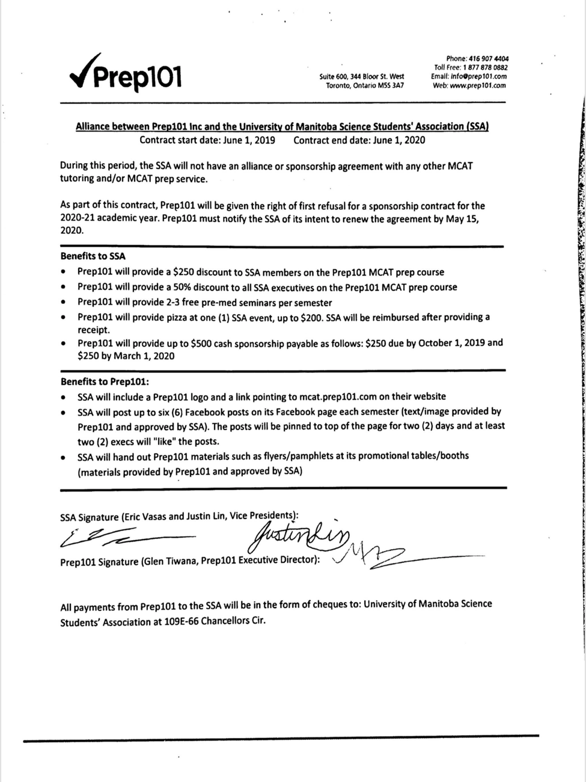

- Council Pictures → ?
- Individual
- Everyone gets their own individual headshot
- Groups
- President + Vice President
- UMSU Reps
- Senators
- Community Reps
- Secretary + Treasurer + Communications
- Student Services
- Academics
- Special Events
- Chairperson
- Need to find out who has a good camera
- Savannah does
- Just need to find a tripod to borrow (if needed)
- Bailey organized it last year
- Savannah will put the pictures up on the website

- Office Tour and General Office Rules
- Tour of the Office
- Not doing office tour today because of construction going on (can’t access room)
- Door Code (DO NOT GIVE OUT) – pay the $40 fee for locksmith to come
- If you give out the good to anyone not in council you have to pay for the locksmith to come and change the code again
- General Office Rules
- Guests
- Currently during office hours you can’t have non-members with you (for now until further discussed – may change in future)
- Outside of office hours you can bring guests in
- Guests are allowed anytime after hours as long as they’re accompanied by a councillor (councillor brings them in ad stays with them)
- Councillors always have priority for spots if there are guests
- Try without guests for the first semester or first month and then can rework if it doesn’t work out
- If there’s too many people in the office sometimes it can get too crowded/too loud
- Allowing guests would only increase the amount of people in the office
- Will bring this up to council another time (would be a Bylaws change possibly?)
- Options:
- Have it so we can bring guests in during office hours for the week
- Keep it closed to guests initially for the first part of the semester so council can get to know each other better and then change it
- Office Hours
- Must attend scheduled office hours
- 8:30-4:30 during weekdays
- Likely going to be changed to earlier to 8:15
- Rules on buying stuff → mainly Chloe
- Cleaning
- Cleaning schedule
- Everyone has a cleaning week
- Schedule organized by Secretary (Tristan)
- Clean up after yourselves
- Watering Plants
- Microwave
- FRIDGE
- Keep fridge clean
- Clean out old food
- Sweeping (Office and Study Room)
- Wiping down tables and countertops
- Taking out the garbage THROUGHOUT THE WEEK
- Tidying up
- Lounge equipment
- Rentals

- Senate
Kristine Macalinao Reports:
Senate Meeting May 15, 2019:
- Senate Committee on Awards (Computer Science)
- New award for women in computer science to encourage participation and inclusion
- Not as many females involved
- Five scholarships for any female student in computer science
- Requirements:
- Second, third, or fourth year student enrolled full time in the Faculty of Science and declared major in the department of Computer Science
- Minimum GPA of 3.5
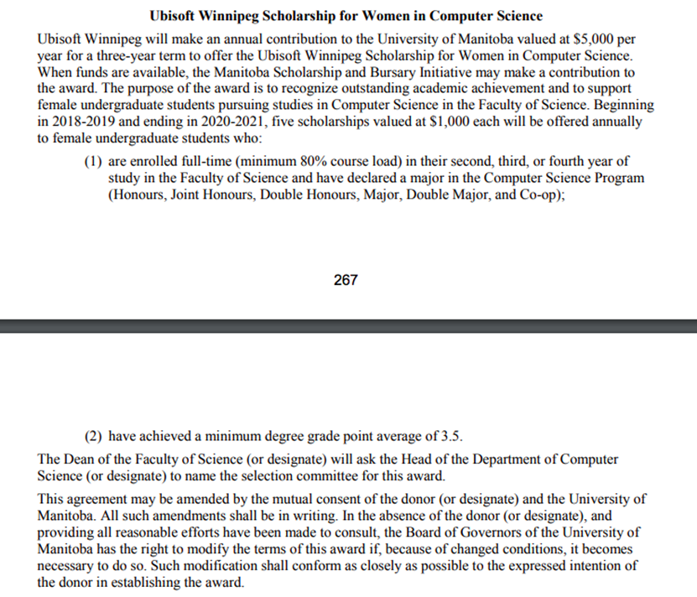

- Senate Caucus Meeting Report:
- Senate Committee Memberships
- Kristine – Senate Committee on Admissions (SCADM) and Senate Committee on Instructions and Evaluations (SCIE)
- Kate – Senate Committee on Admissions (SCADM) and Senate Committee on Nominations (SCN)
- Jaime – Senate Committee on Appeals
- Senate website: www.umanitobassa.com/senate
- Agenda and minutes are posted on the website if anyone wants to look at them
- Anyone can come to Senate meeting (as long as they’re open session)

- UMSU
Dani Stackiw on behalf of Brendan Scott Reports:
UMSU Meeting May 16, 2019:
- Healthcare for International Students at UofM
- In 2018 the Provincial government ended covering the cost of healthcare for international students
- The university stepped in for that school year and covered the expenses
- However this coming school year international students will have to pay a premium on top of their tuition and living expenses
- Different from last year
- At the moment UMSU is working hard to fight for the best options on behalf of the international students
- Details of the costs will be released in the near future

- Summer UPass
- UMSU is negotiating for summer UPass as the contract for the current UPass is ending this year
- If UMSU negotiates successfully with City Hall, any increase in fees will have to go to a referendum

- Robert’s Rules of Order
- Roberts Rules of Order were gone over as well with previous chairperson from UMSU

- Communications
Savannah Szocs Reports:
- Poster Advertising for Events
- If anyone needs any kind of advertising for any type of SSA event please let Savannah know
- See Savannah for any kind/type of advertising for SSA
- Try to submit your event information at least 2 weeks prior to the upcoming event
- 1 week to get the posters designed and printed, 1 week to advertise
- Posters will be put up around science complex
- If you are hosting an event that requires tickets (like a social) please give at least 3 weeks notice
- About a week and a half for ticket/poster design and printing (need time to be designed as well)
- At least 1 week for ticket sales and advertising

- Social Media Advertising
- Savannah will also be advertising for events on Instagram and Facebook
- If there are posters being made for an event, Savannah will automatically make posts on our social media to help advertise
- We can also organize ticket giveaways and promotions for events as well
- The SSA website will be updated with events accordingly as well
- We can also run livestreams for larger events like LabTrek and Orientation
- Lots of stories will be posted on social media as well
- Savannah is also going to try to make photos at as many science events as she can this year
- More social media posts this year
- More active on social media
- Going to put them on SSA website as well
- Savannah has a decent camera to use and was thinking of putting the photos on our social media accounts and the SSA website
- DM’s:
- Savannah will answer messages sent to our social media accounts with general questions and concerns
- If a message is directed towards a specific councillor or team Savannah will reach out to them
- If a question pertains to someone else’s role she will follow up with them
- If you’re on the social media and there’s a general question that you can answer, you can go ahead and answer it

- “Meet the Councillors” Instagram Posts
- This isn’t specific to Savannah’s position but she thinks the “Meet the Councillors” Instagram posts from Bailey last year were a really great idea
- Everyone agrees with this
- Helpful for students to get to know whose on council
- Thinking we could do the same idea and councillor photos for this year
- Savannah has a good camera and tripod we could use

- New Addition Ideas for SSA Website and/or Social Media
- If anyone has anything else they want to see added to the SSA website or posted on social media throughout the year, feel free to let Savannah know!

- Other Business
- Important Dates/Notes
- Date for Science Gala
- Special Events is looking into days for Gala
  - Thoughts on convention centre location
    - Was safer and ran more smoothly
    - Google survey to see what people liked/what we should change
    - Or Instagram poll
      - See what people want from the Gala in general
    - Open forum
      - Google form through email would reach the most people
      - Thoughts on Gala and what they want from it (Demi will make it)
  - Need to book the location earlier rather than later to guarantee the chosen date
  - Want to make sure it doesn’t conflict with other major events as well

- Dismissal
Kristine Macalinao motions for dismissal at 7:24 PM, Eric Vasas seconds; Motion passed.

Motions
June 10th 2019

Motion Regarding: SSA Website Renewal | Category: Reimbursement
Motion: $226.88 to be approved to be reimbursed for purchasing the SSA website renewal from Squarespare.
Status: Motion passed

Moved By: Eric Vasas
Seconded By: Jaime McNicholl

